**PYTHON BASICS**

**Python Operators**

**1.Python Program to perform ‘Arithmetic Operators’**

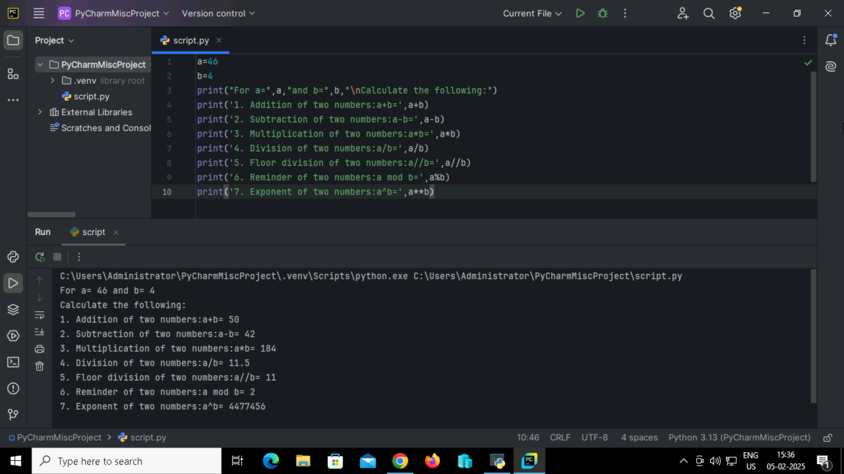

**Output:**

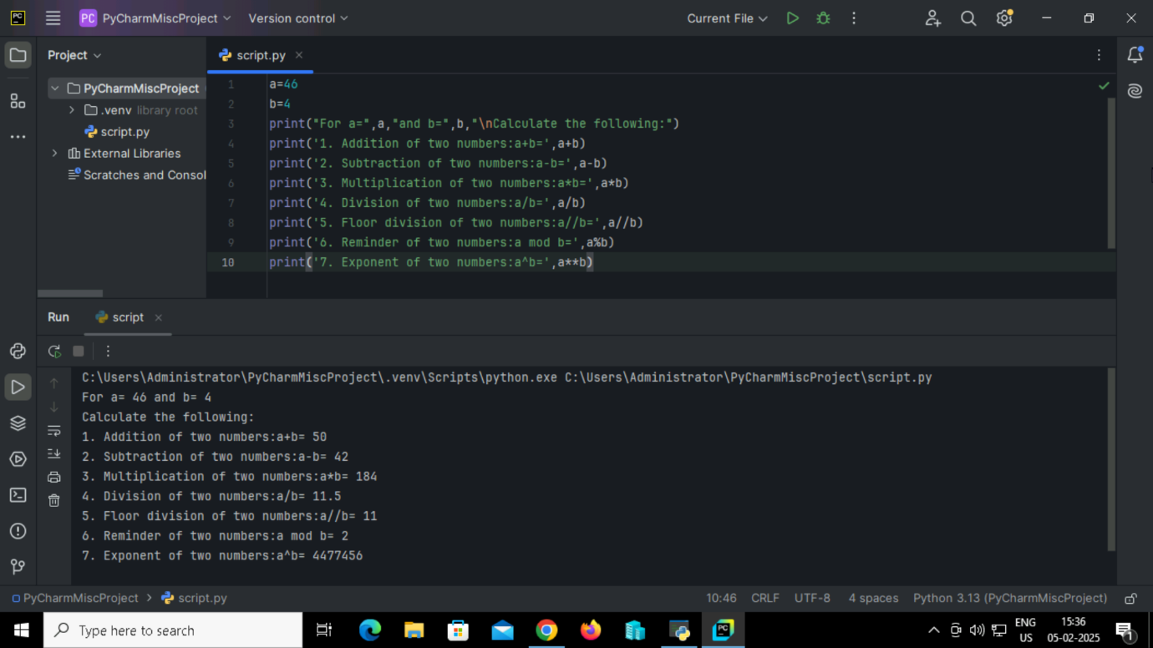

**2. Python Program to perform ‘Comparison Operators’**

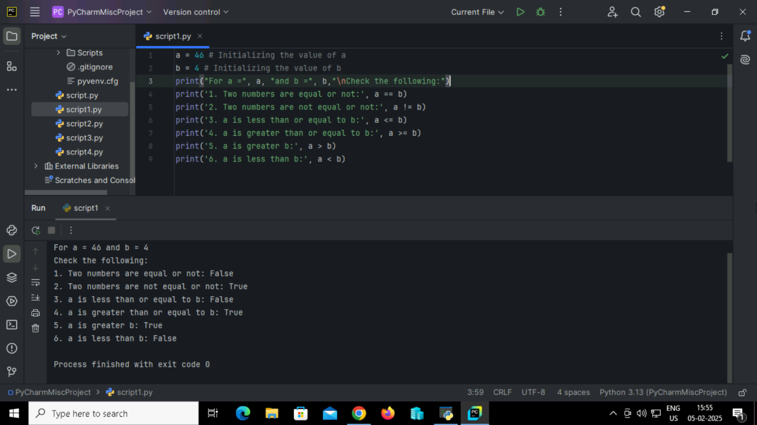

**Output:**



**3. Python Program to perform ‘Assignment Operators’**

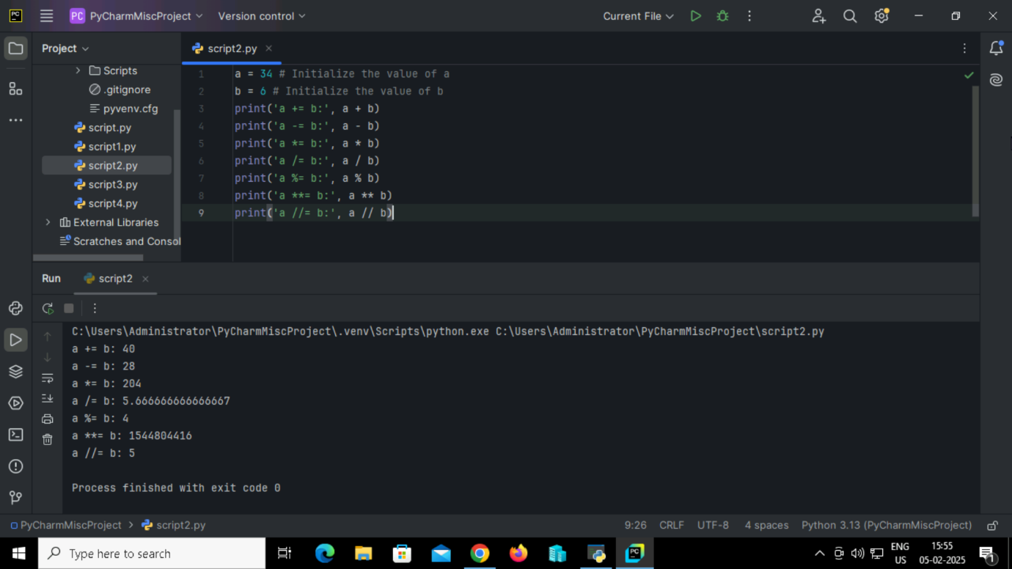

**Output:**



**4. Python Program to perform ‘Bitwise Operators’**

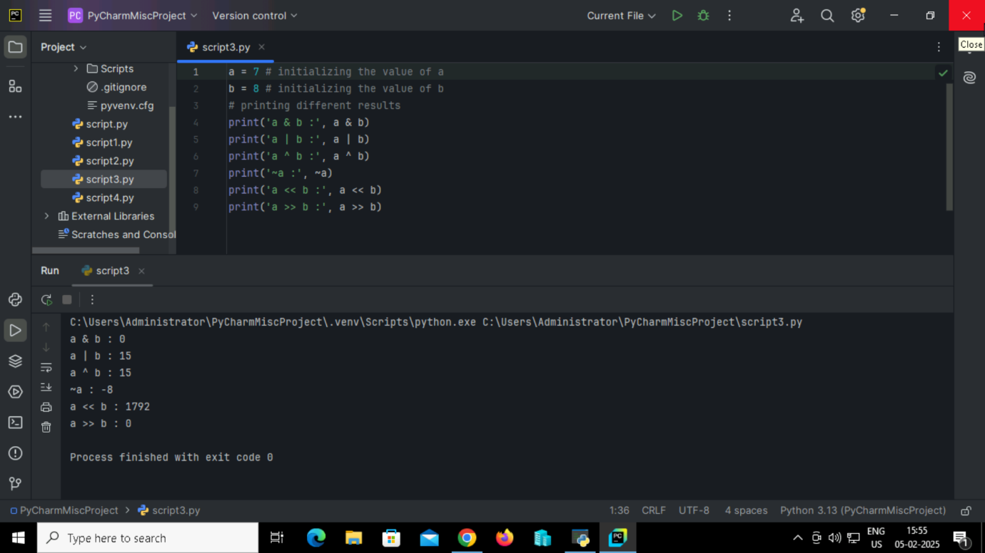

**Output:**



**5. Python Program to perform**  ‘**Logical Operators’**

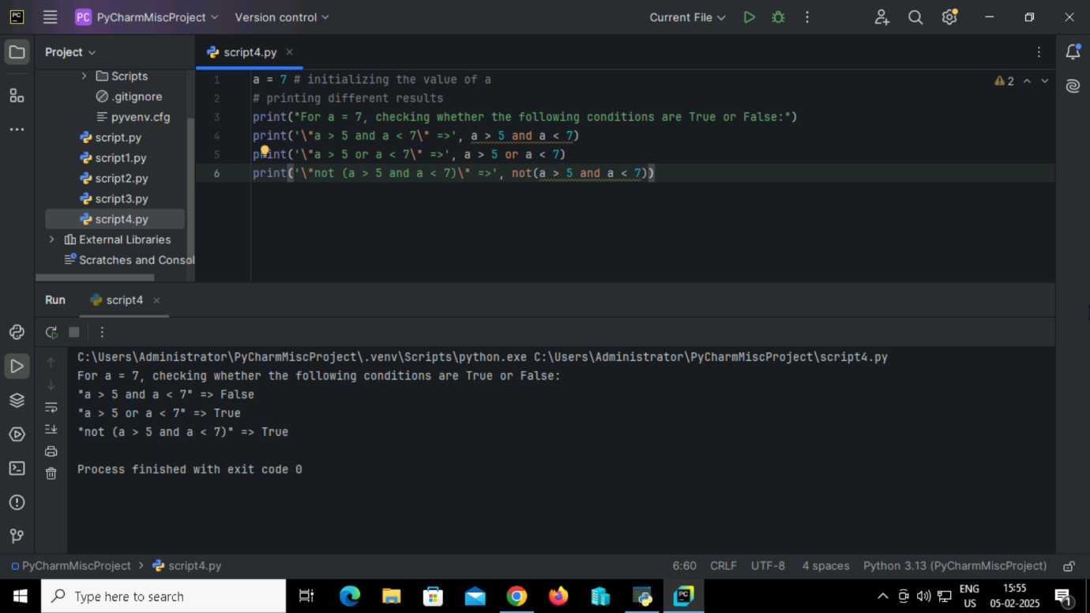

**Output:**



**6. Python Program to perform ‘Membership Operators’**

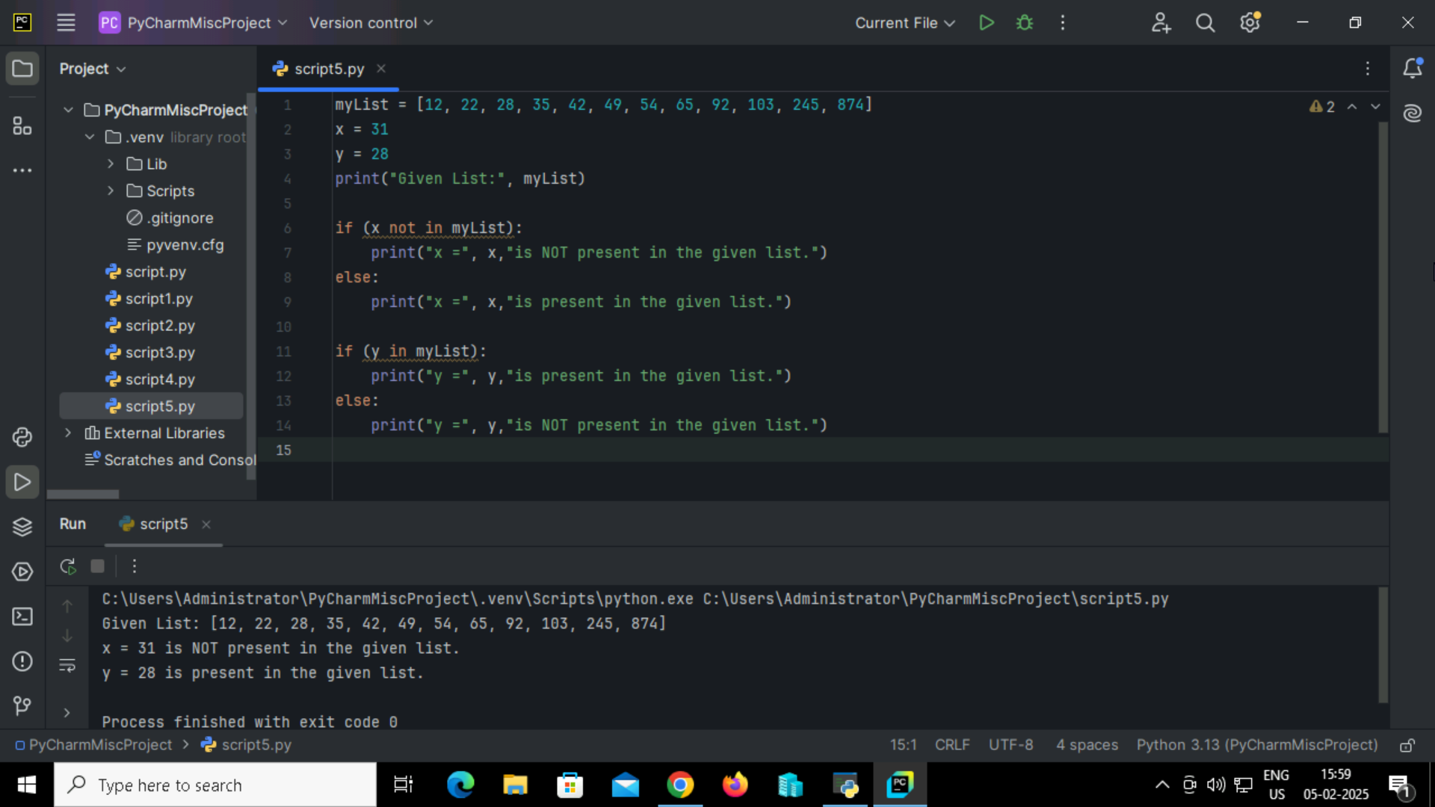

**Output:**



**7. Python Program to perform ‘** **Identity Operators’**

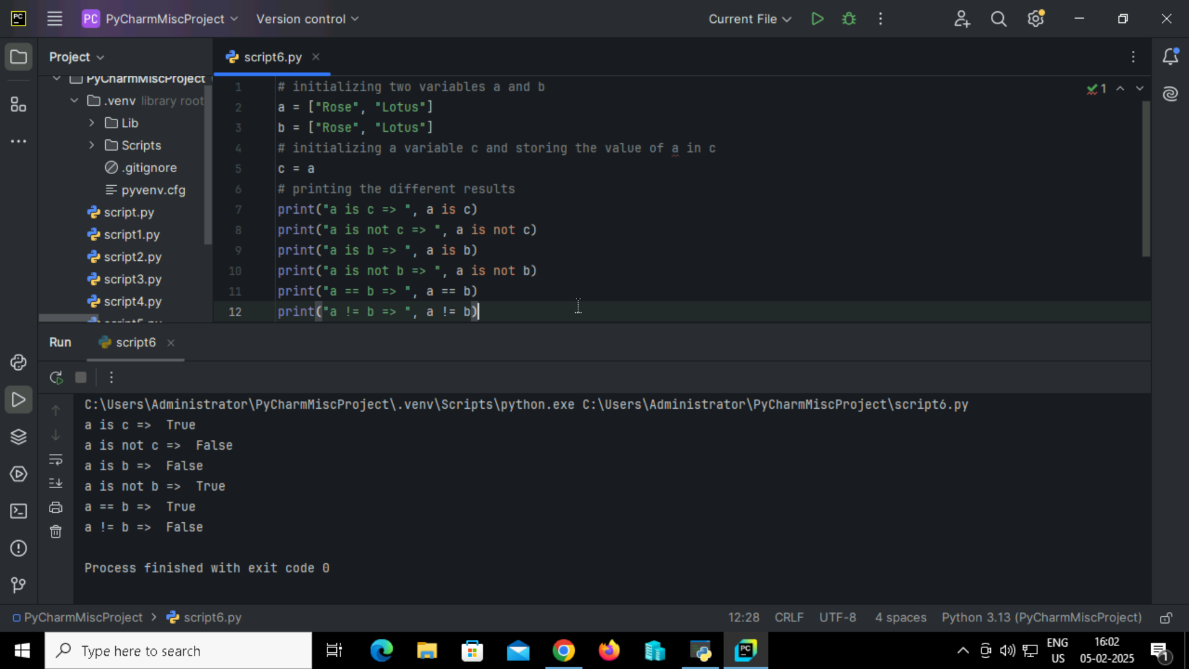

**Output:**

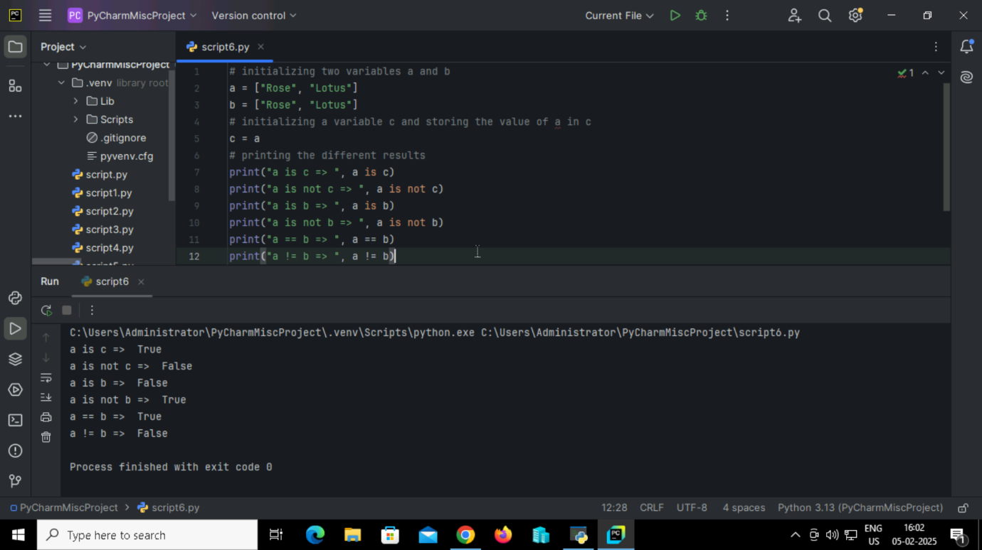

**8. Python program to read a ‘CSV file’**

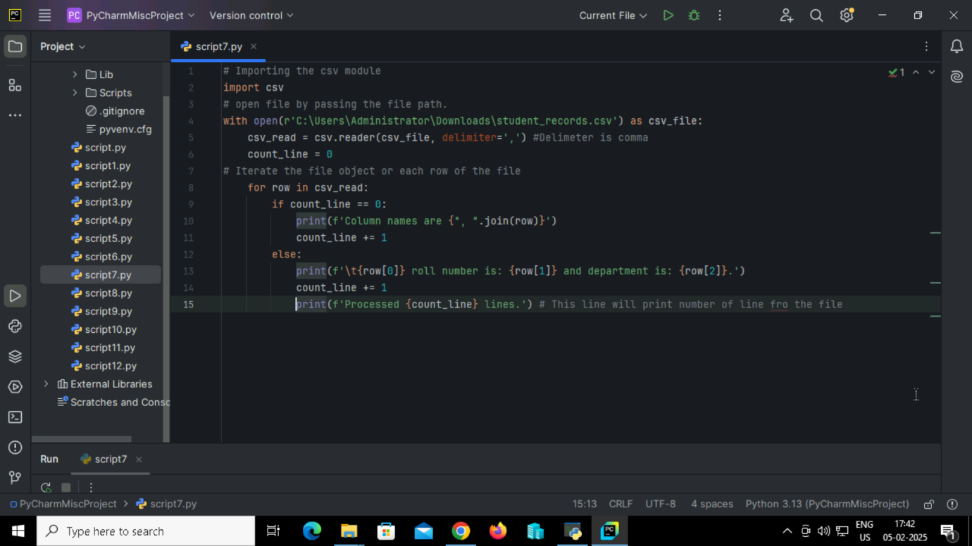

**Output:**

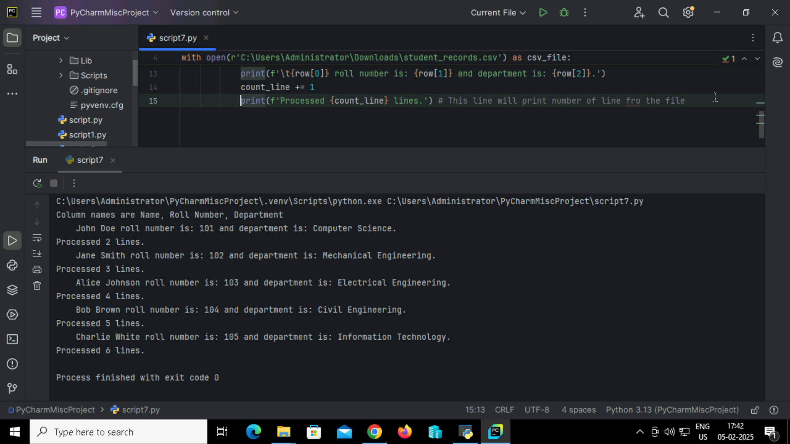

**9. Reverse a string using for loop in python.**

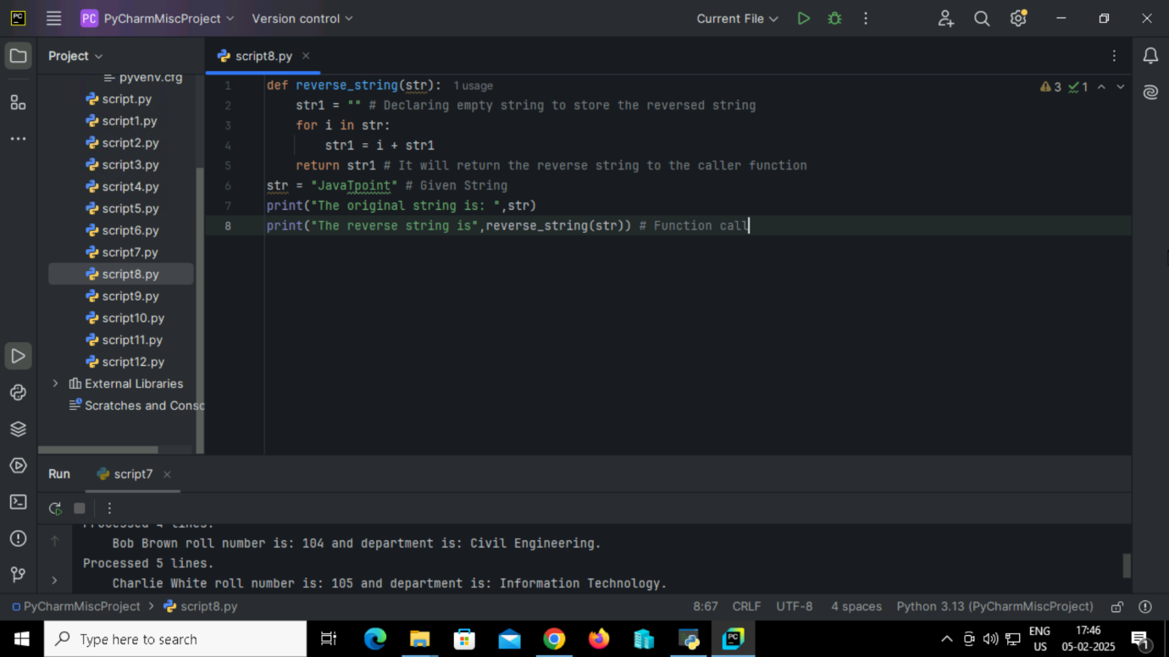

**Output:**

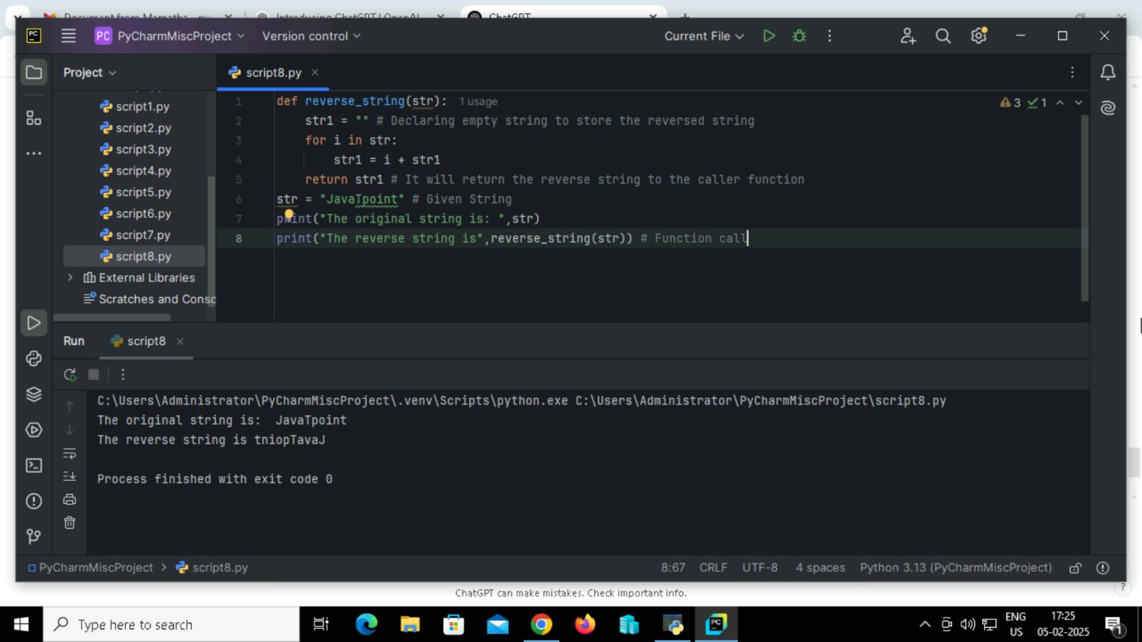

**10. Reverse a string using while loop in python**

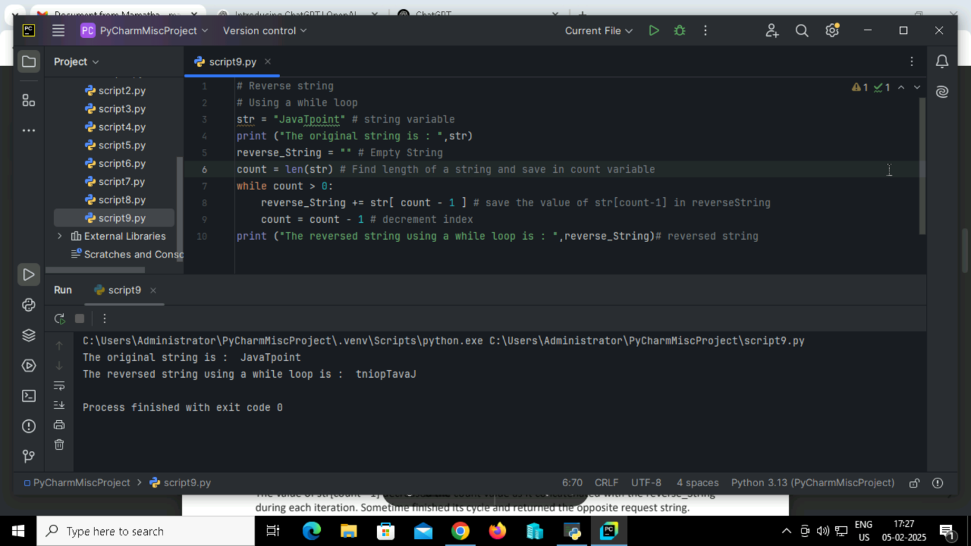

**Output:**



**11. Reverse a string using the slice ([]) operator in python**

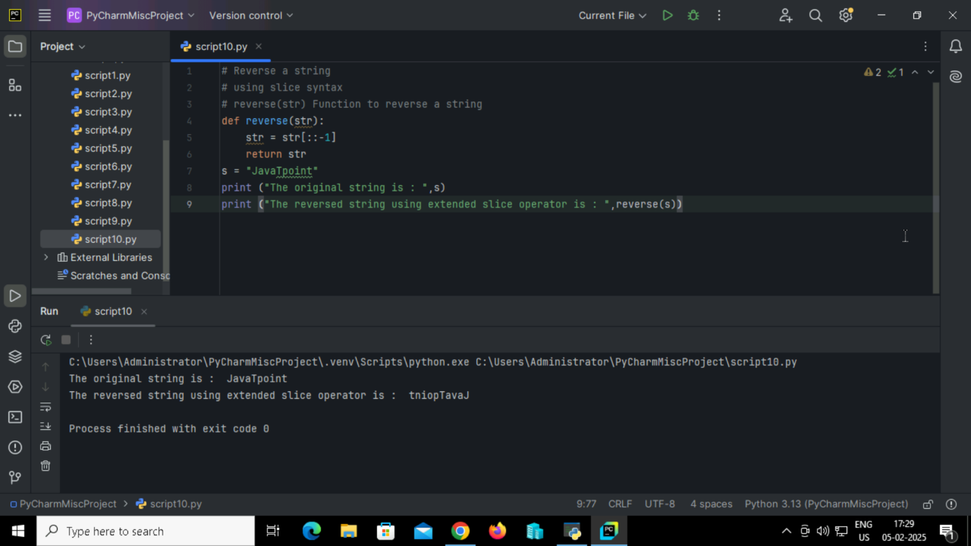

**Output:**



**12. Reverse a string using reverse function with join in python**

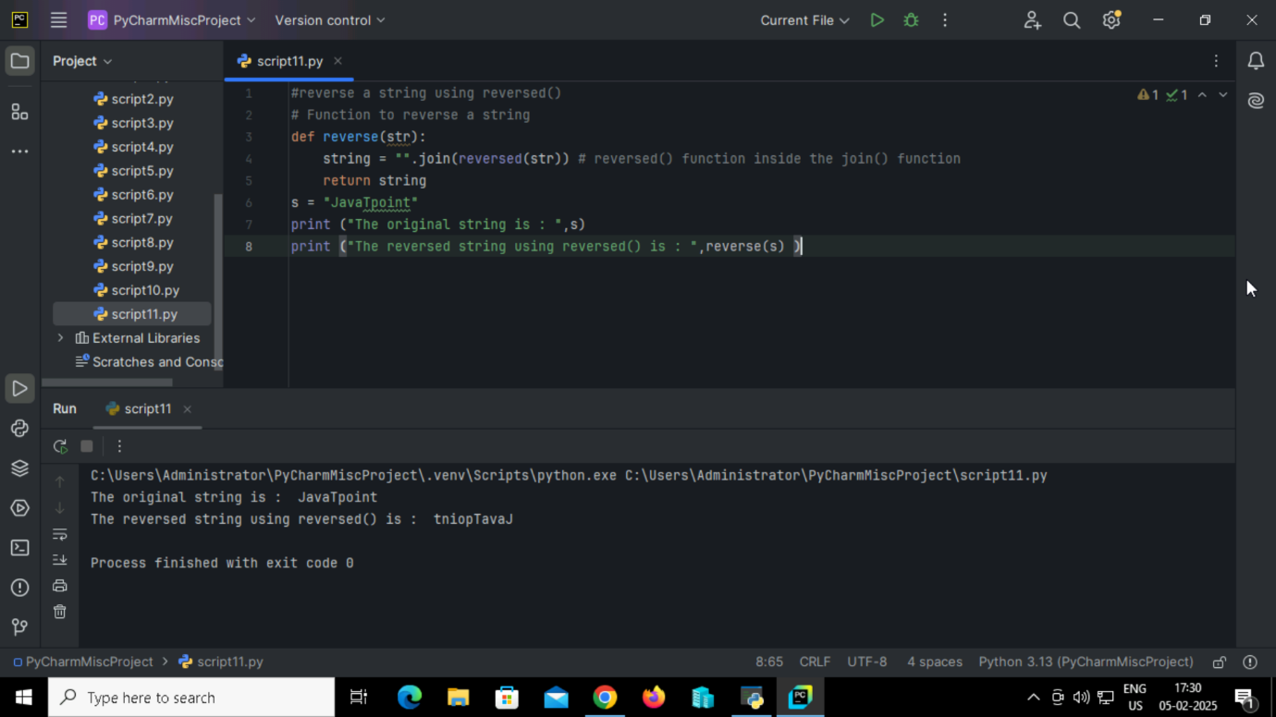

**Output:**



**13. Reverse a string in using recursion function in python**

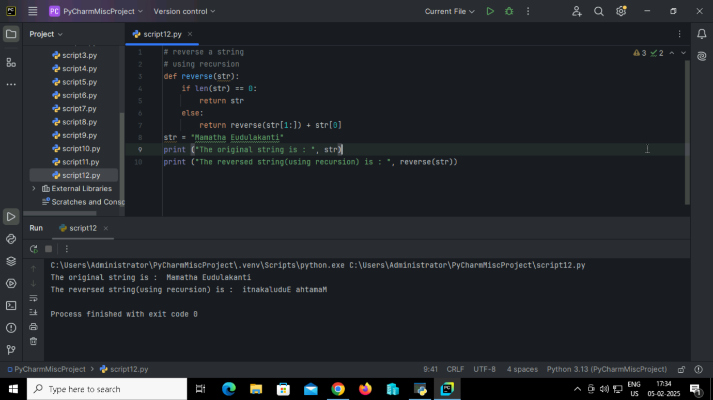

**Output:**



**LOOPS**

**14. Python program to understand the ‘if statement’**

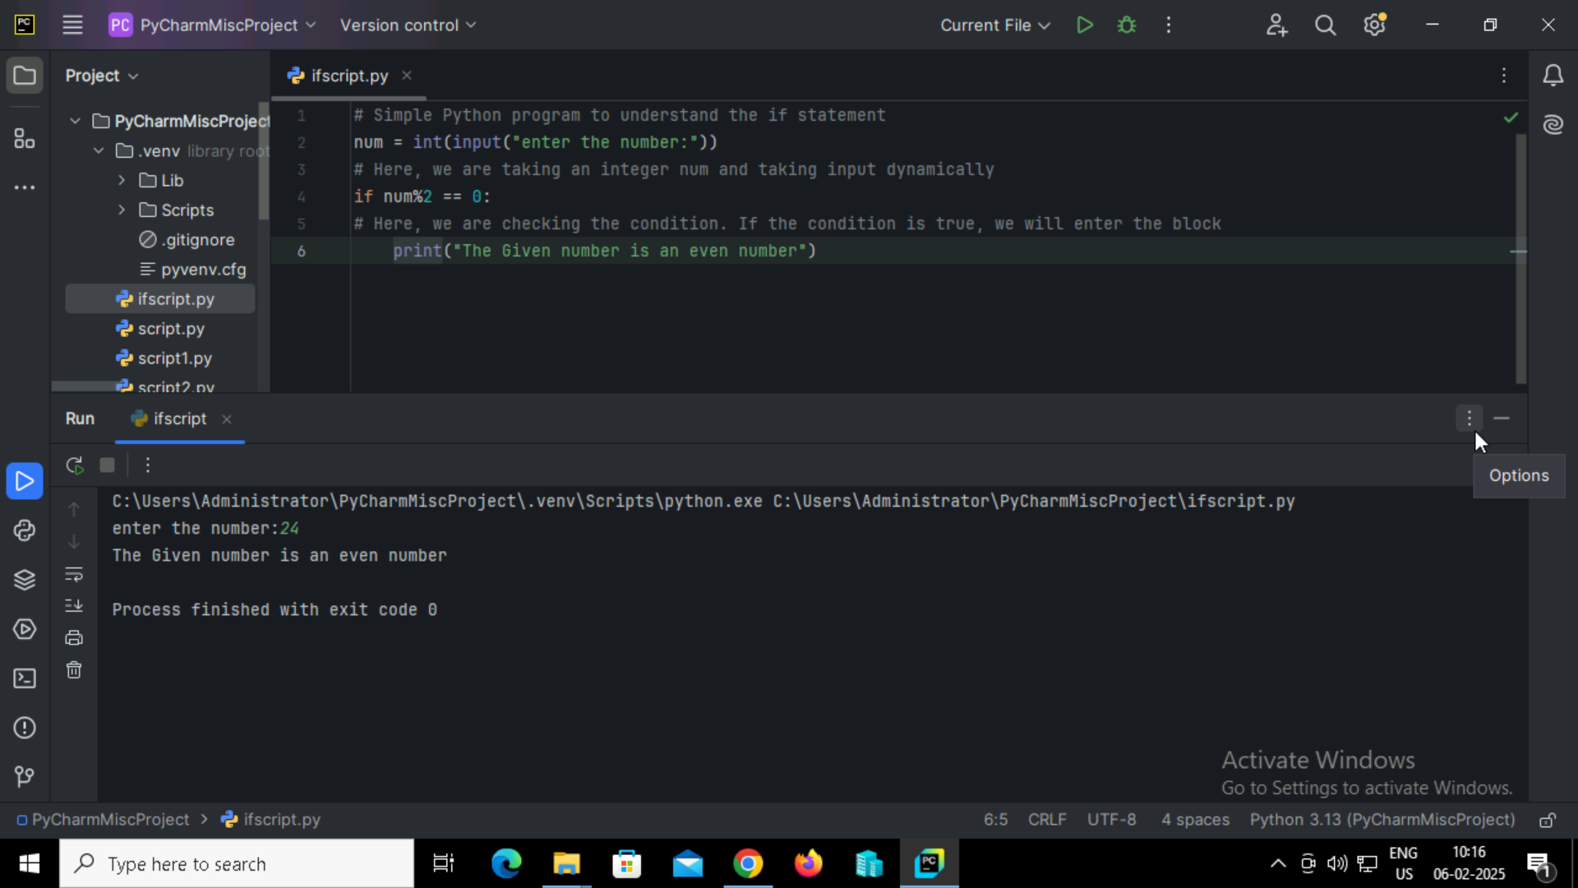

**Output:**



**15. Program to print the largest of the three numbers using ‘If Statement’**

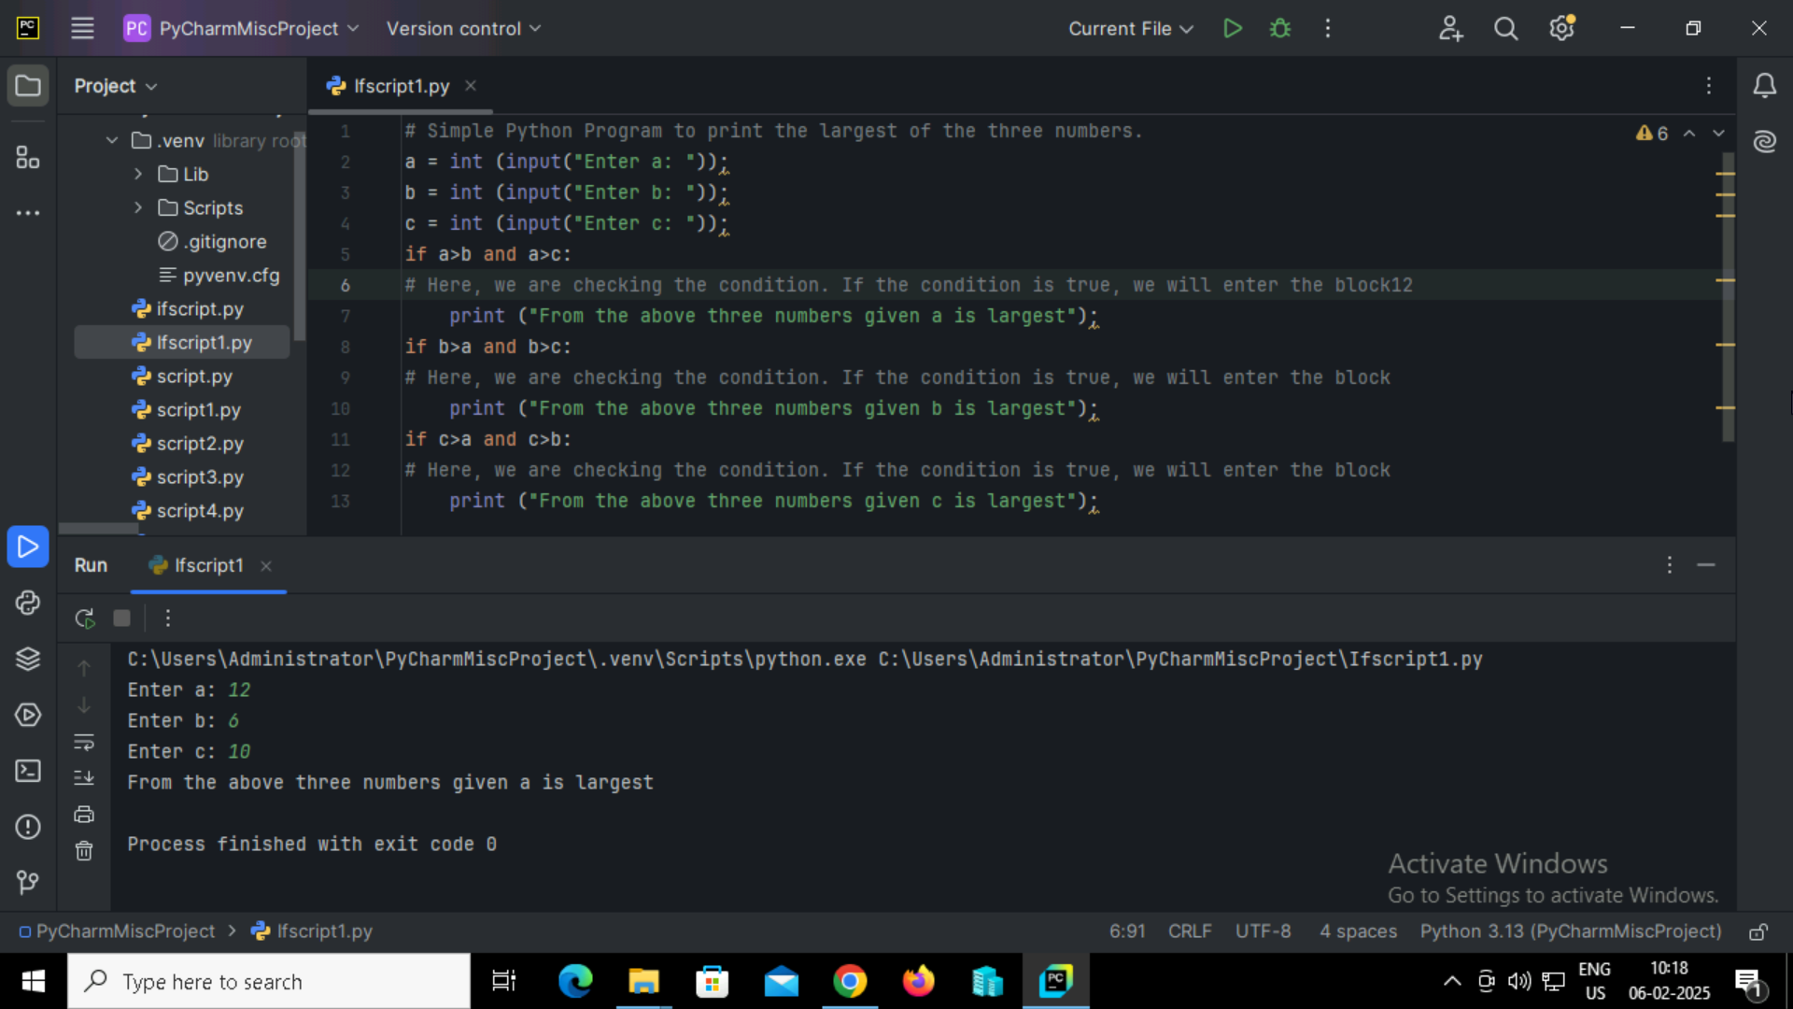

**Output:**

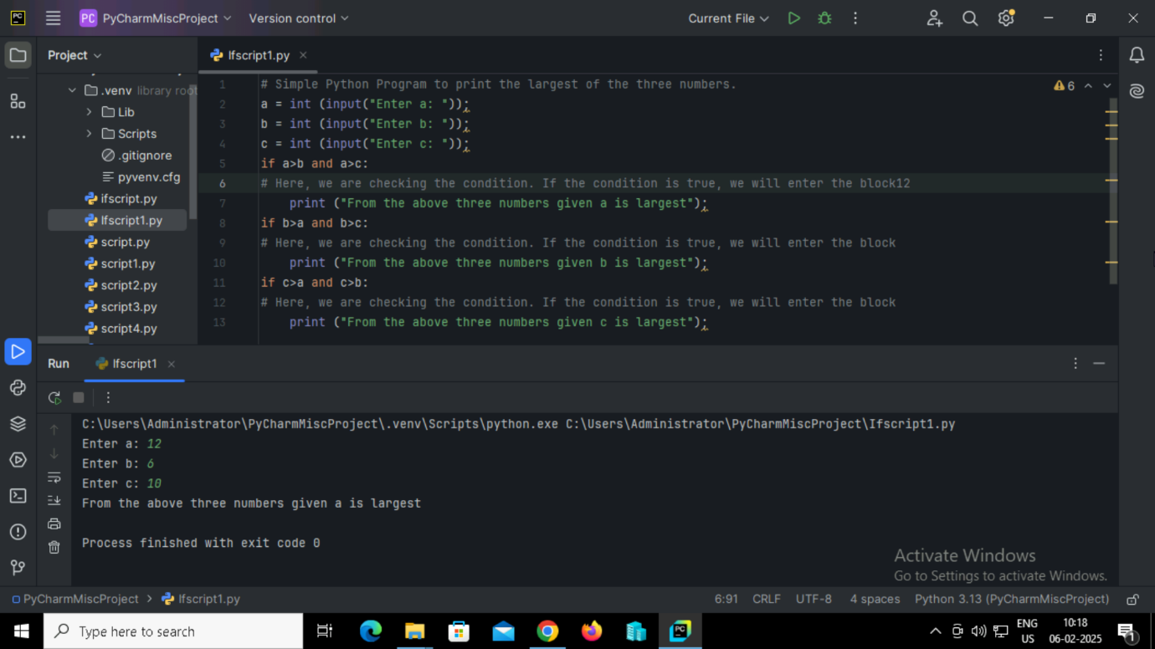

**16.** **Program to check whether a person is eligible to vote or not using ‘If-else Statement’.**

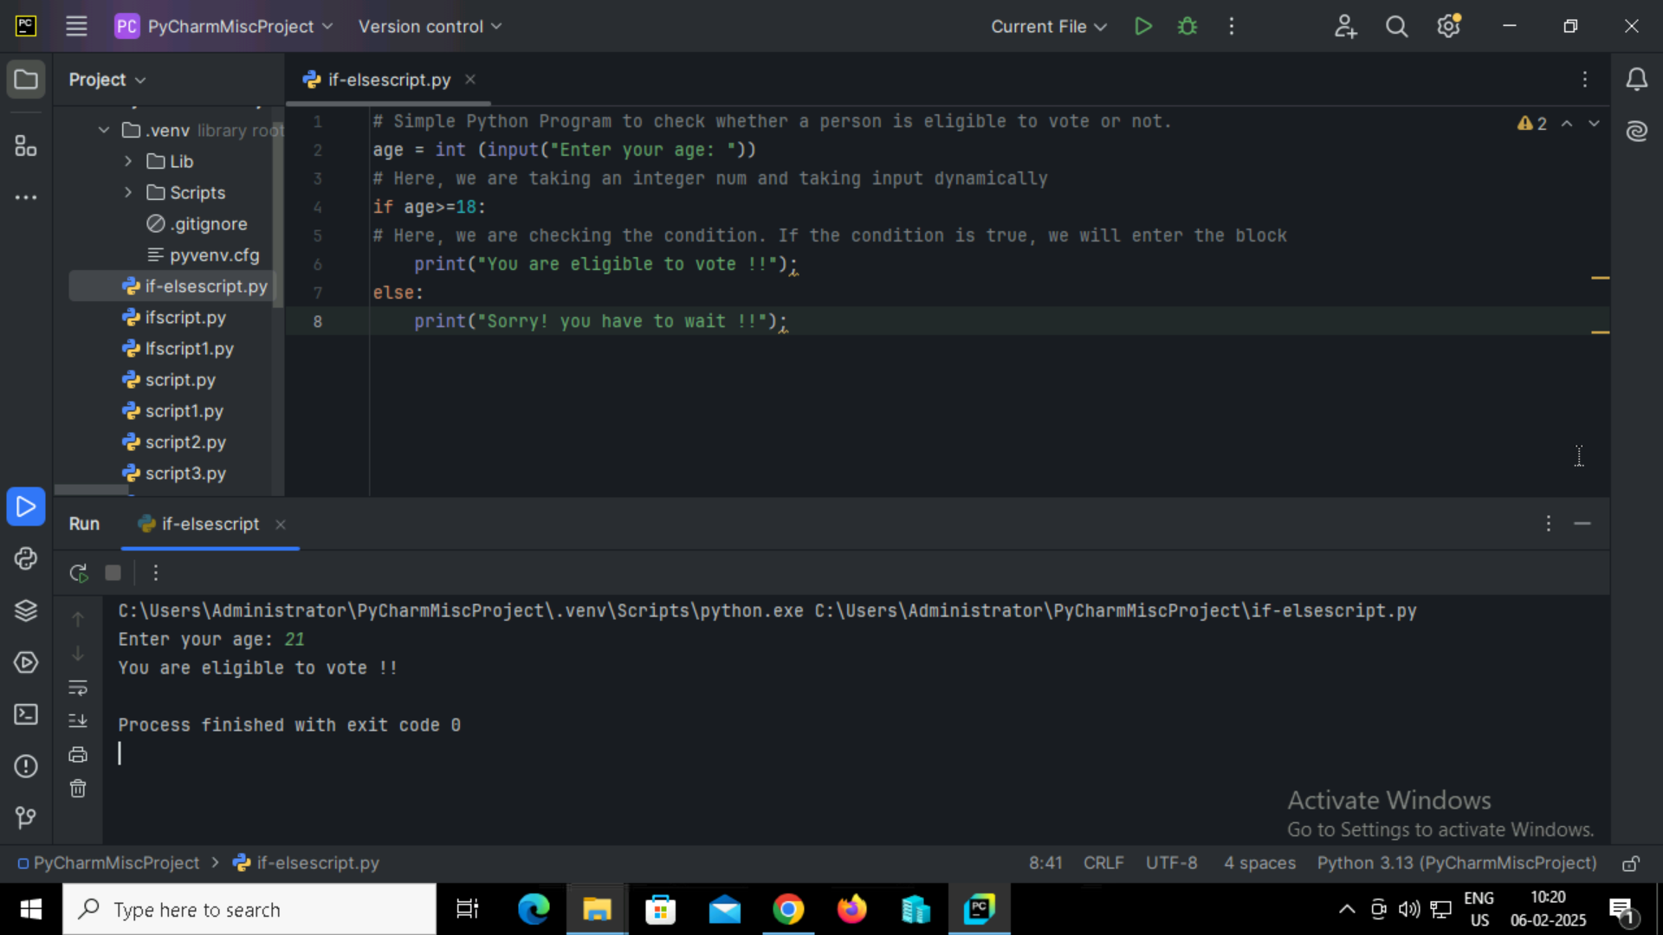

**Output:**



**17.** **Program to check whether a number is even or not using ‘If-else statement’.**

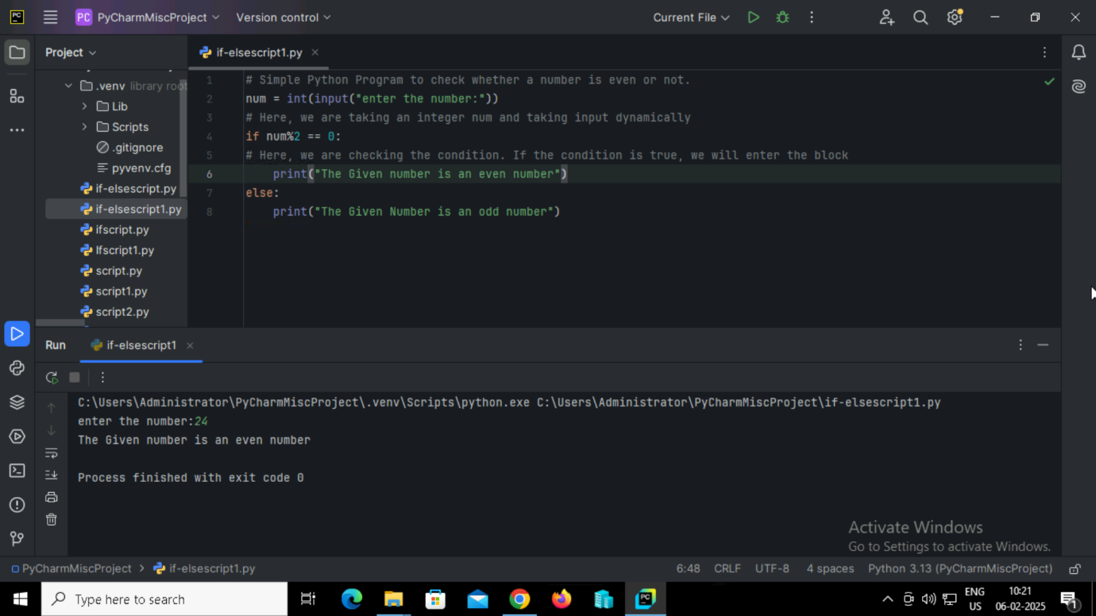

**Output:**



**18.** **Simple Python program to understand ‘elif statement’.**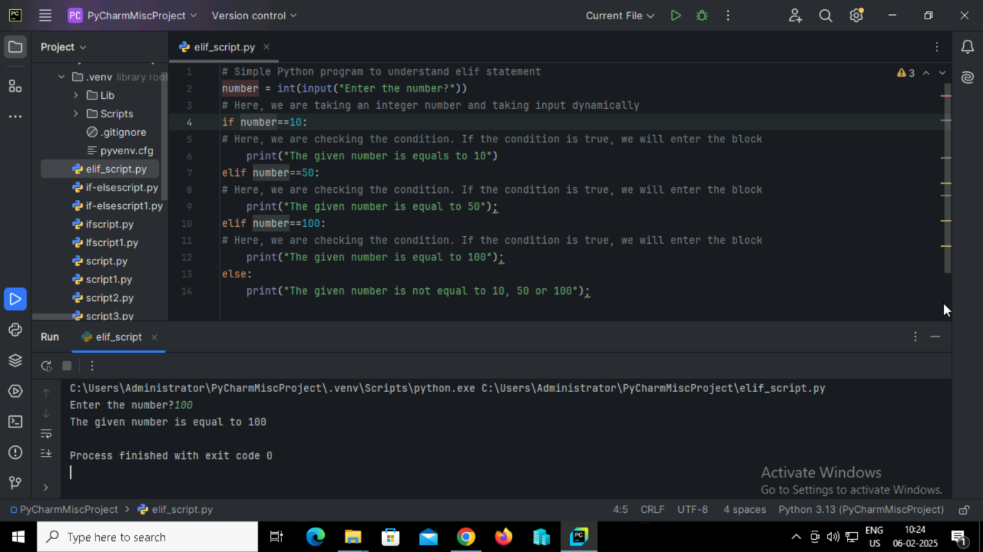

**Output:**

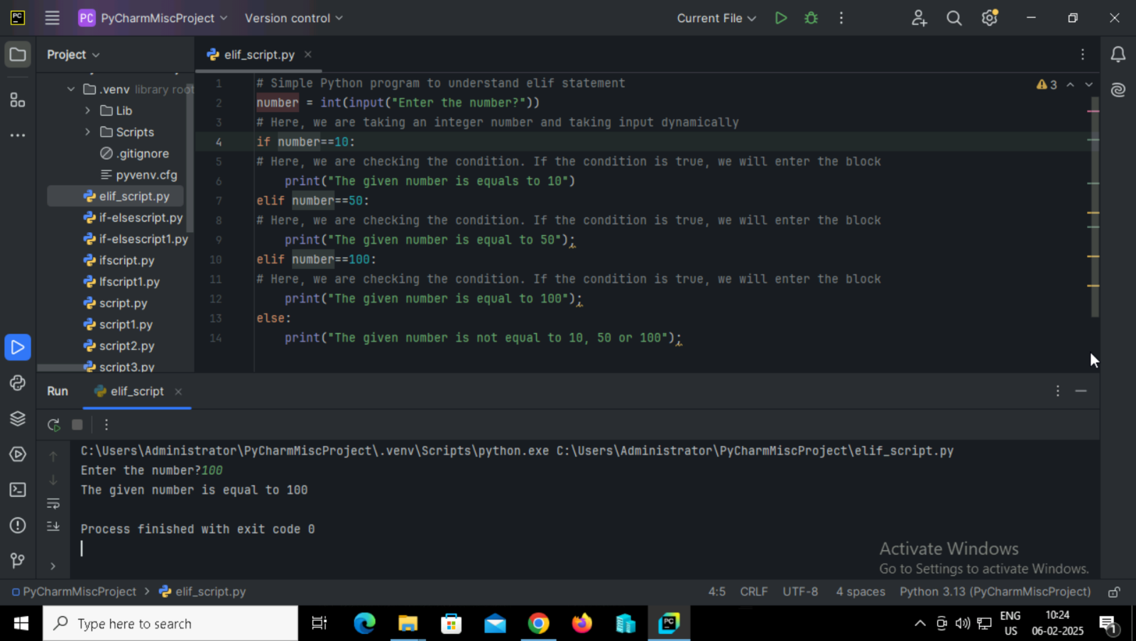

**19.** **Python program to classify a student's grade based on their marks using ‘elif statement’.**

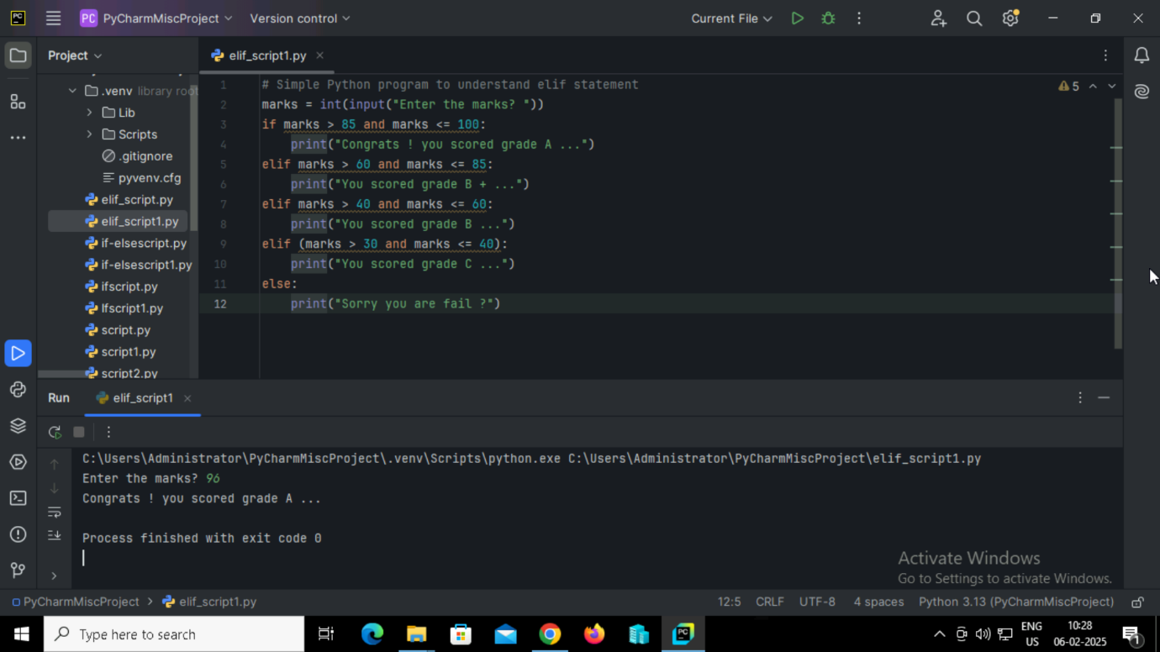

**Output:**



**20. Python program that takes a list of numbers and creates a new list containing the square of each number using ‘For Loop’.**

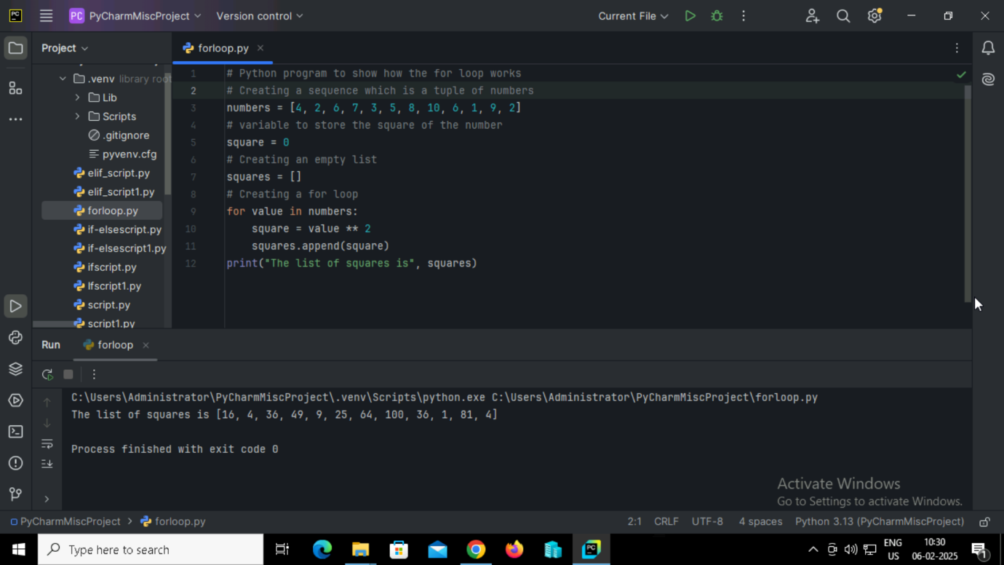

**Output:**



**21. Python program that loops through each character in a string. If the character is the letter 'o', print 'If block'. Otherwise, print the character."**

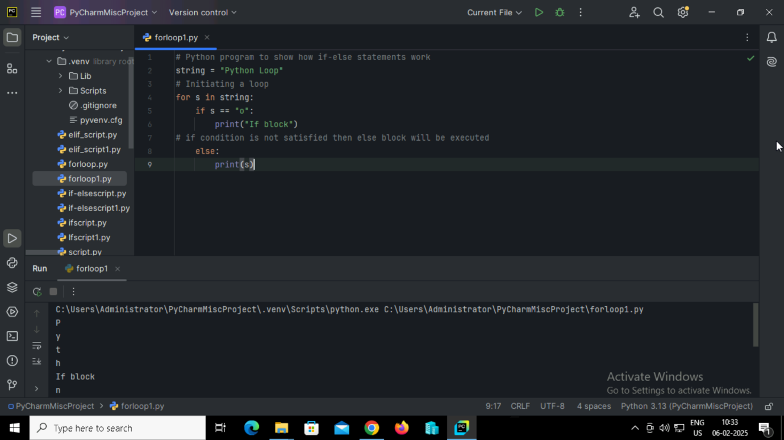

**Output:**

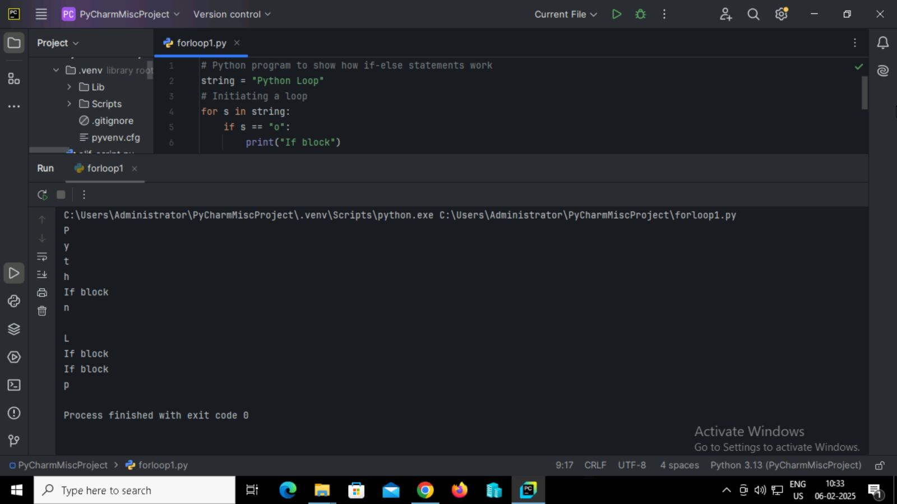

**22. Python program to loop through a tuple and print all the odd numbers.**

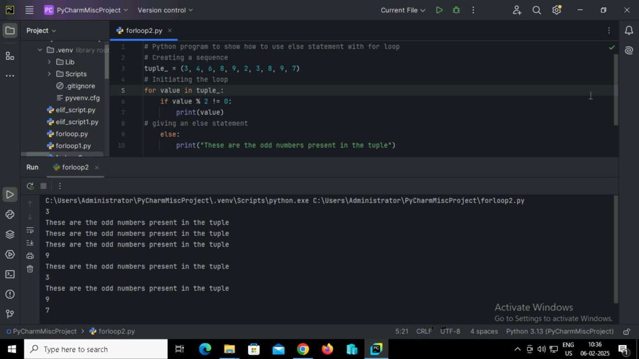

**Output:**



**23. Python program to demonstrate the usage of the range() function.**

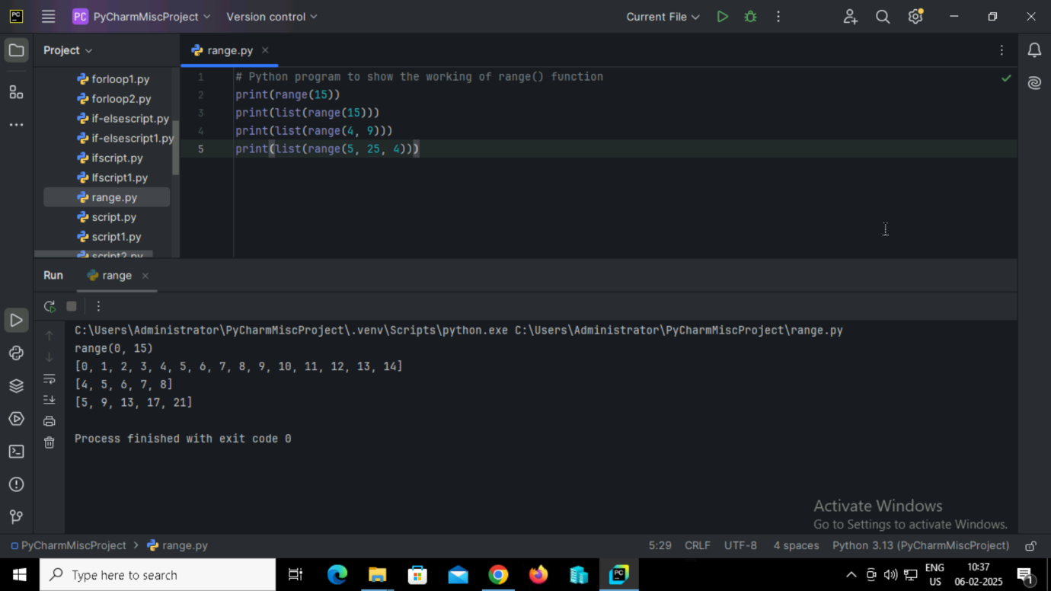

**Output:**



**24. Python program to iterate through a tuple and print each element in uppercase. Use the range() function to iterate over the indices of the tuple.**

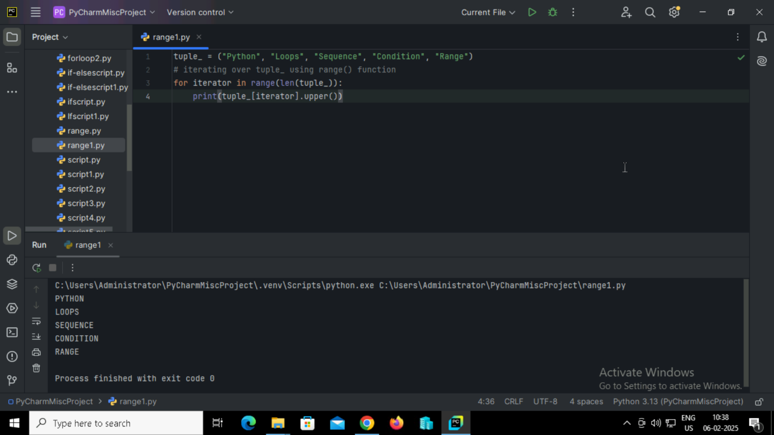

**Output:**

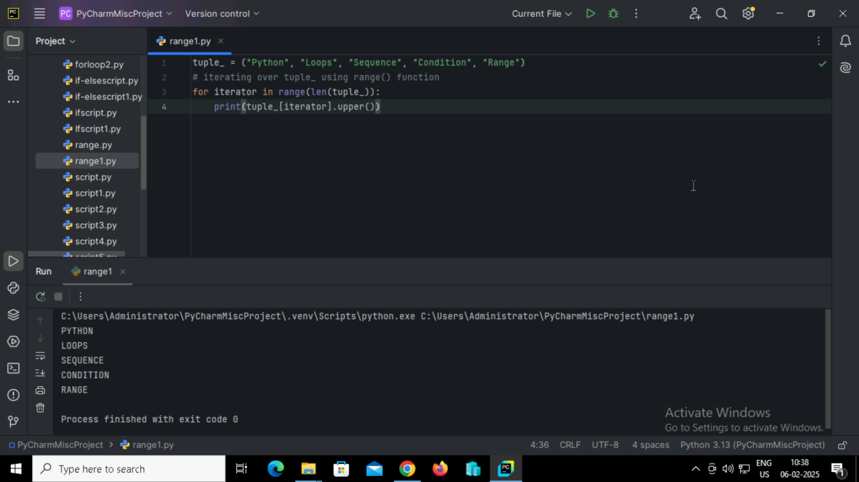

**25. Python program that uses a while loop to print 'Python Loops' multiple times.**

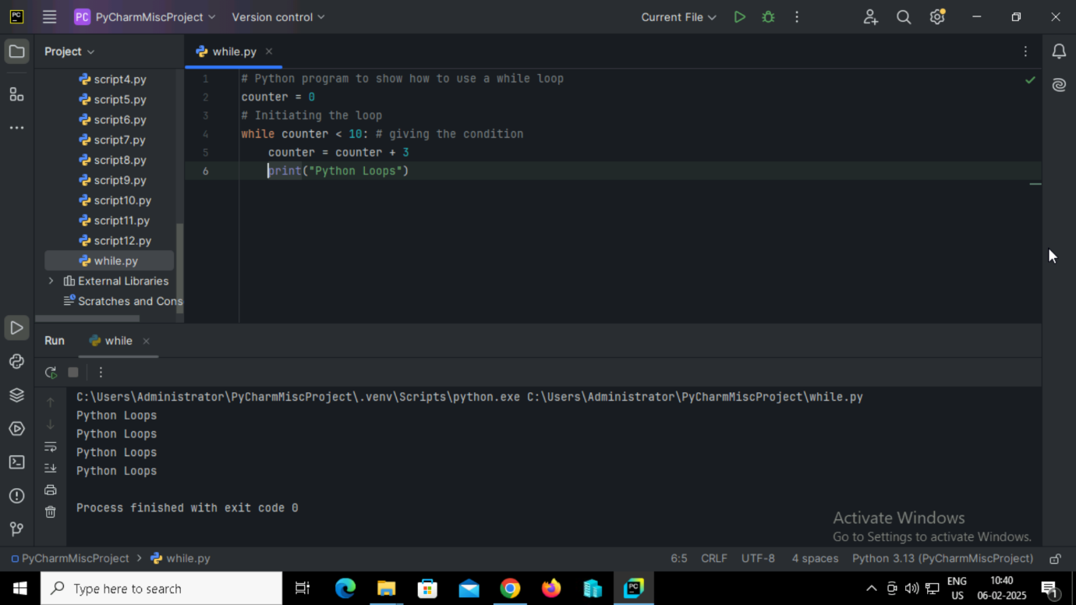

**Output:**



**26. Python program using a while loop to print 'Python Loops' and then print a message from the else block after the loop ends.**

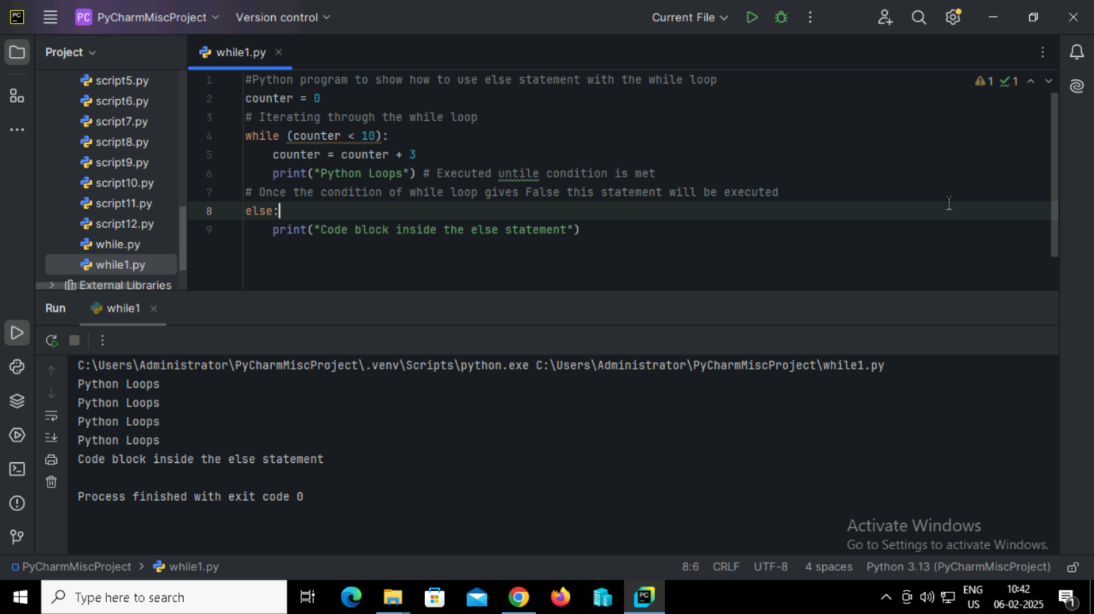

**Output:**



**27. Python program to print each character in 'Python Loops' except 'o', 'p', and 't' using continue statement.**

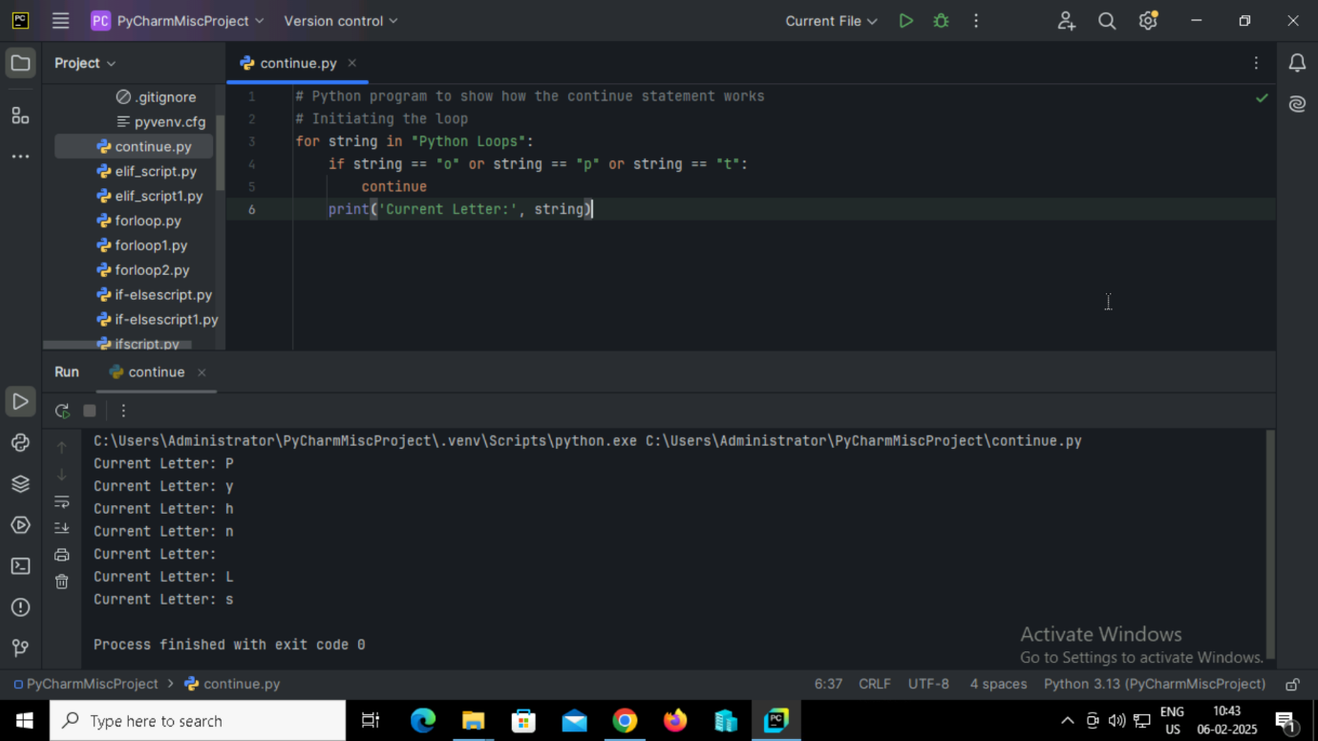

**Output:**



**28. Python program to print each character in 'Python Loops' until the letter 'L' is encountered using break statement.**

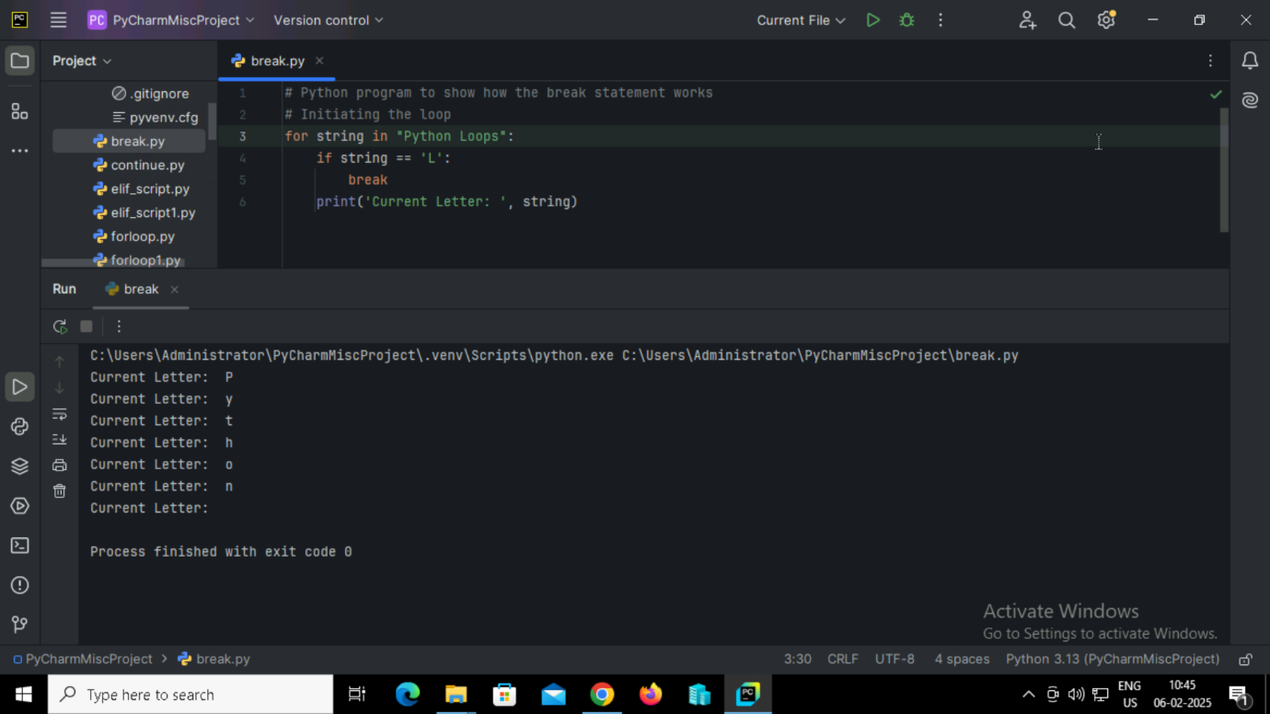

**Output:**



**29. Python program to demonstrate the use of the pass statement inside a loop.**

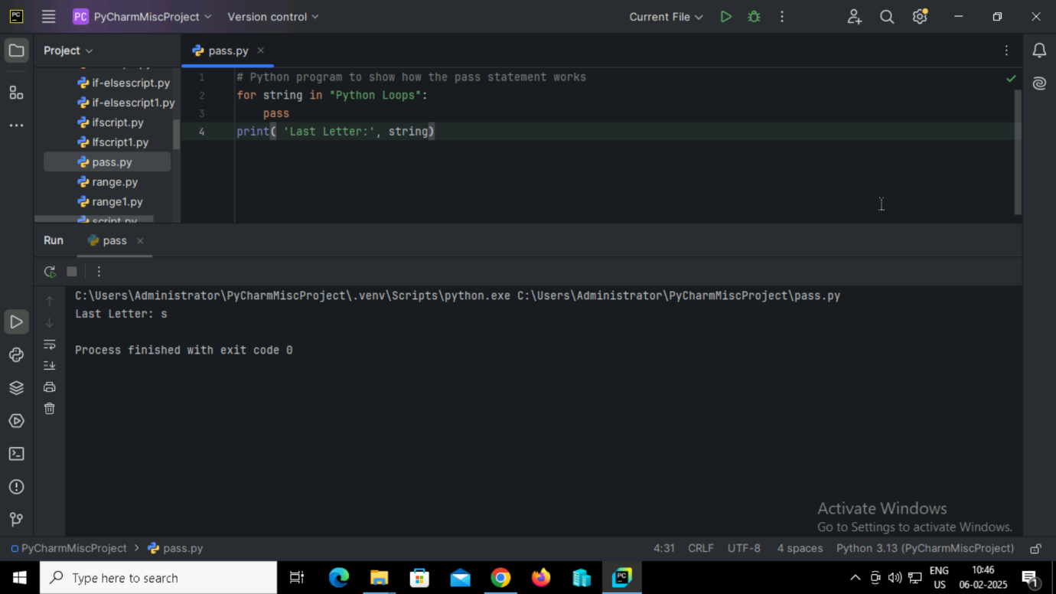

**Output:**



**30. Python program to calculate the sum of squares of all numbers in a list.**

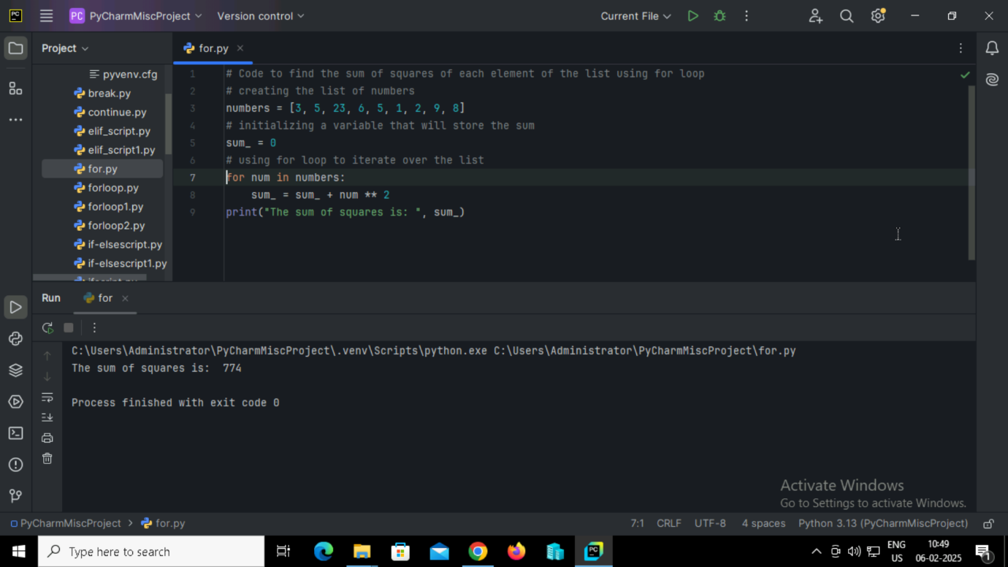

**Output:**



**31. Python program to iterate over a list and append each element plus 2 to the list, avoid modifying the list during iteration.**

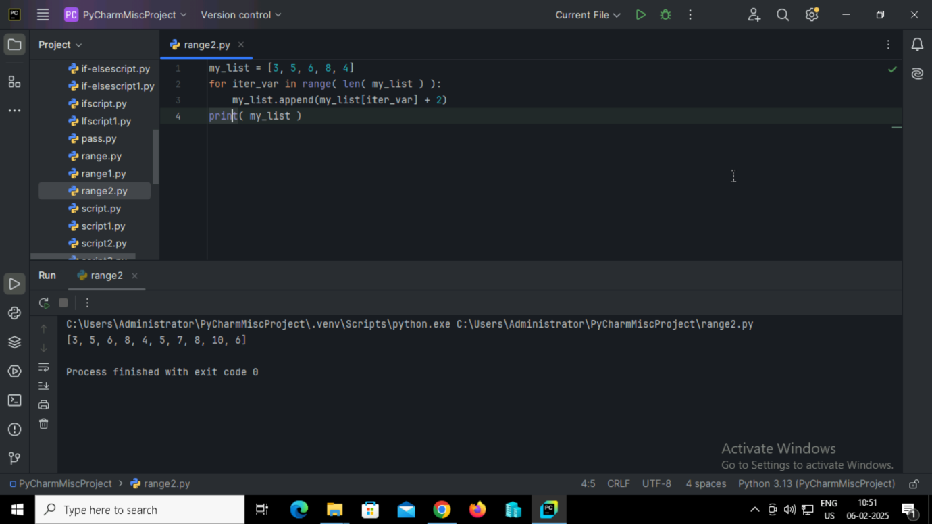

**Output:**



**32. Python program to find the sum of squares of each element of the list using for loop.**

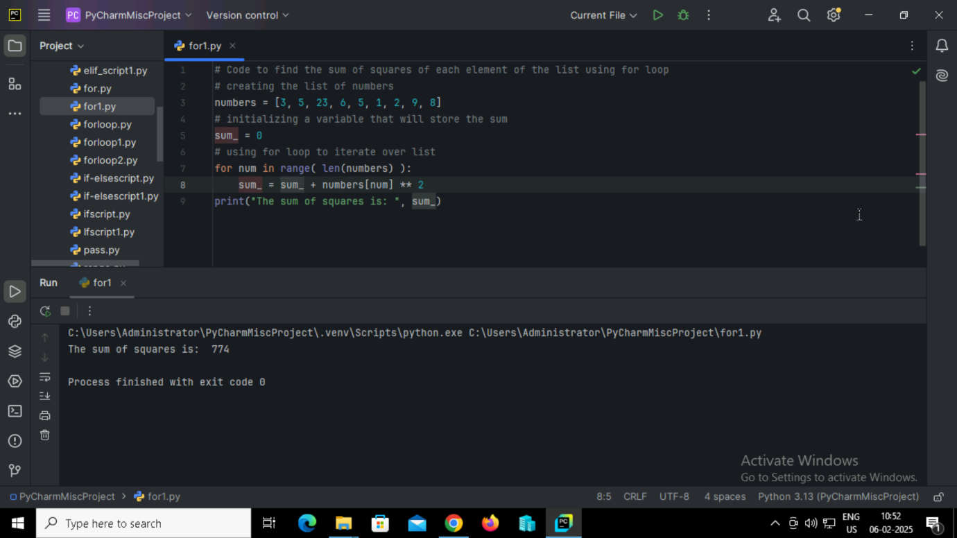

**Output:**

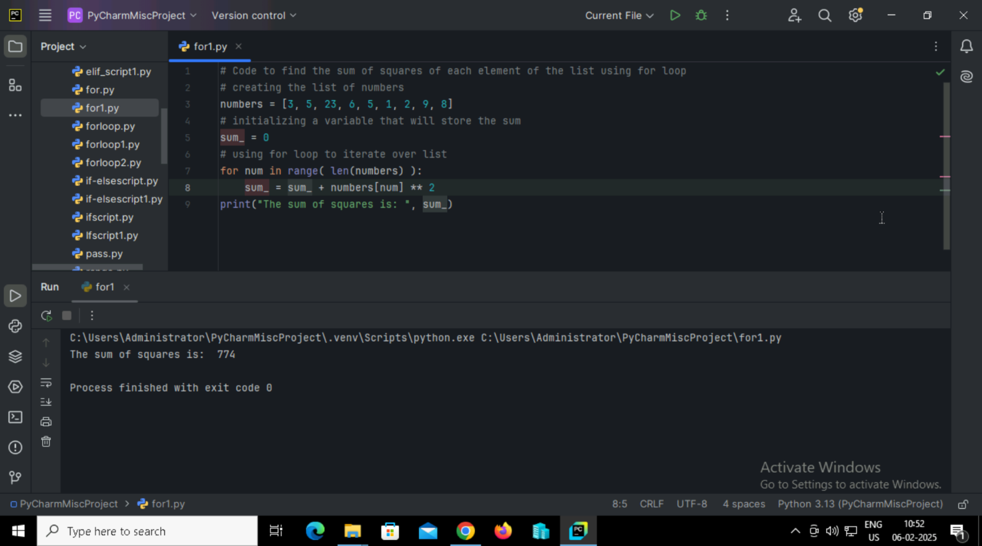

**33. Python program to look up and print the marks of a student from a dictionary, and handle the case when the student is not found.**

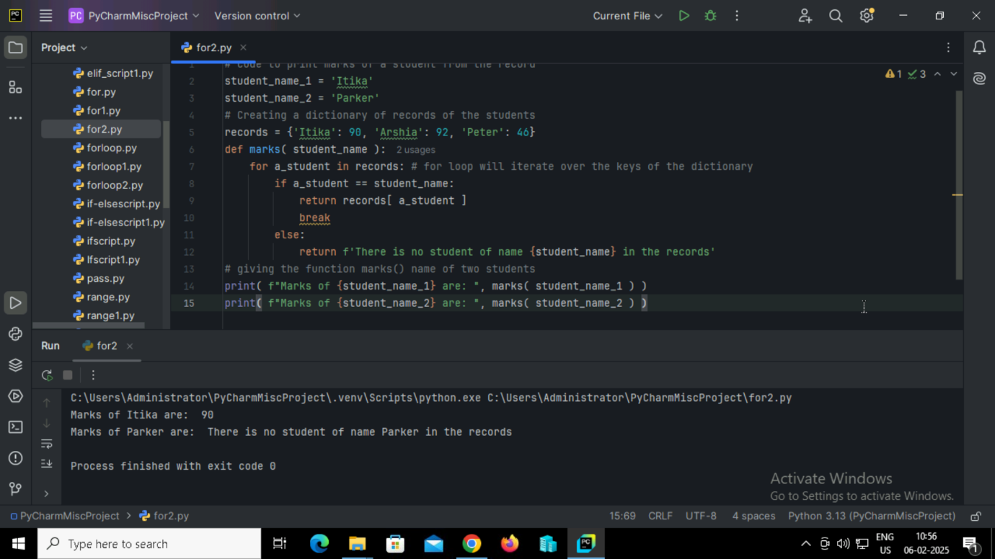

**Output:**

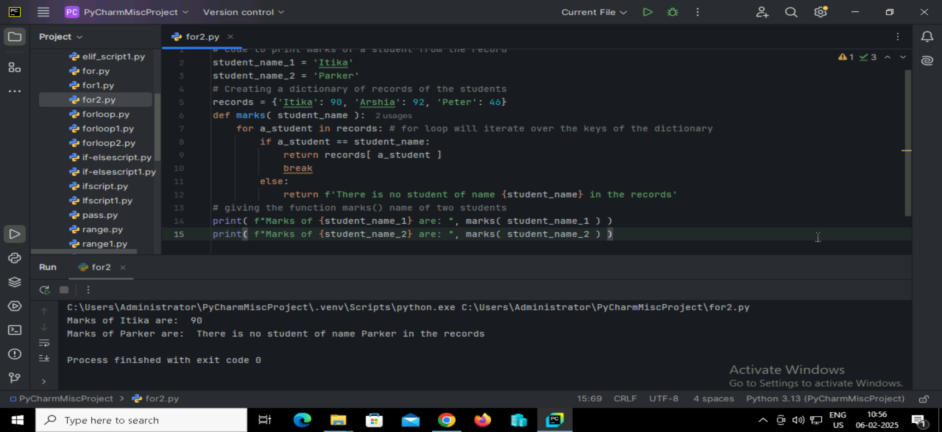

**34. Python program to generate 11 random numbers between 0 and 11, and print the numbers that appear in both the range 0-10 and generate list.**

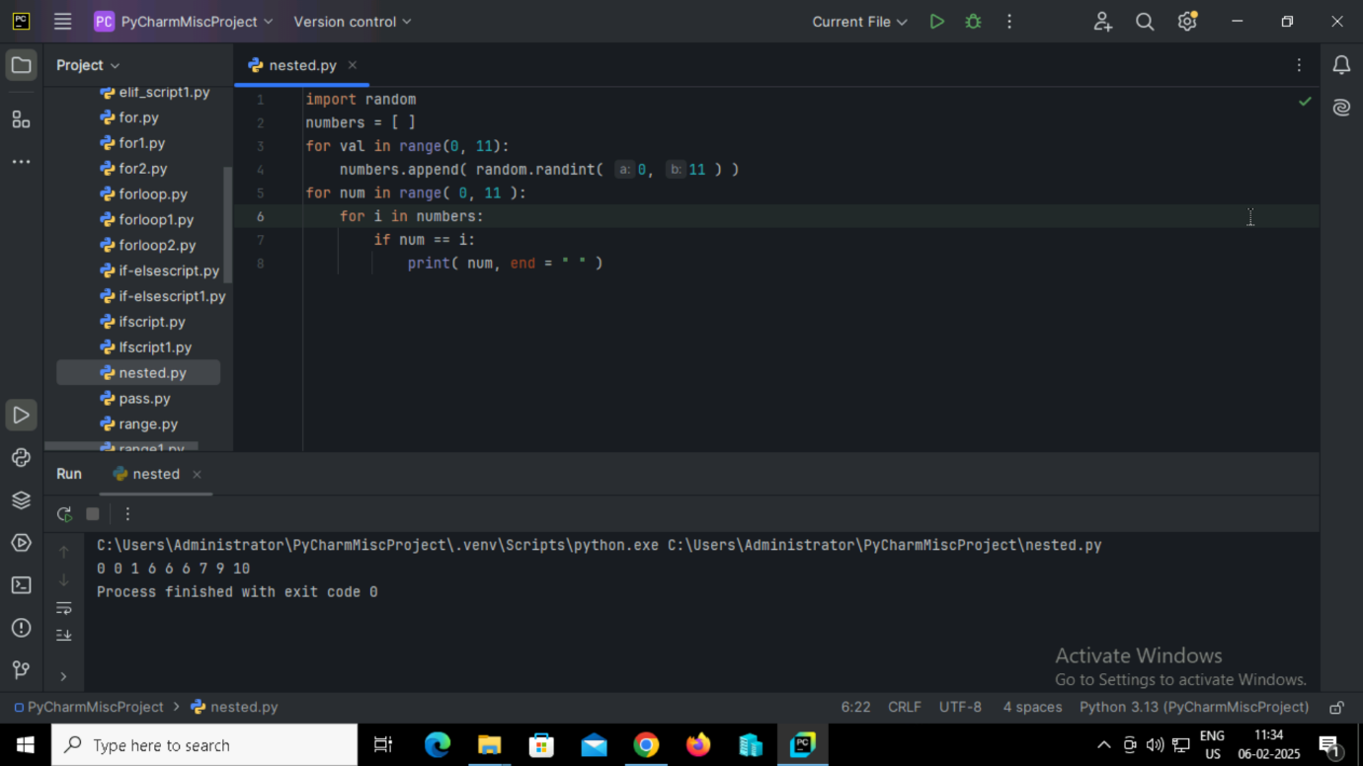

**Output:**



**35. Python program to print the numbers from 1 to 10 in a single line, separated by spaces.**

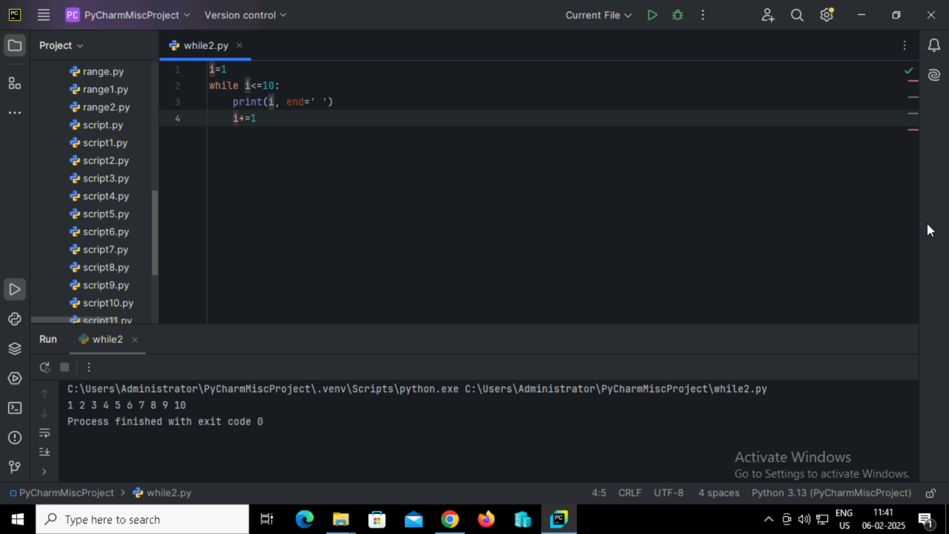

**Output:**



**36. Python program to print all numbers between 1 and 50 that are divisible by 5 or 7, separated by spaces.**

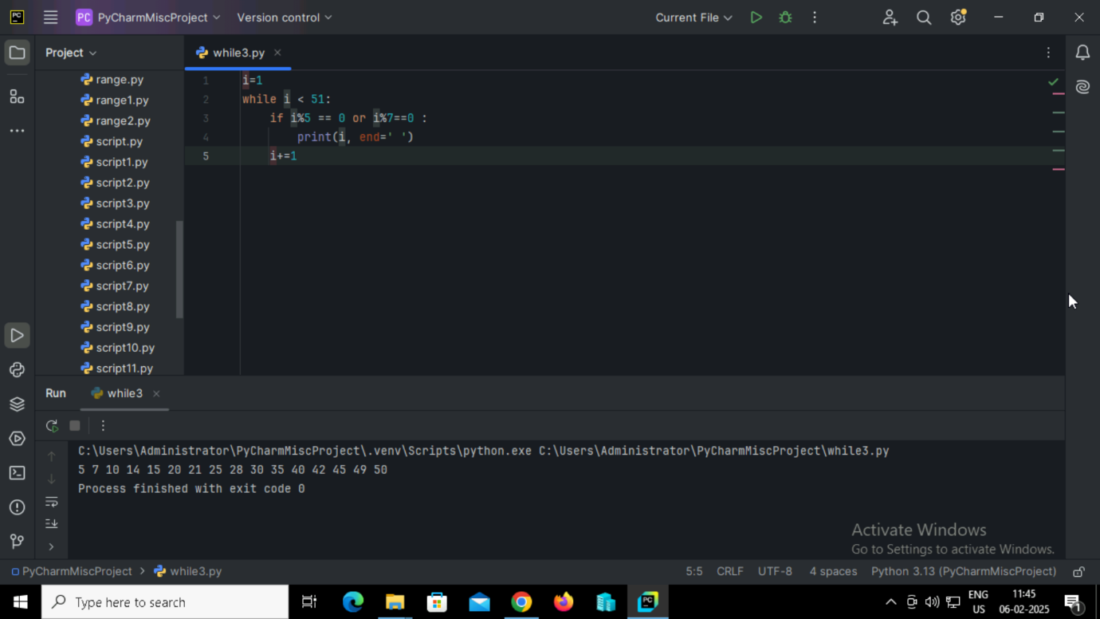

**Output:**

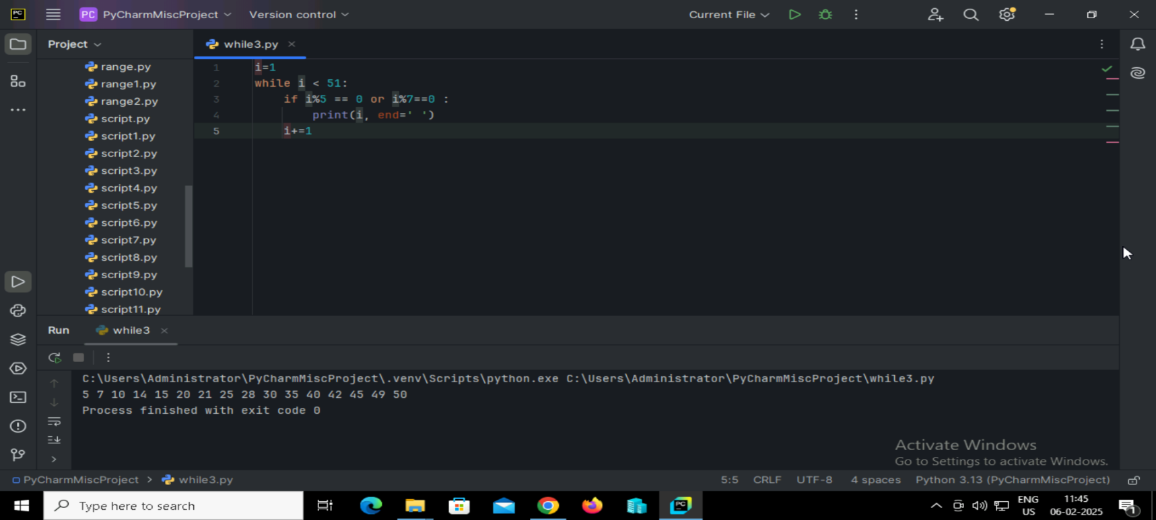

**37. Python program to calculate the sum of squares of all integers from 1 to 15.**

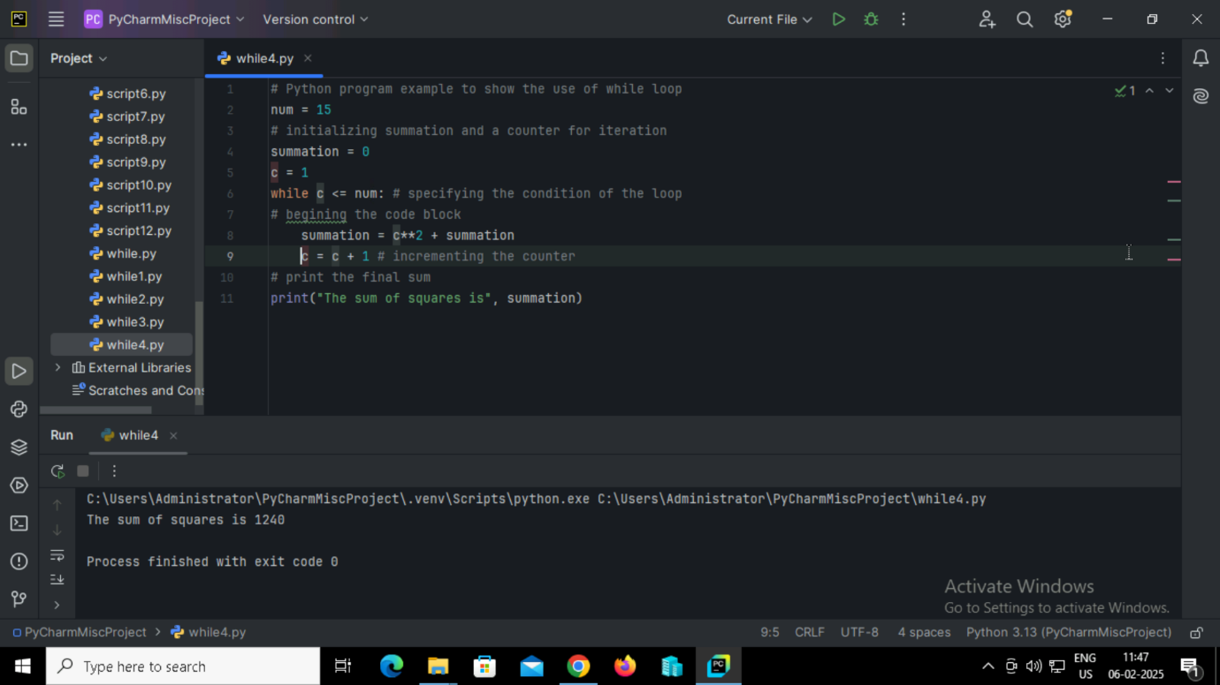

**Output:**

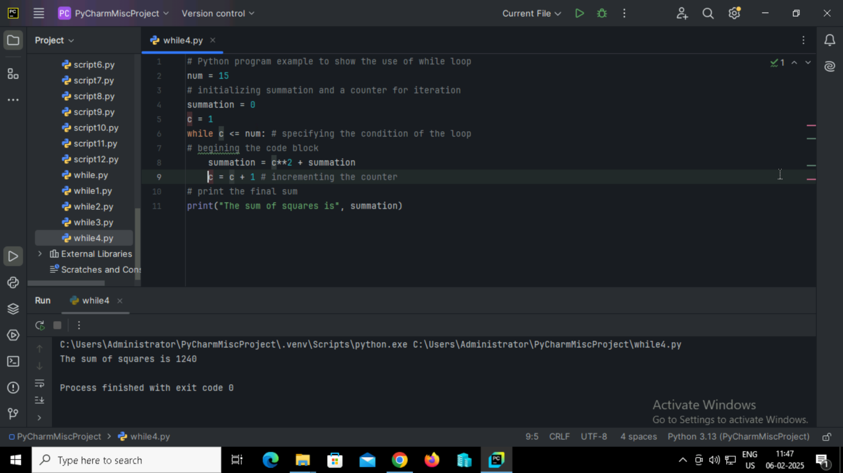

**38. Python program to check if each number in a list is prime or not.**

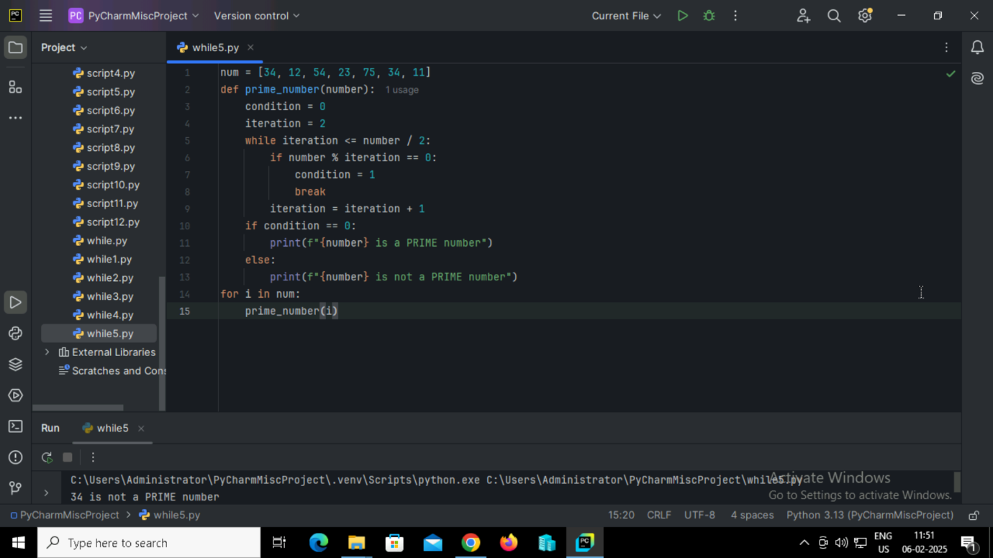

**Output:**

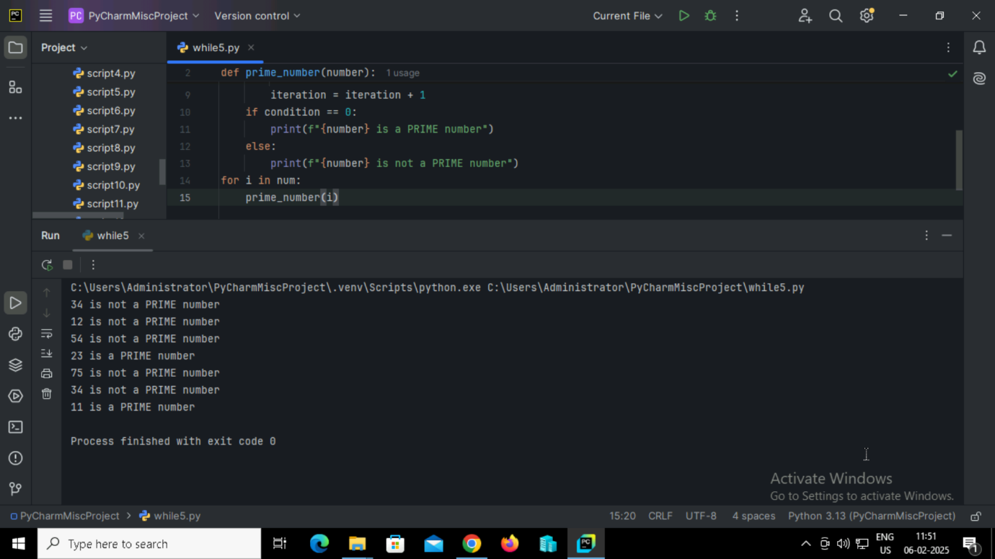

**39. Python program to check if a number is an Armstrong number.**

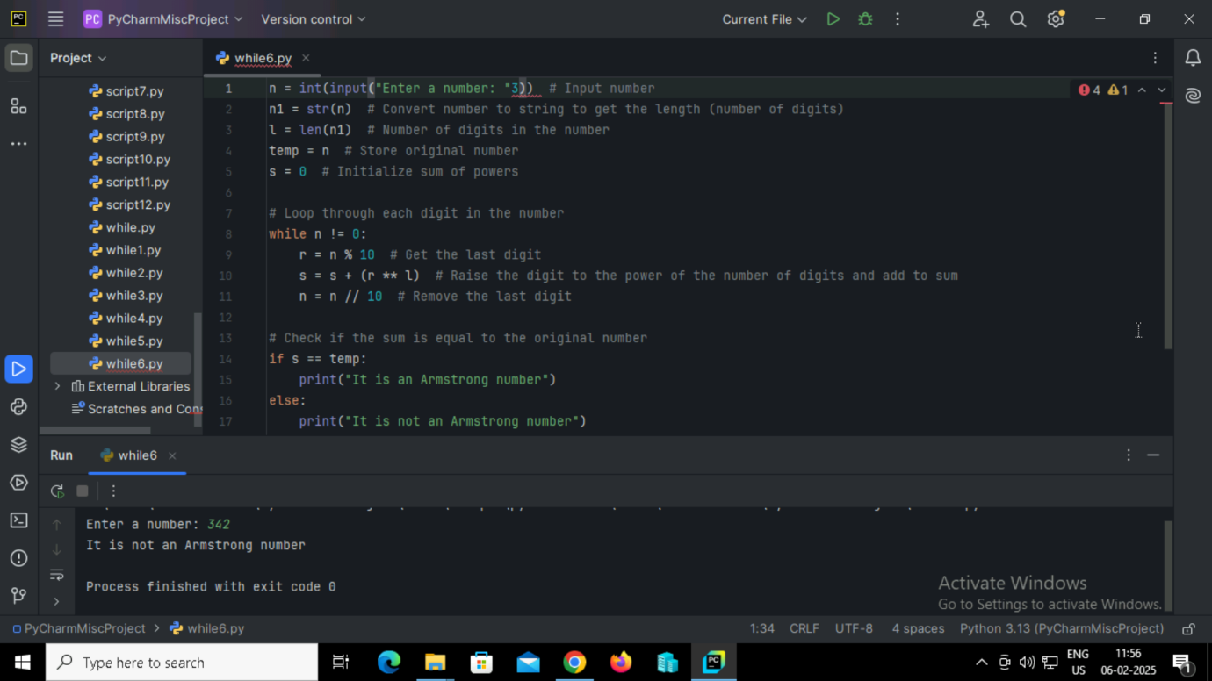

**Output:**



**40. Python program to print the multiplication table of a given number.**

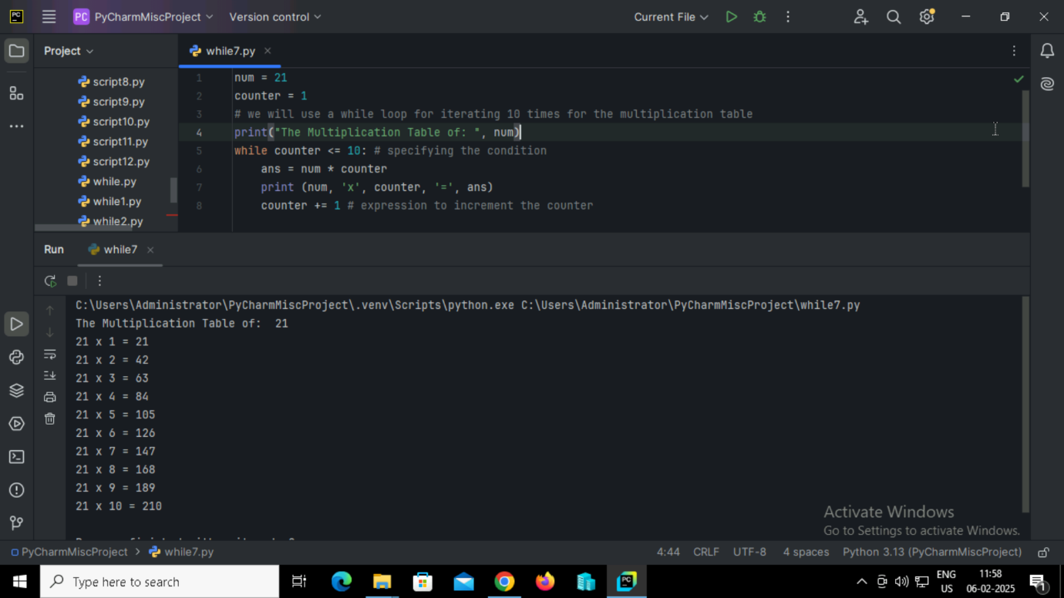

**Output:**



**41. Python program that squares each element of a list and stores the results in a new list using a while loop.**

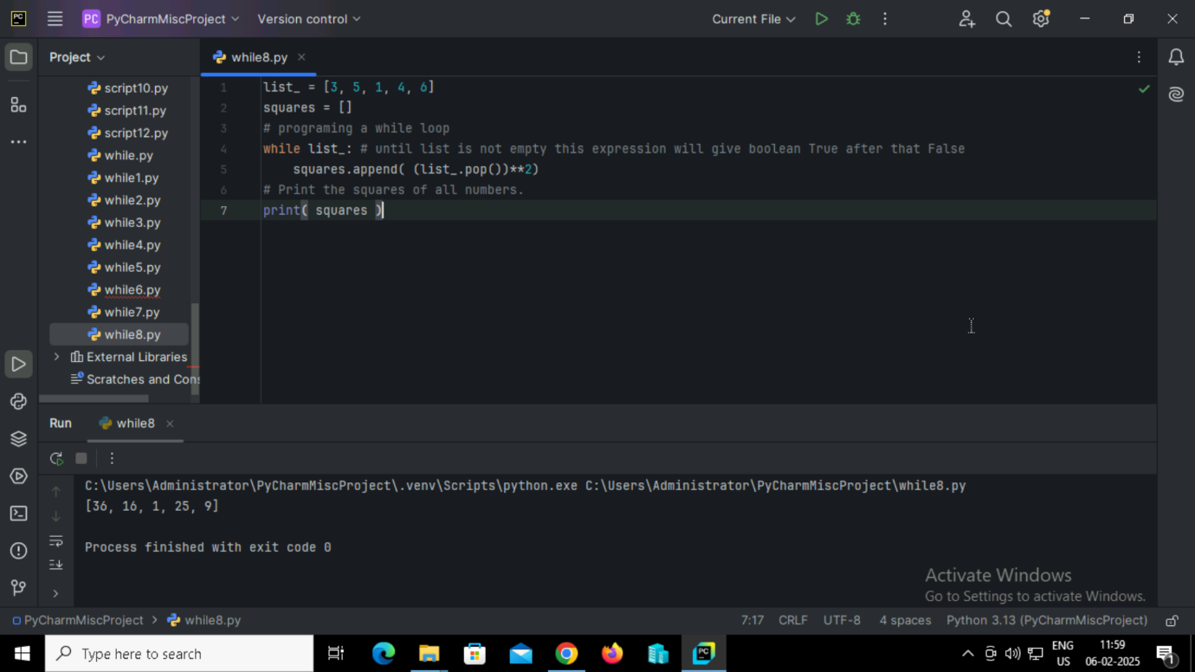

**Output:**

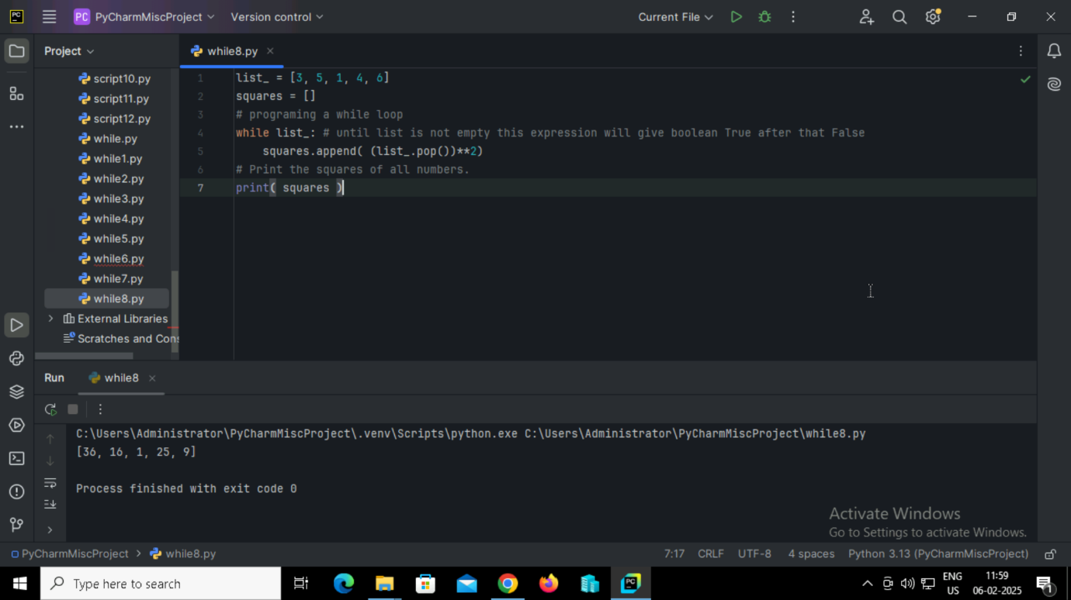

**42. Python program to check if each element in a list is even or odd and print the appropriate message.**

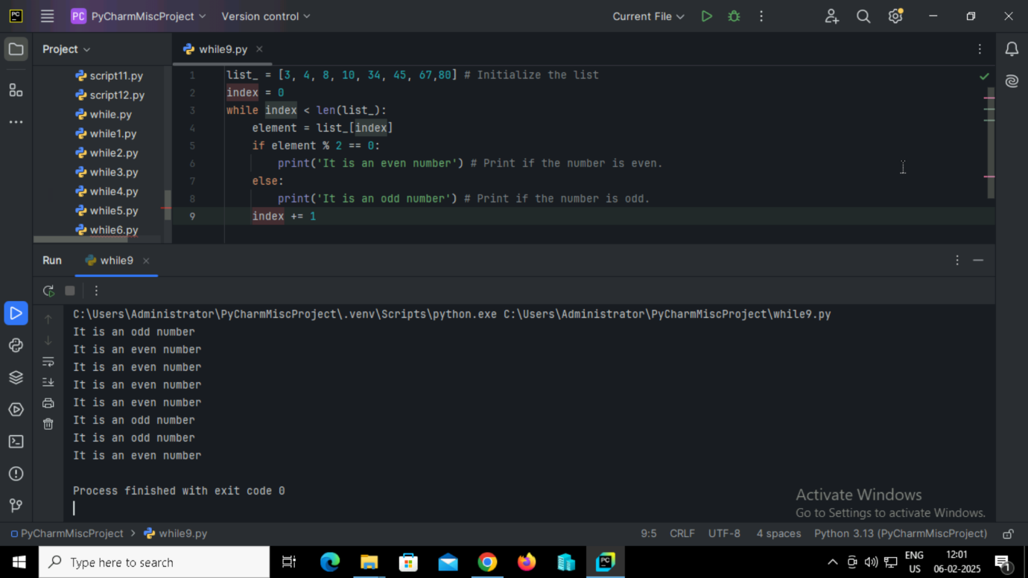

**Output:**

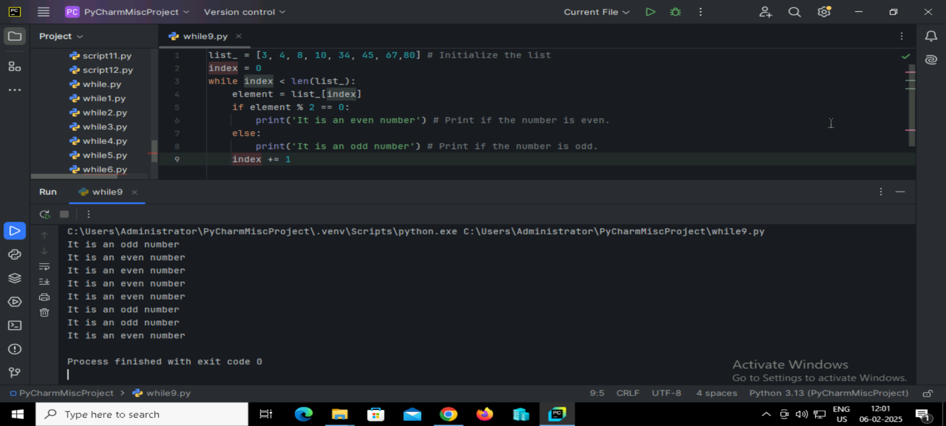

**43. Python program to print the length of each element in a list.**

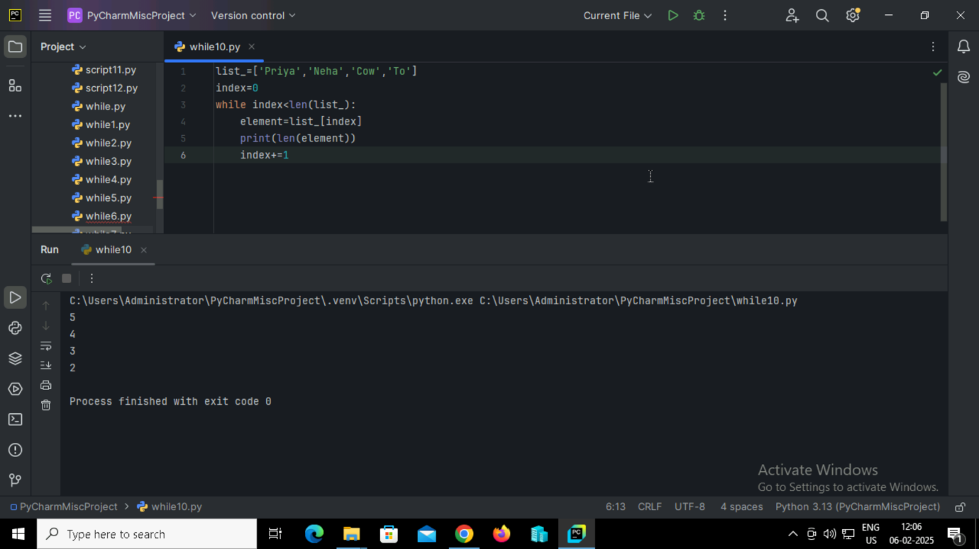

**Output:**



**44. Python program to modify two numbers using a while loop with conditions.**

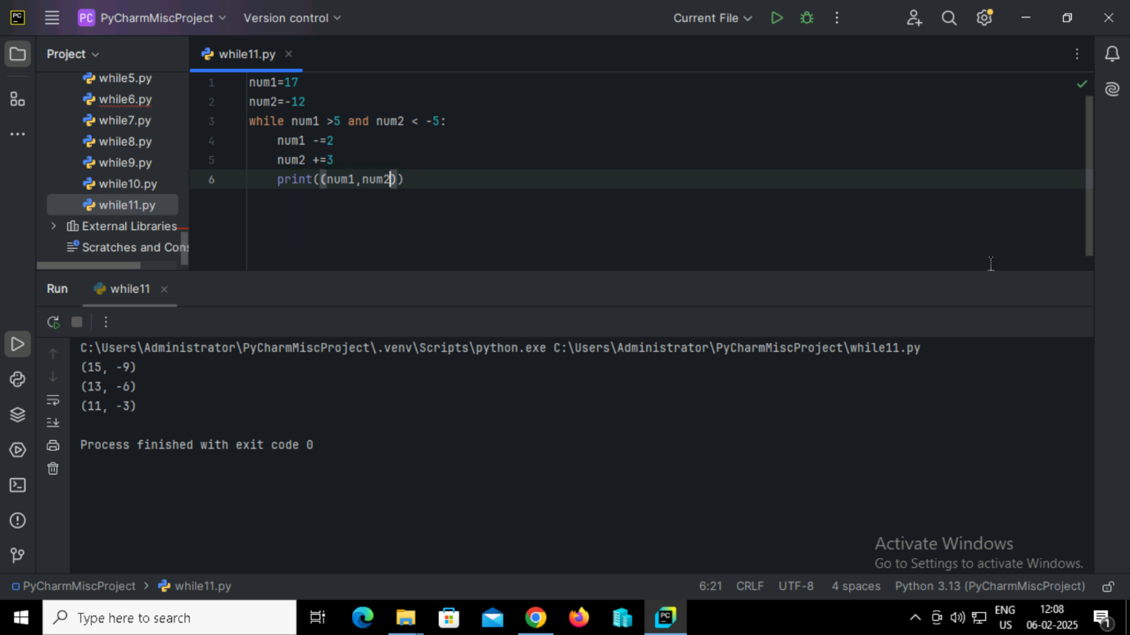

**Output:**

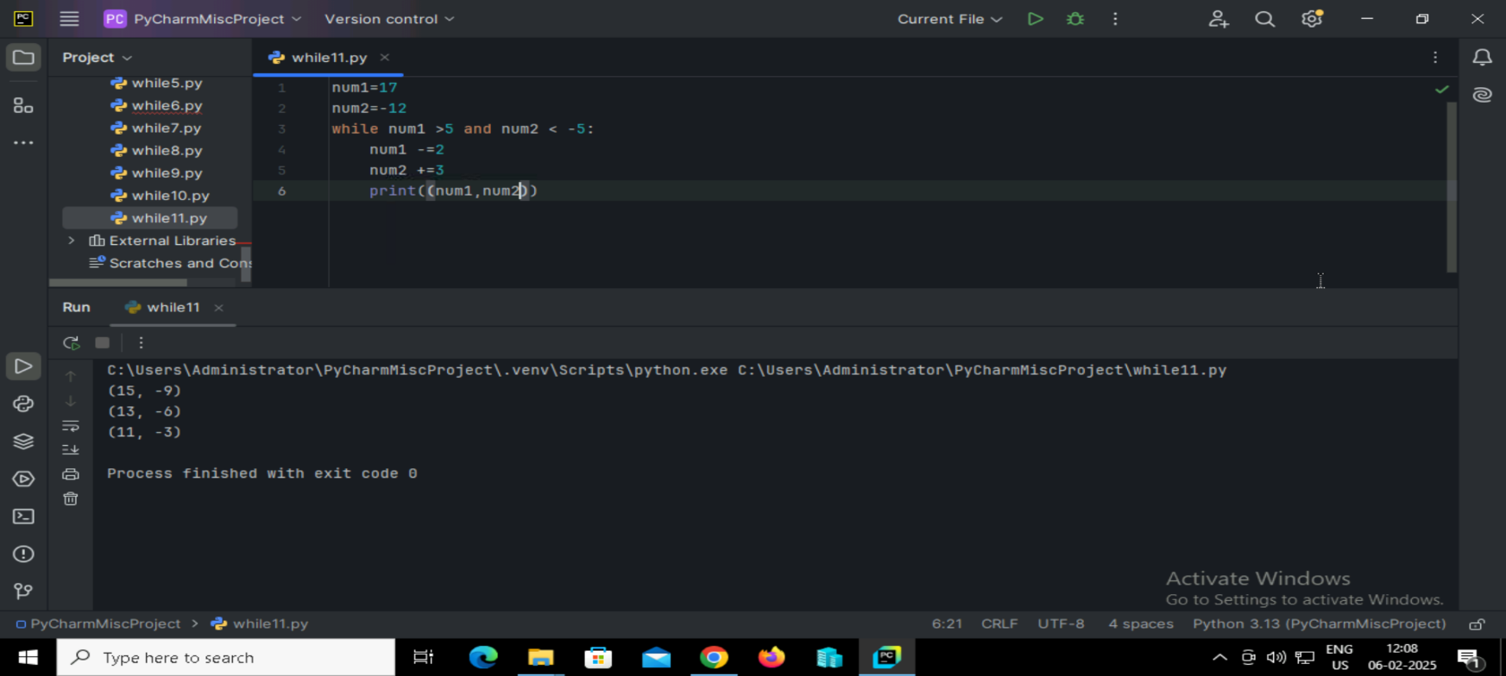

**45. Python program to modify two numbers using a while loop with OR operator.**

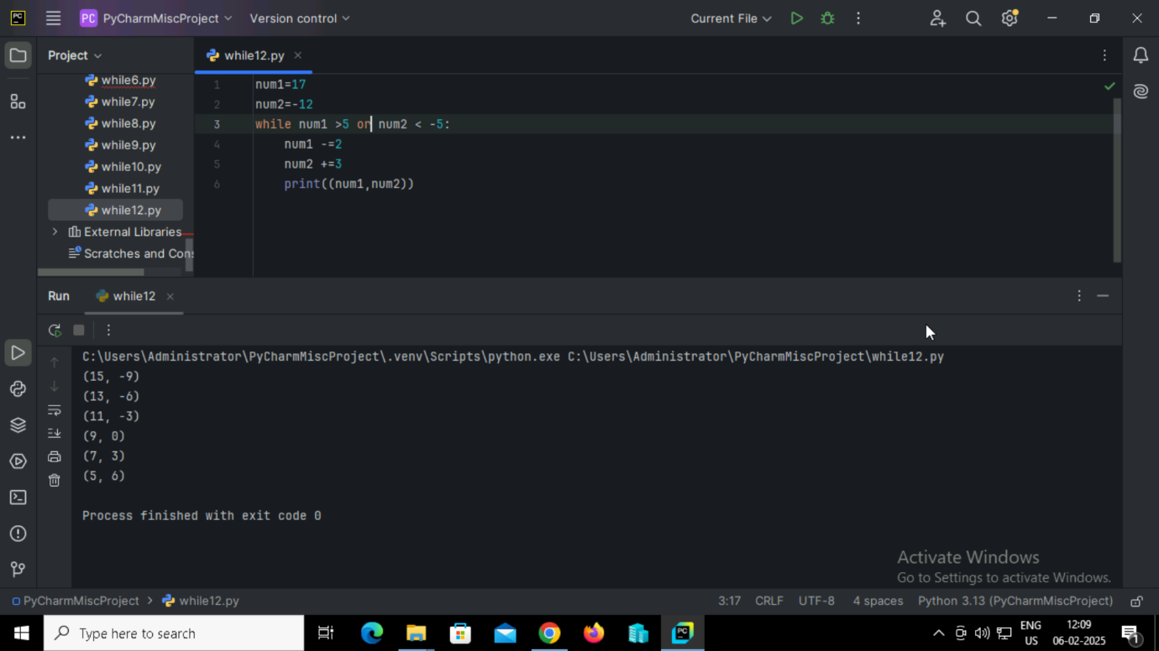

**Output:**



**46. Python program to print the number of iterations using a while loop with multiple conditions.**

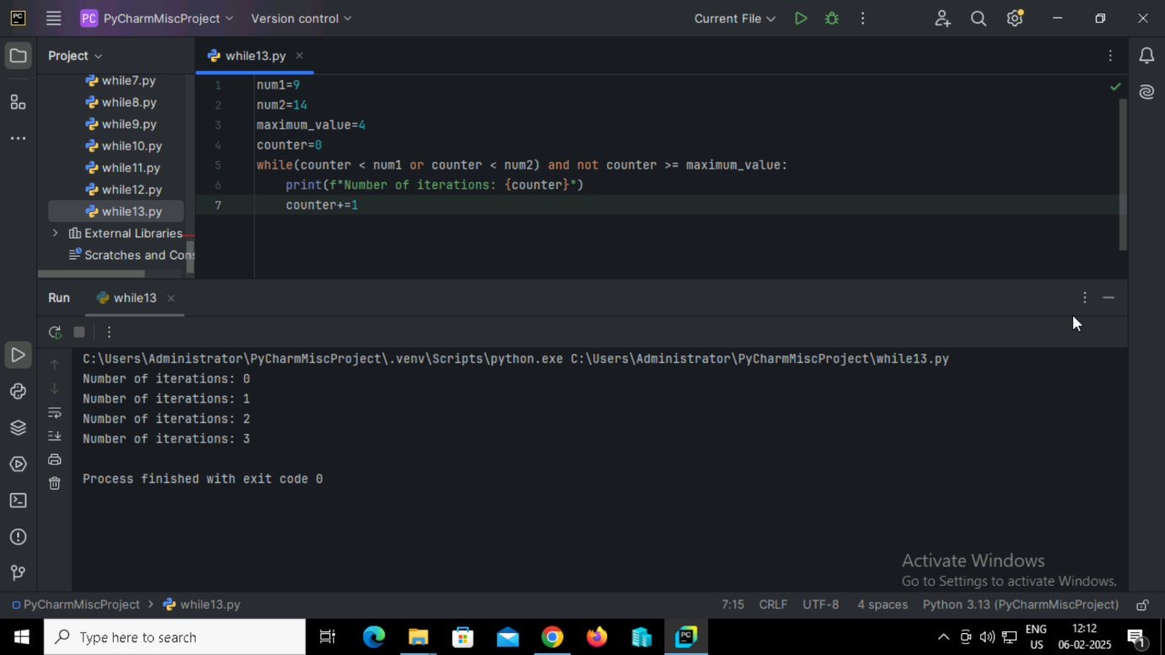

**Output:**

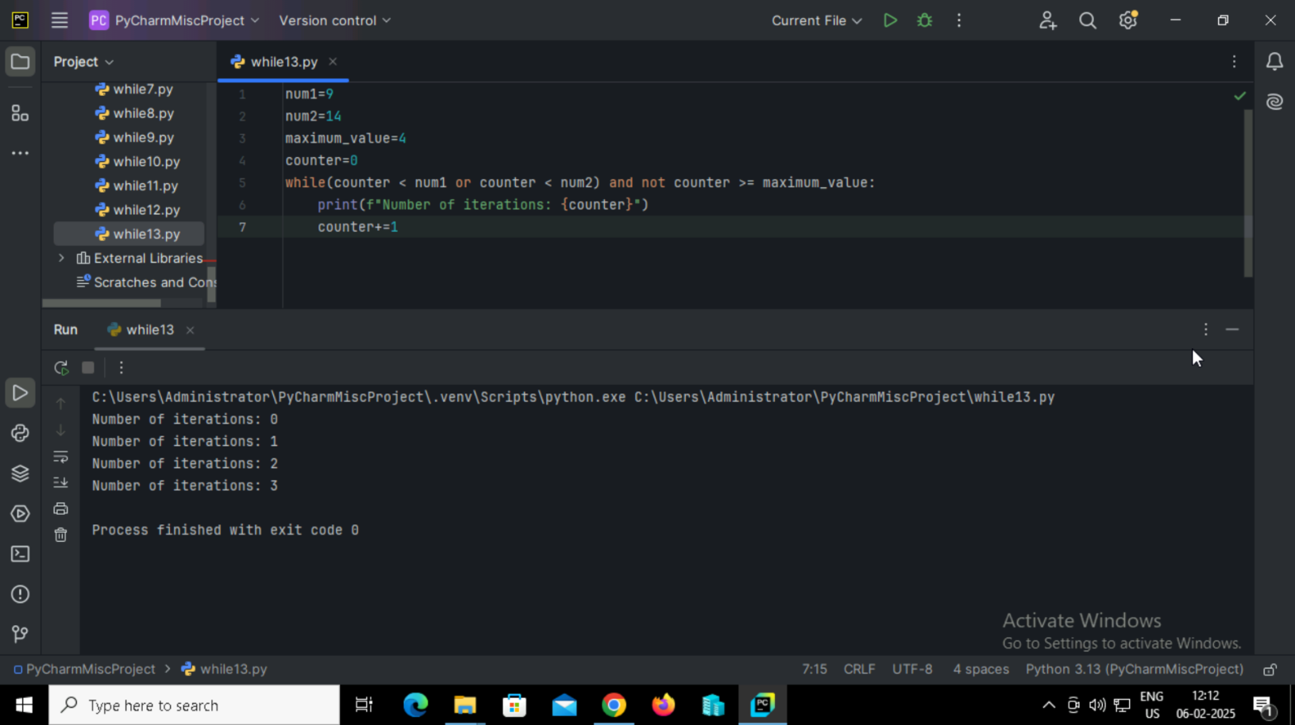

**47. Python program to iterate over the string 'While Loops' and skip the vowels using a continue statement.**

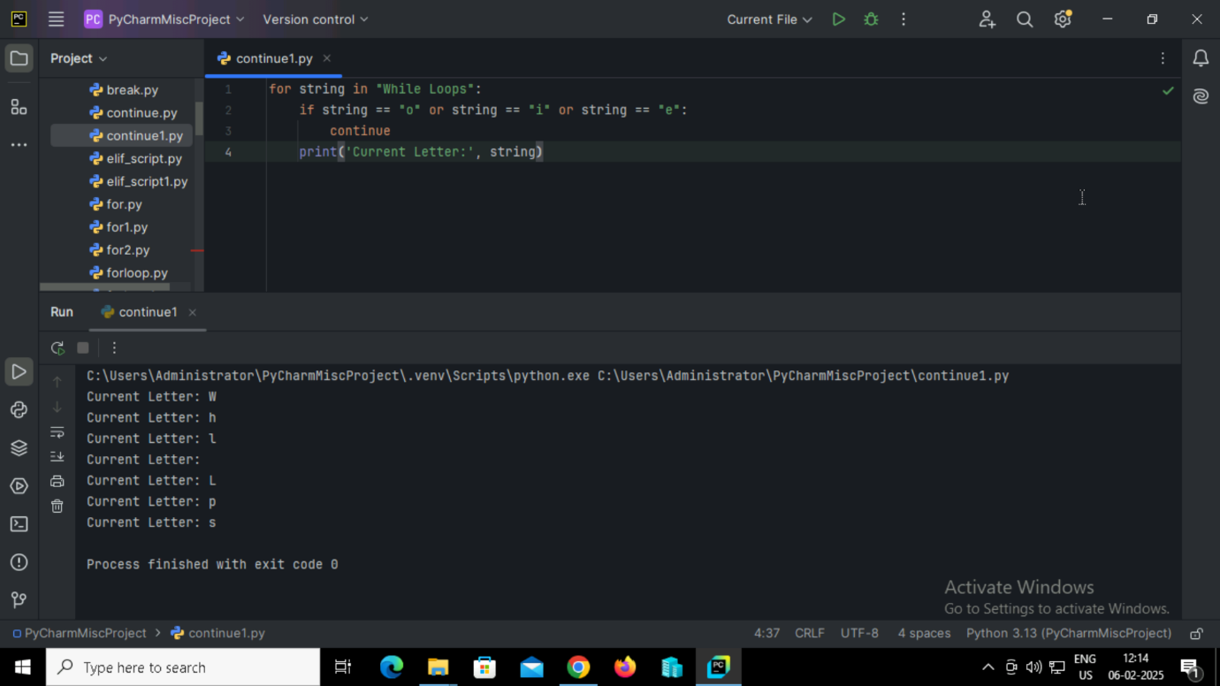

**Output:**

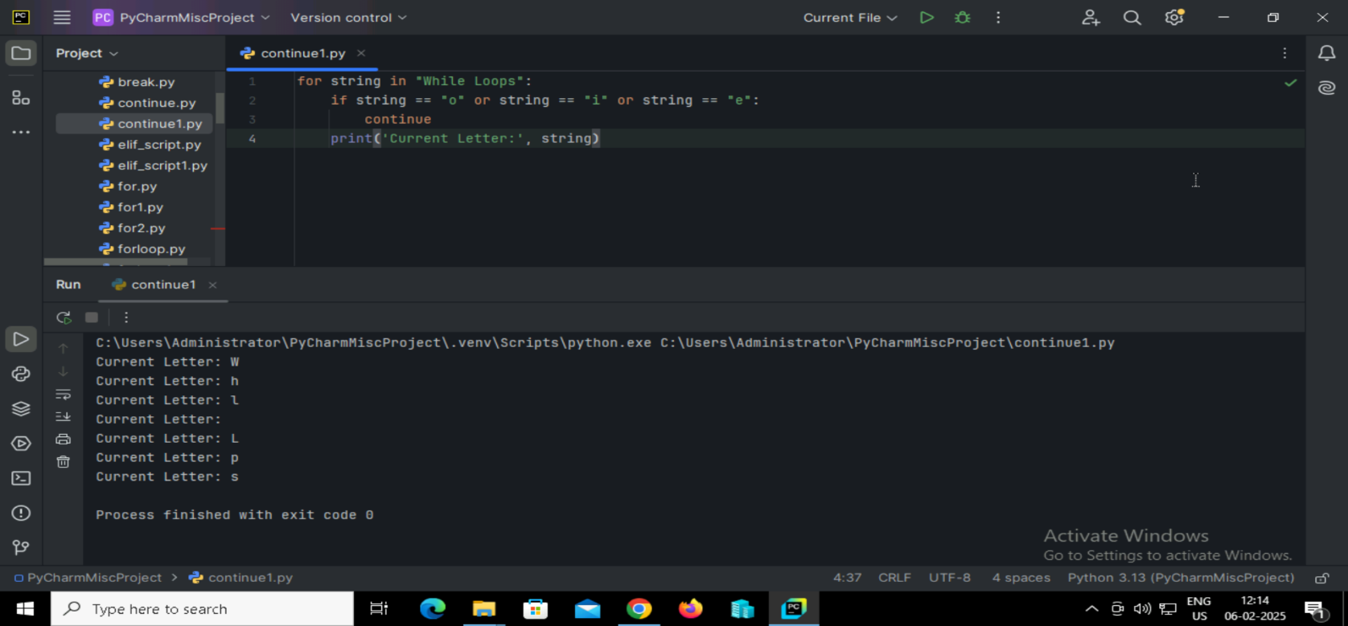

**48. Python program to iterate over the string 'Python Loops' and stop the loop when the letter 'n' is encountered.**

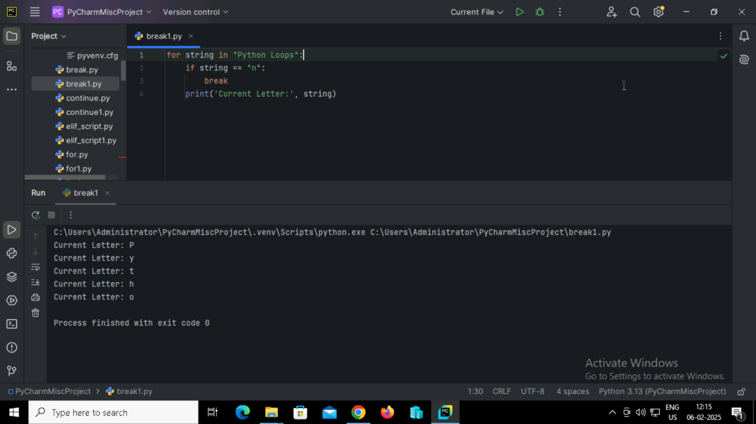

**Output:**



**49. Python program to iterate over the string 'Python Loops' using the pass statement and print the last letter.**

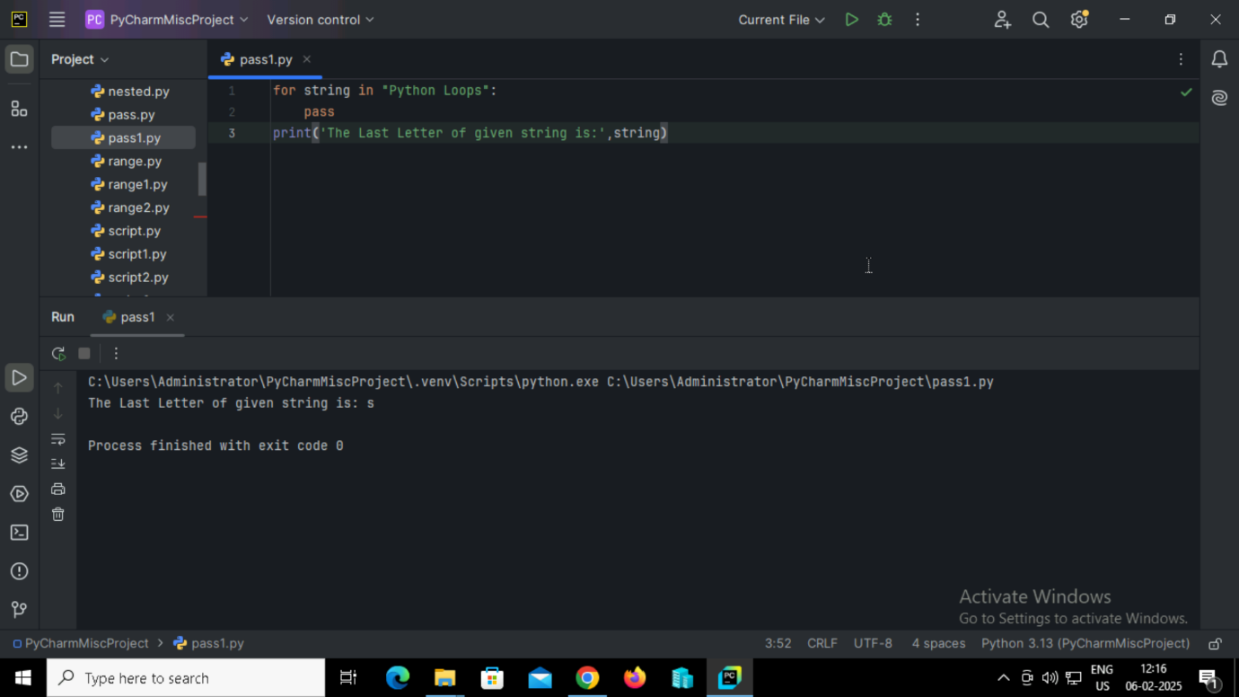

**Output:**



**50. Python program to break the loop when a specific item is found in a list**

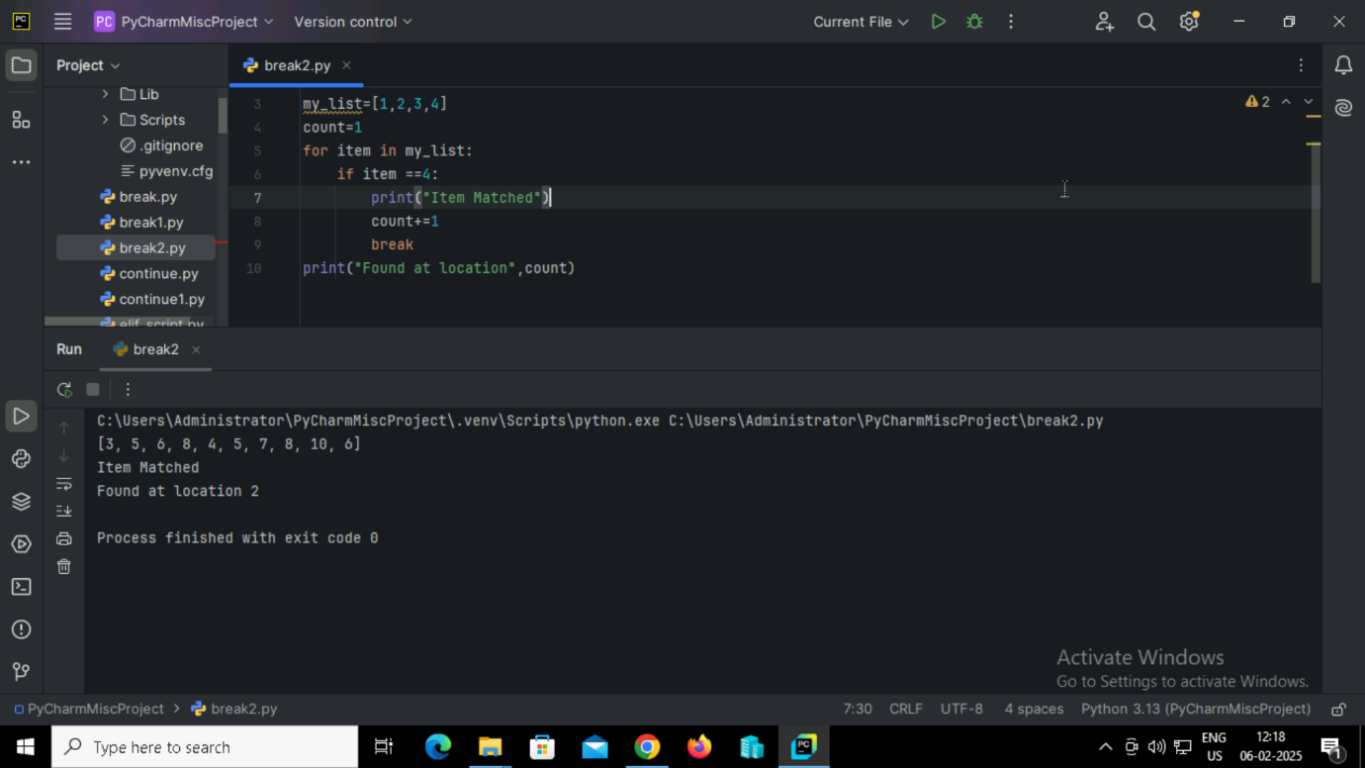

**Output:**

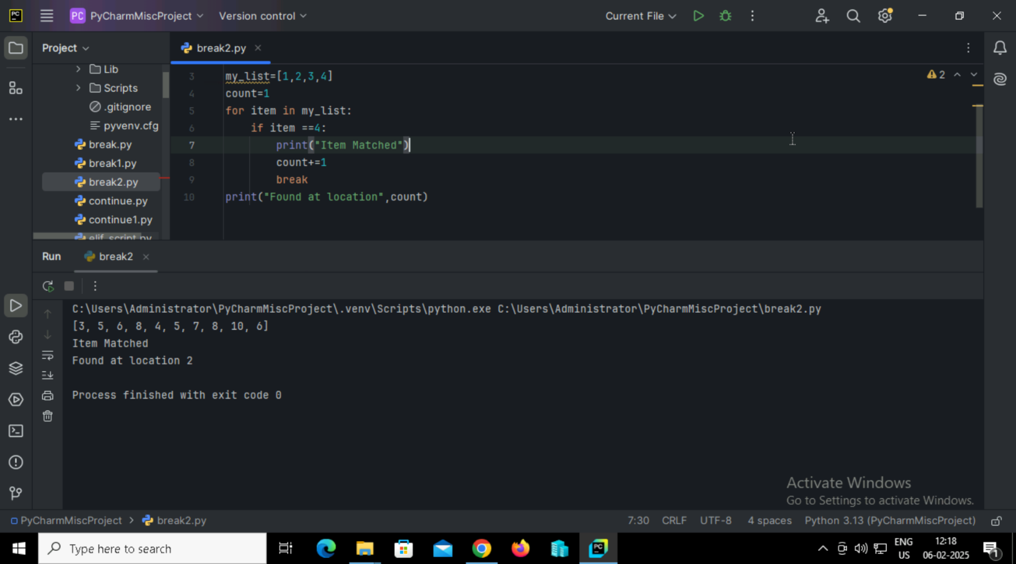

**51. Python program to break the loop when the character 'o' is found in the string 'python.**

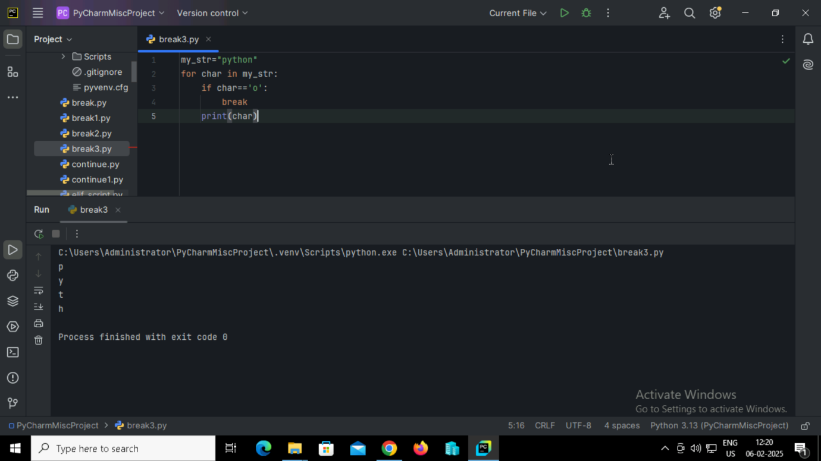

**Output:**

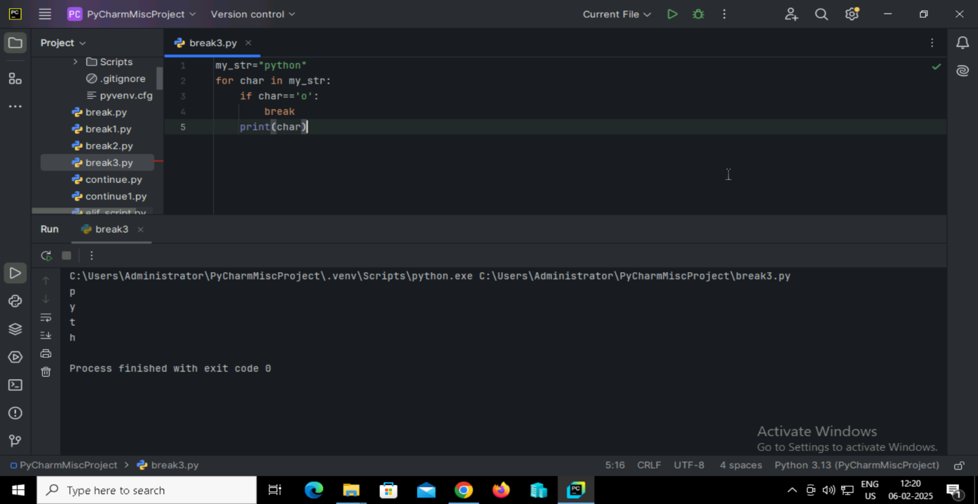

**52. Python program to exit a while loop when a variable equals 10.**

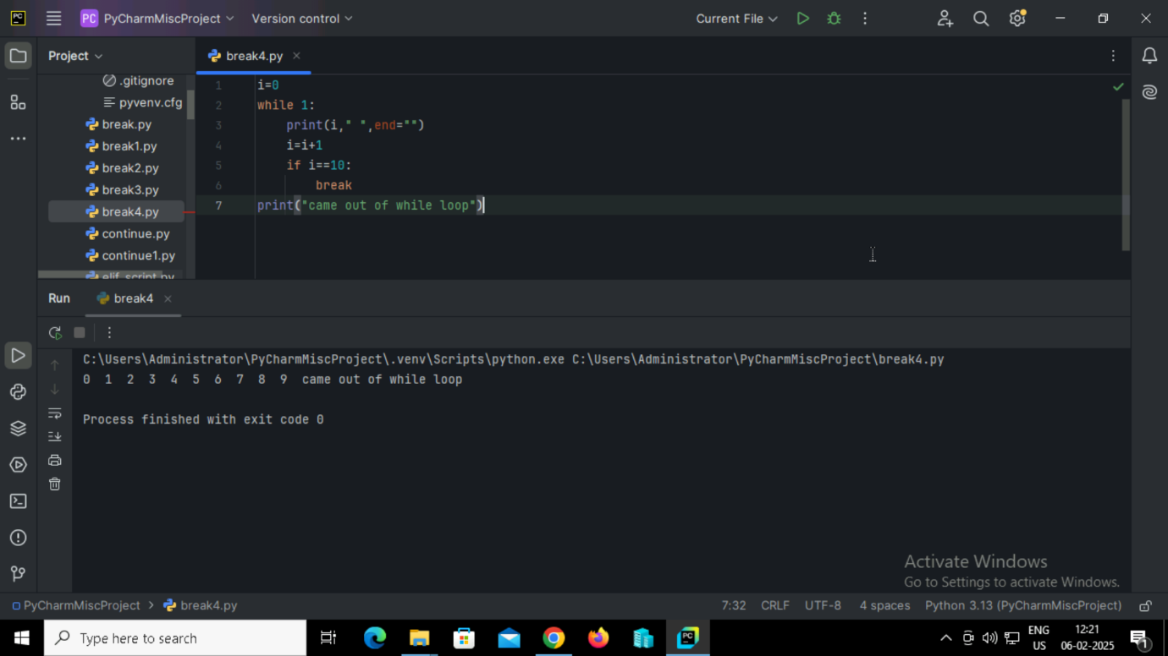

**Output:**



**53. Python program to print multiplication tables and exit when the user chooses to stop.**

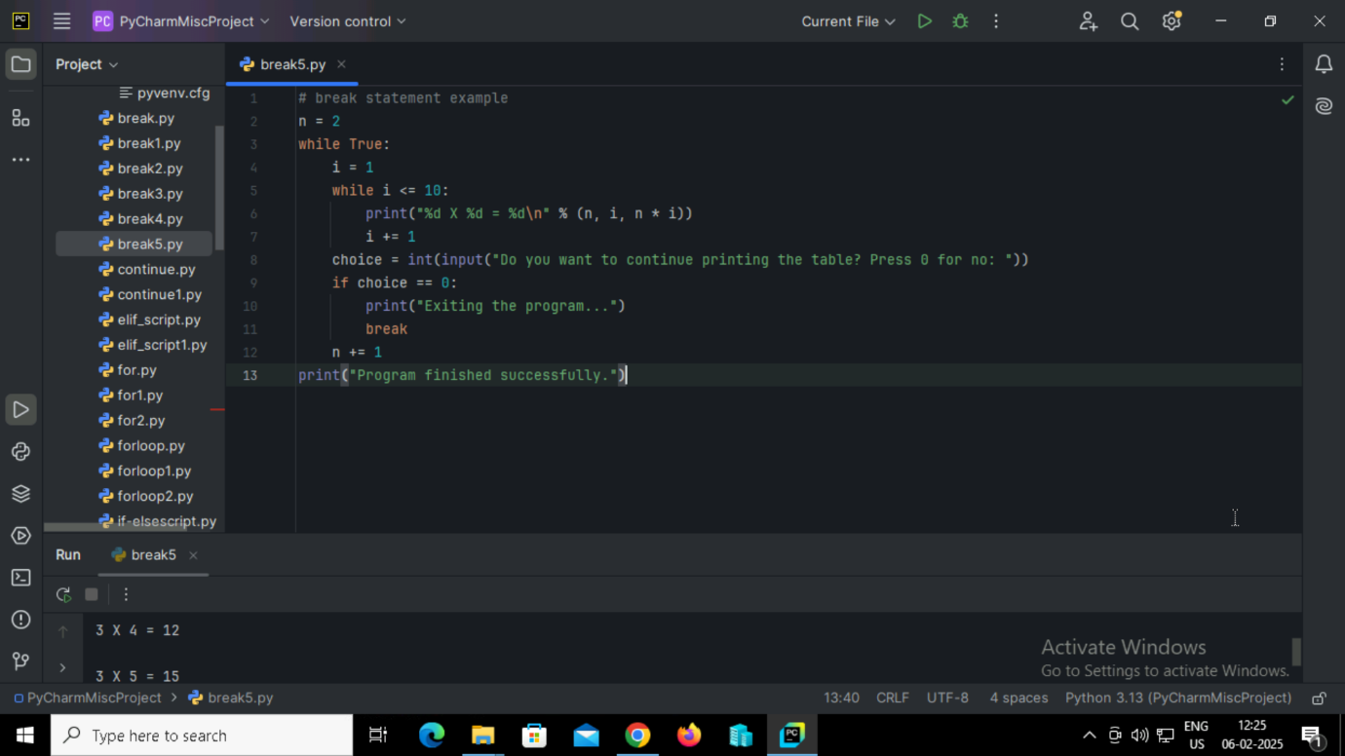

**Output:**

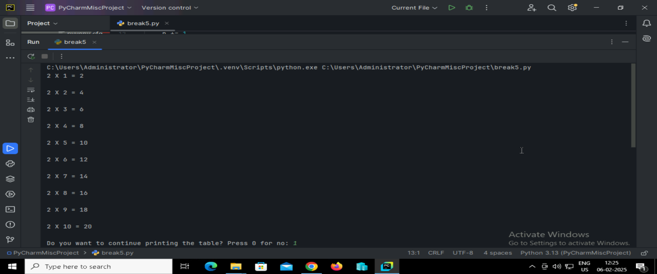

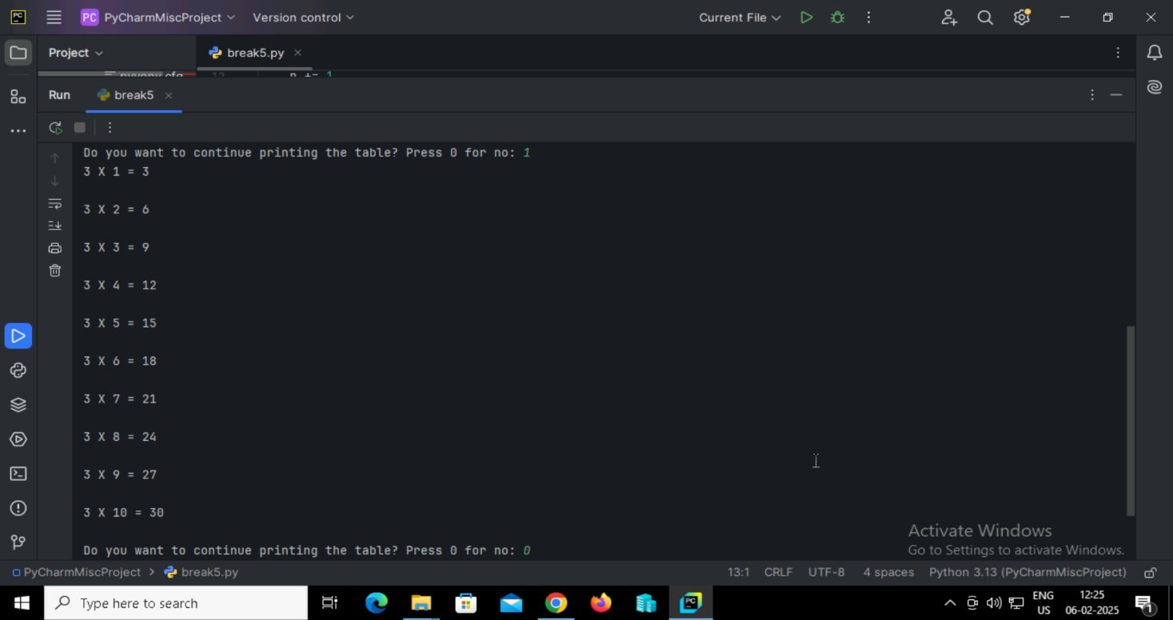

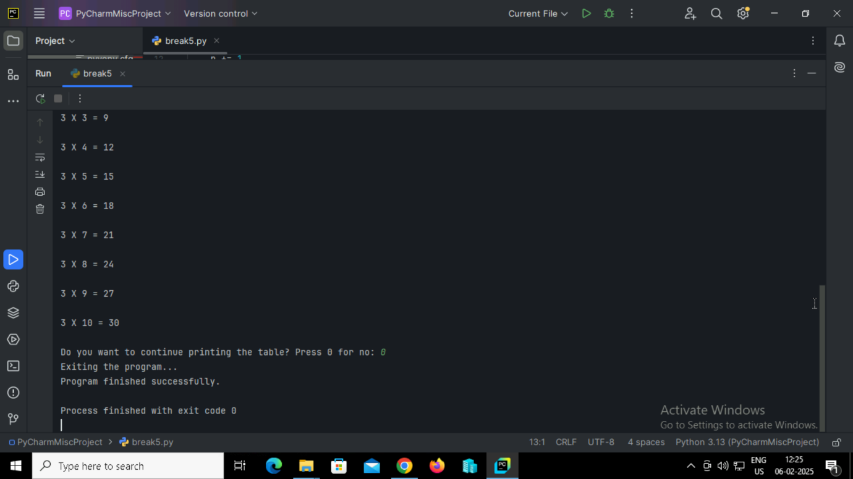

**54. Python program to loop from 10 to 20 and skip printing 15 using the continue statement.**

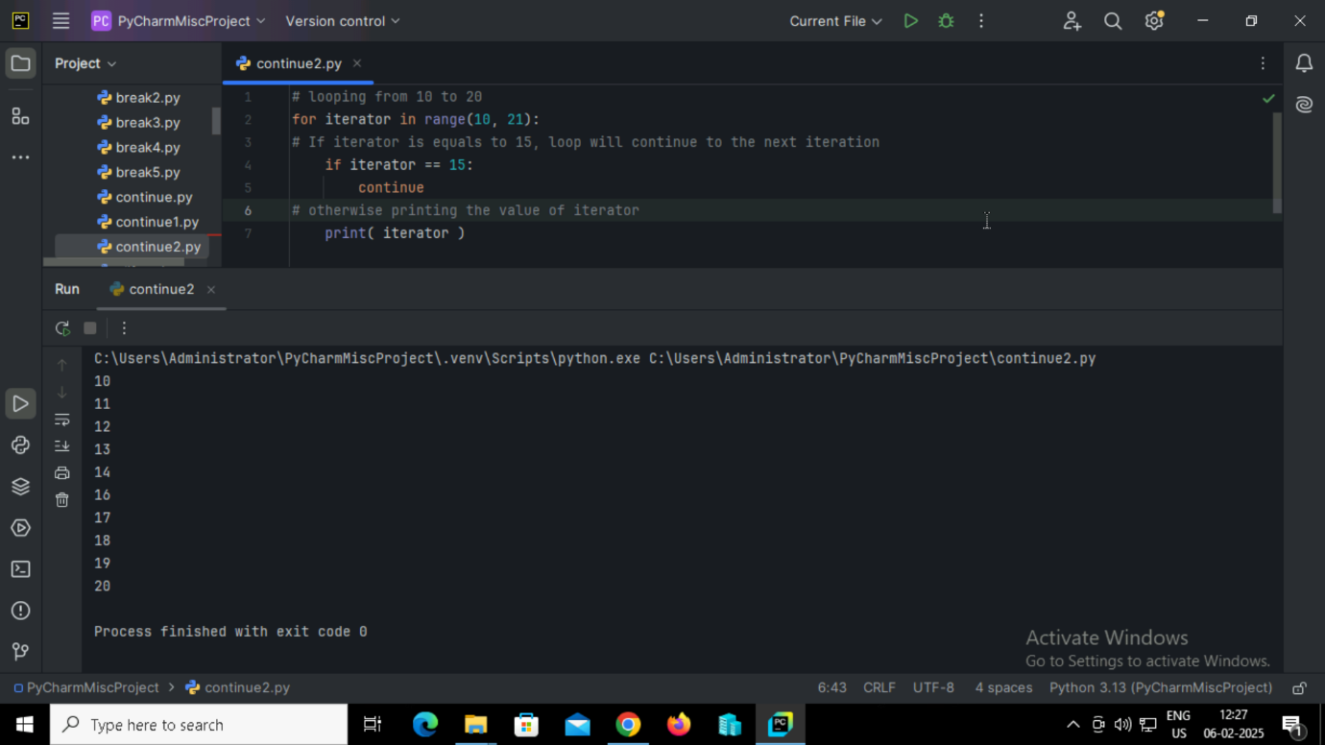

**Output:**

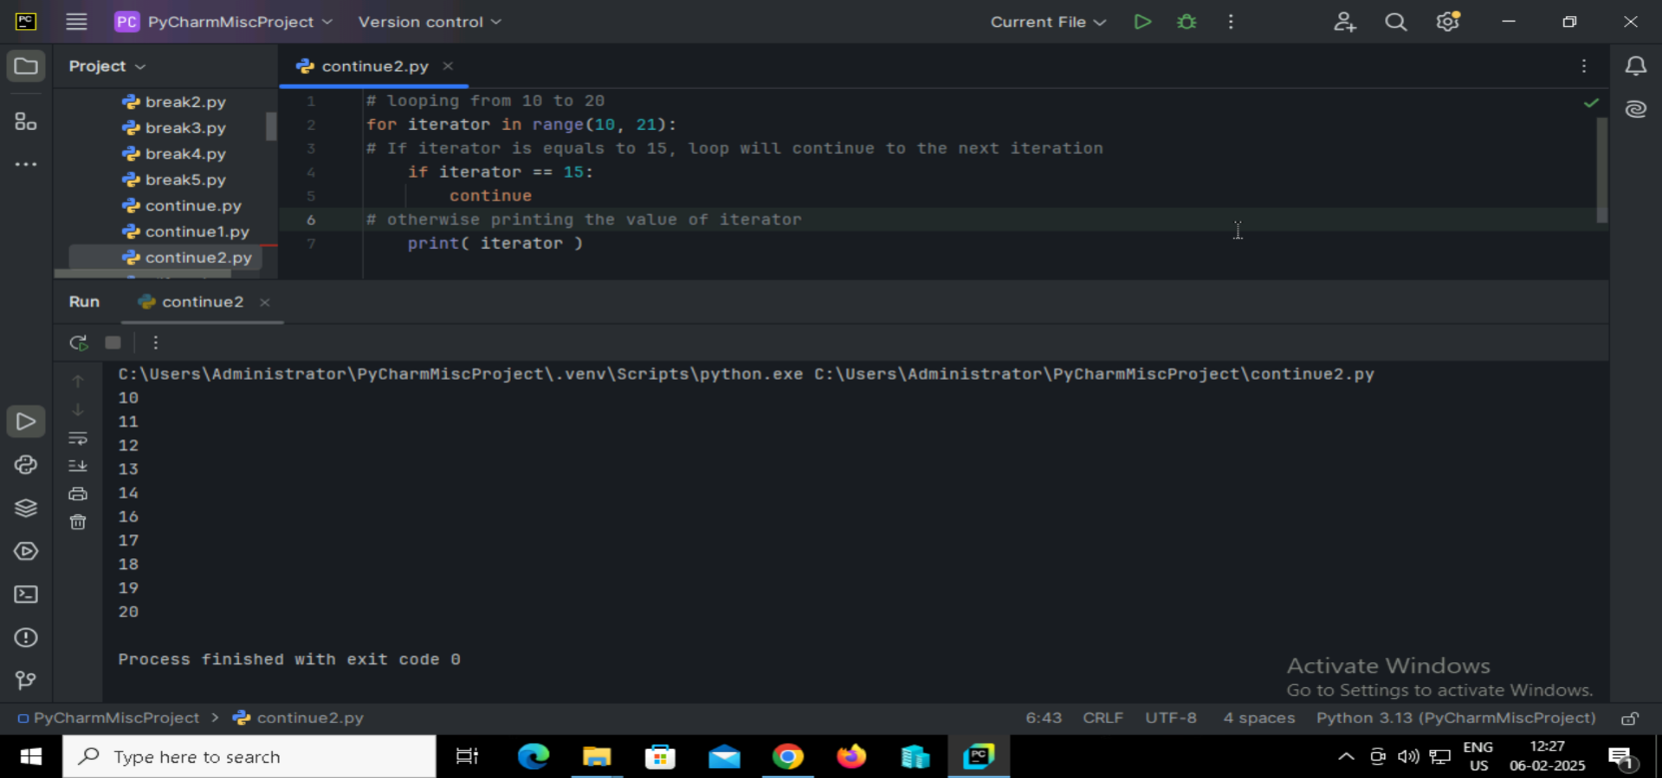

**55. Python program to loop through a string and skip the letter 'a'.**

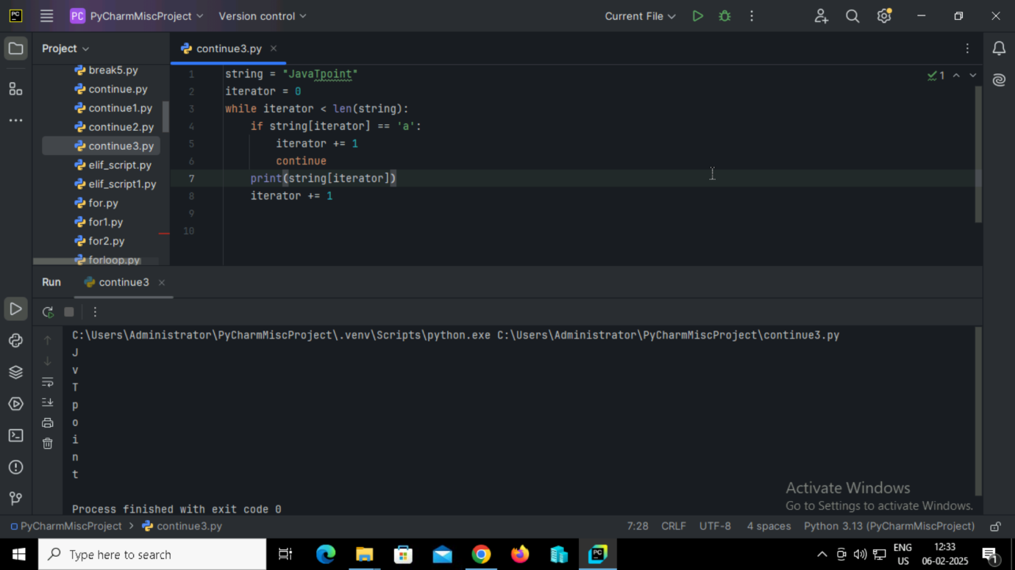

**Output:**

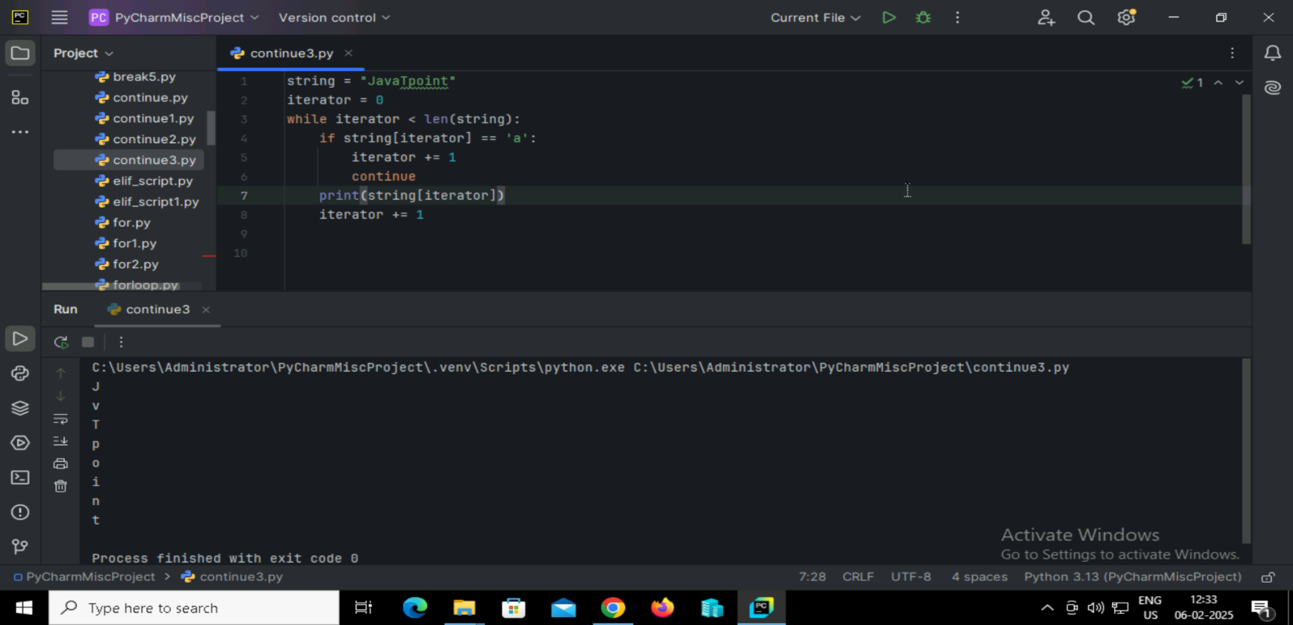

**56. Python program to square only the even numbers in a list using list comprehension.**

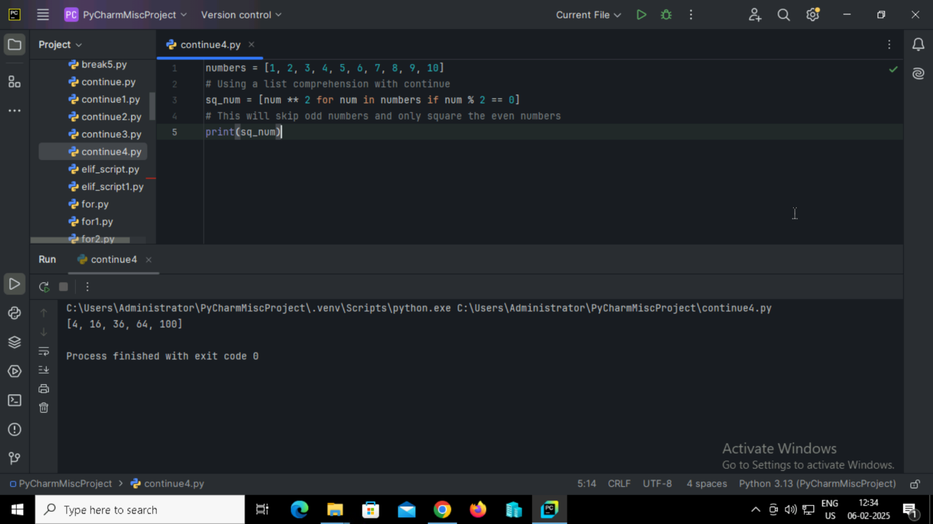

**Output:**

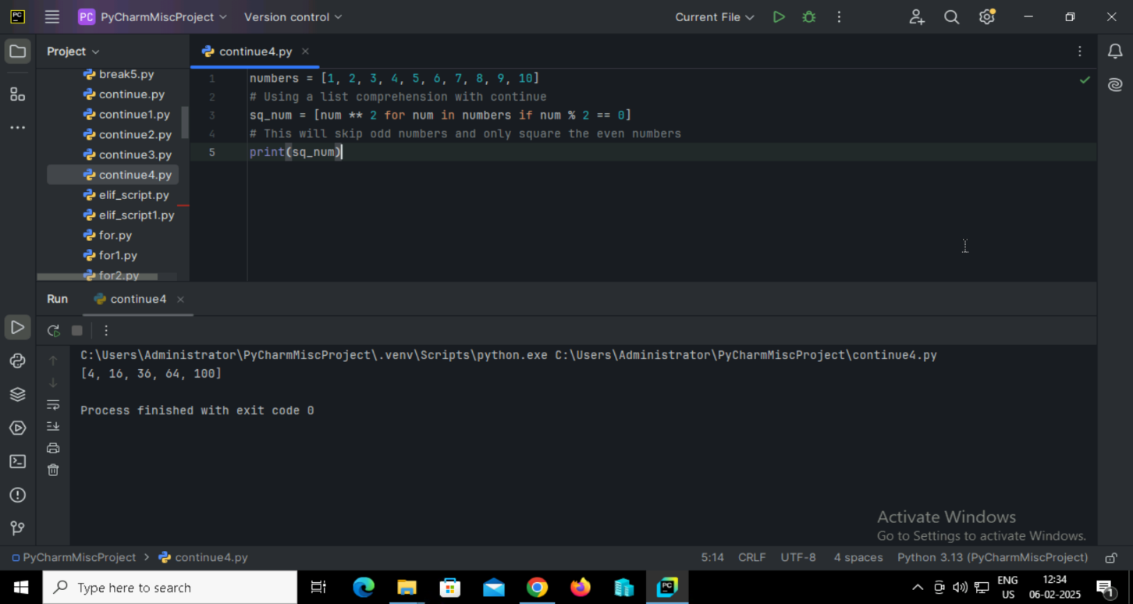

**STRING**

**57. Create a string by enclosing the characters in single-quotes or double- quotes.**

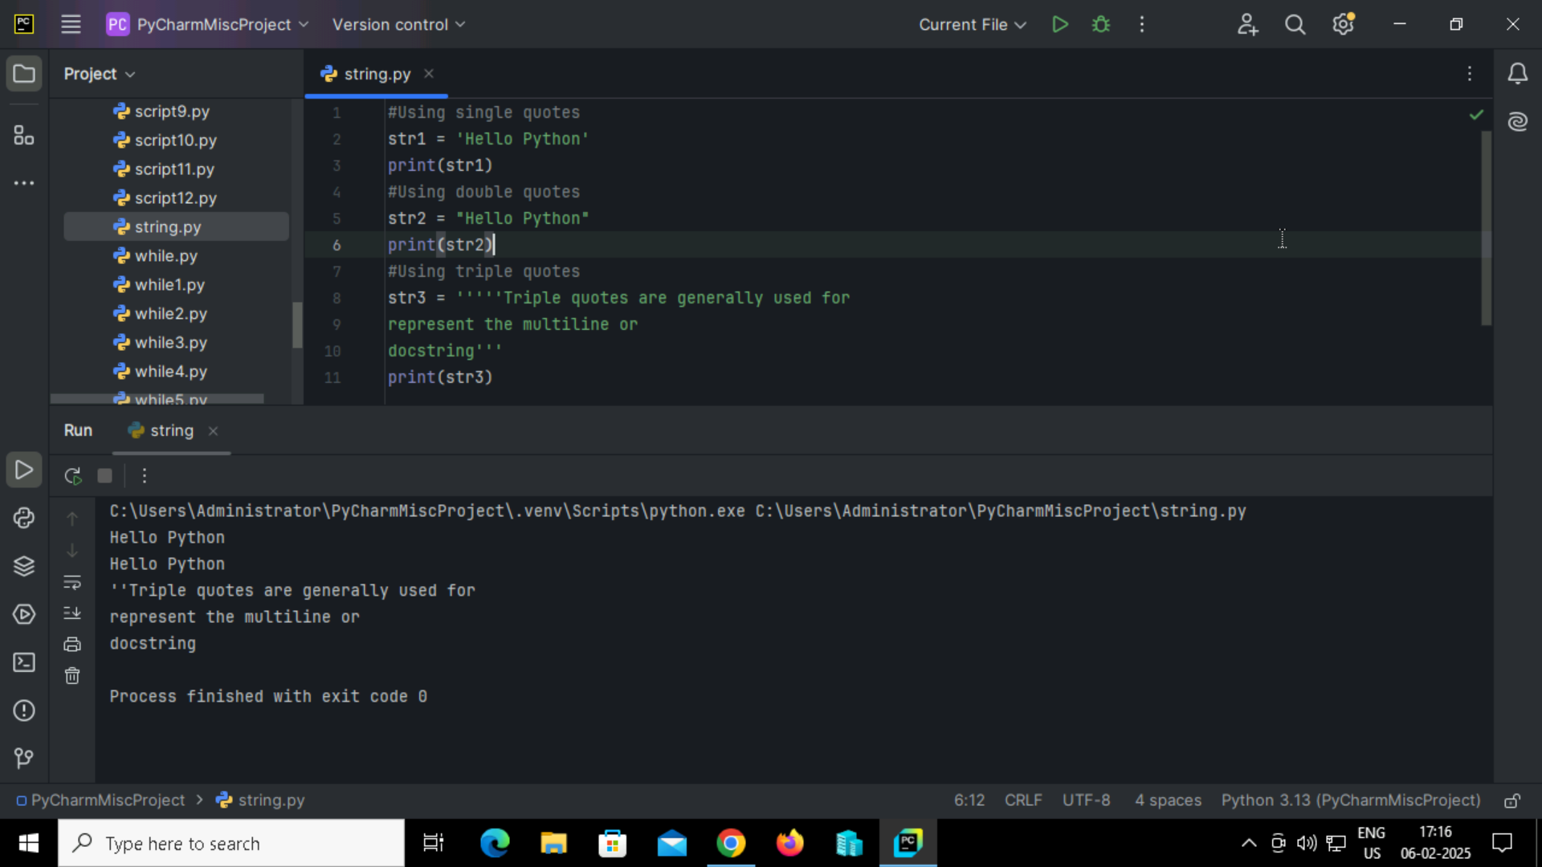

**Output:**

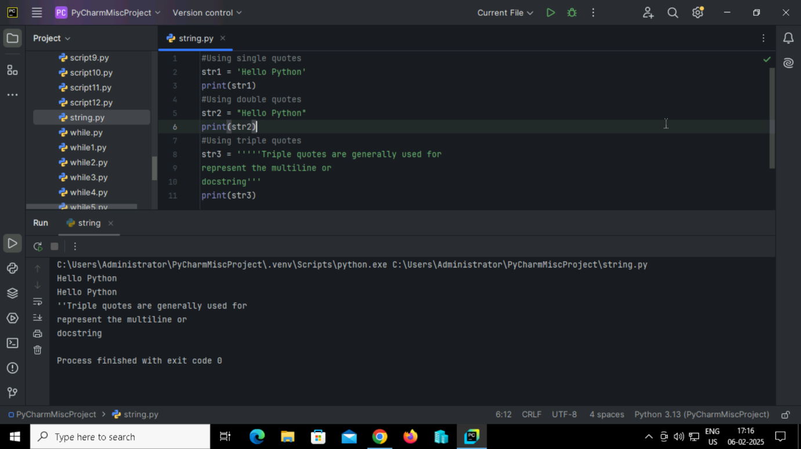

**58. Python program to access each character of a string and handle the Index Error when accessing an invalid index.**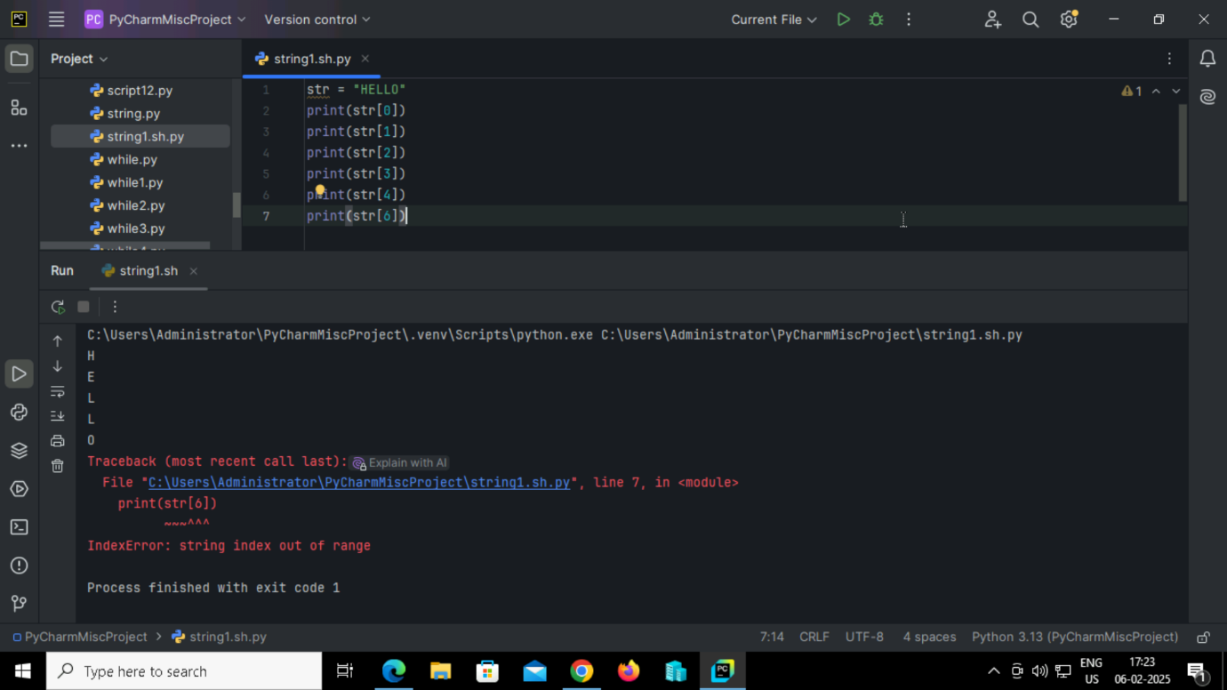

**Output:**



**59. Python program to slice a string in different ways using index ranges**

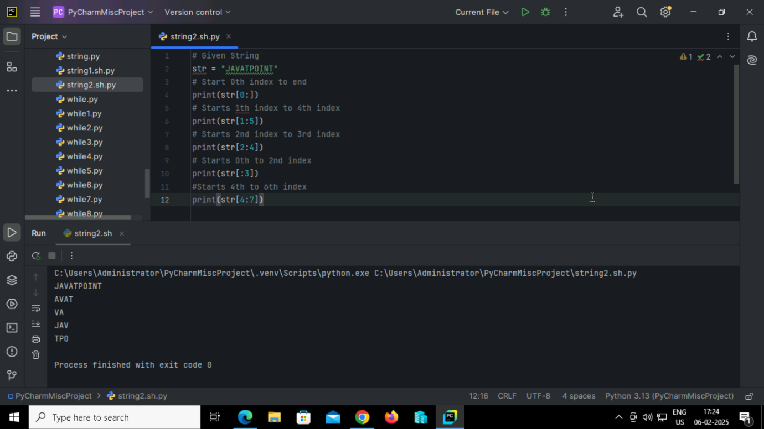

**Output:**



**60. Python program to access elements from a string using negative indexing and slice the string in various ways.**

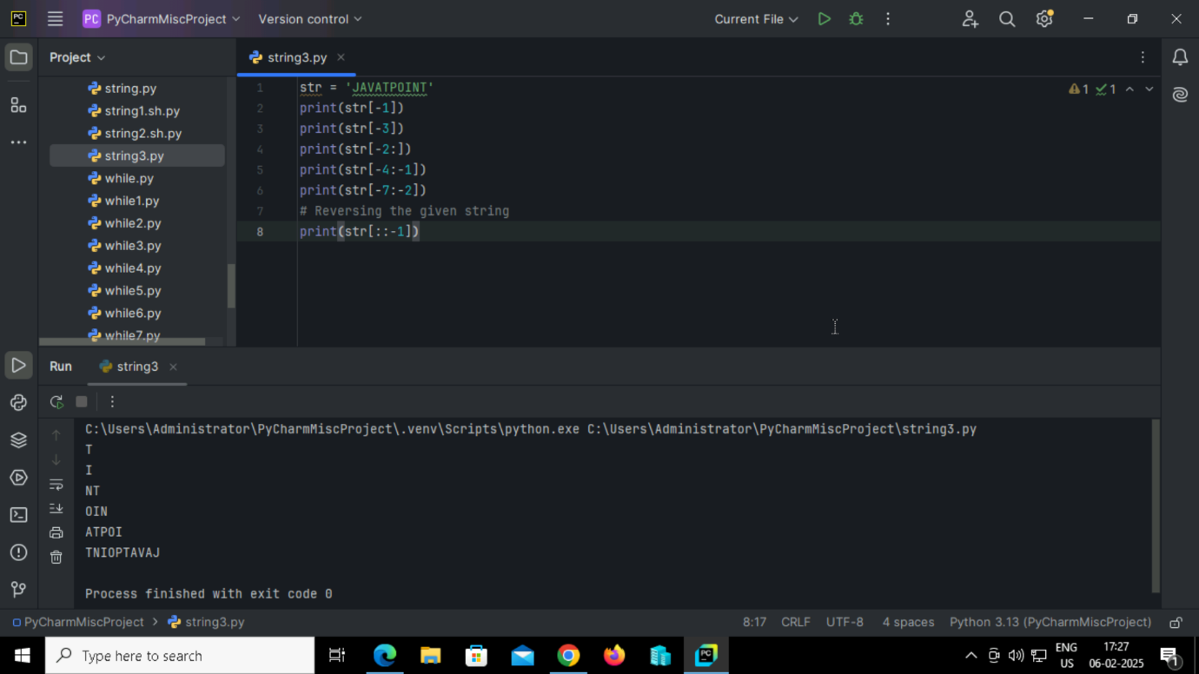

**Output:**



**61. Python program to try modifying a character of a string.**

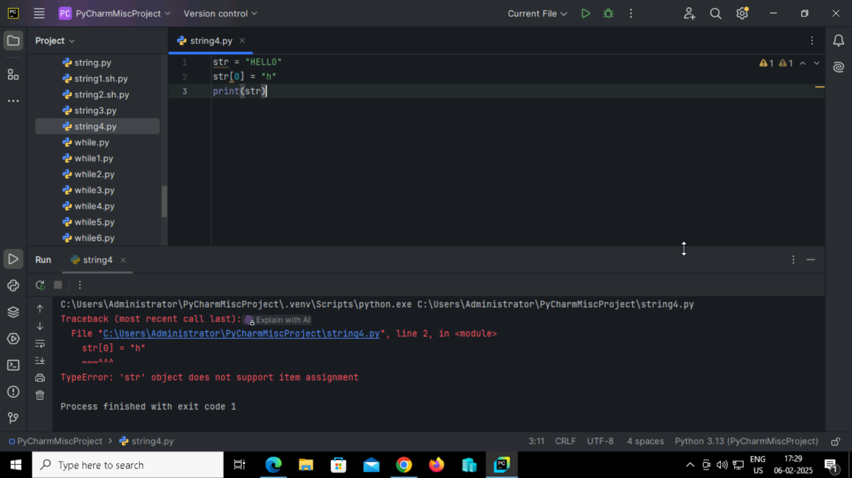

**Output:**



**62. Python program to modify a character in a Python string**

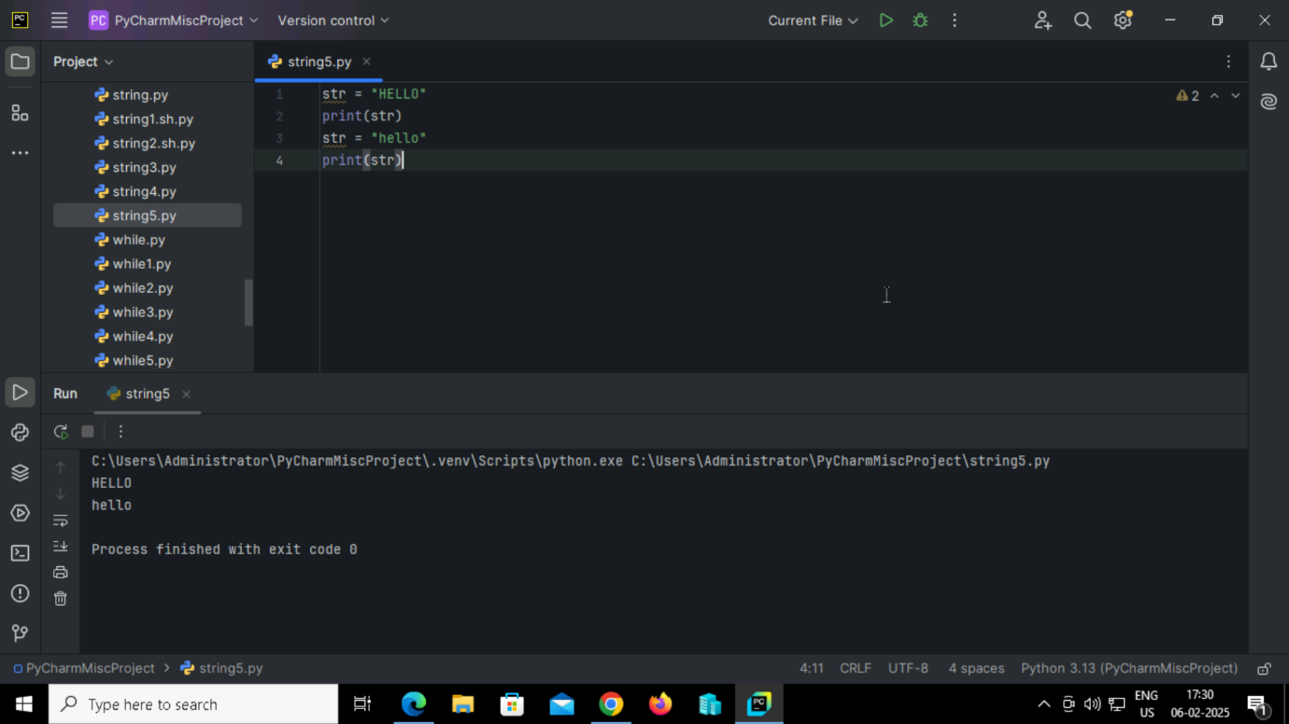

**Output:**

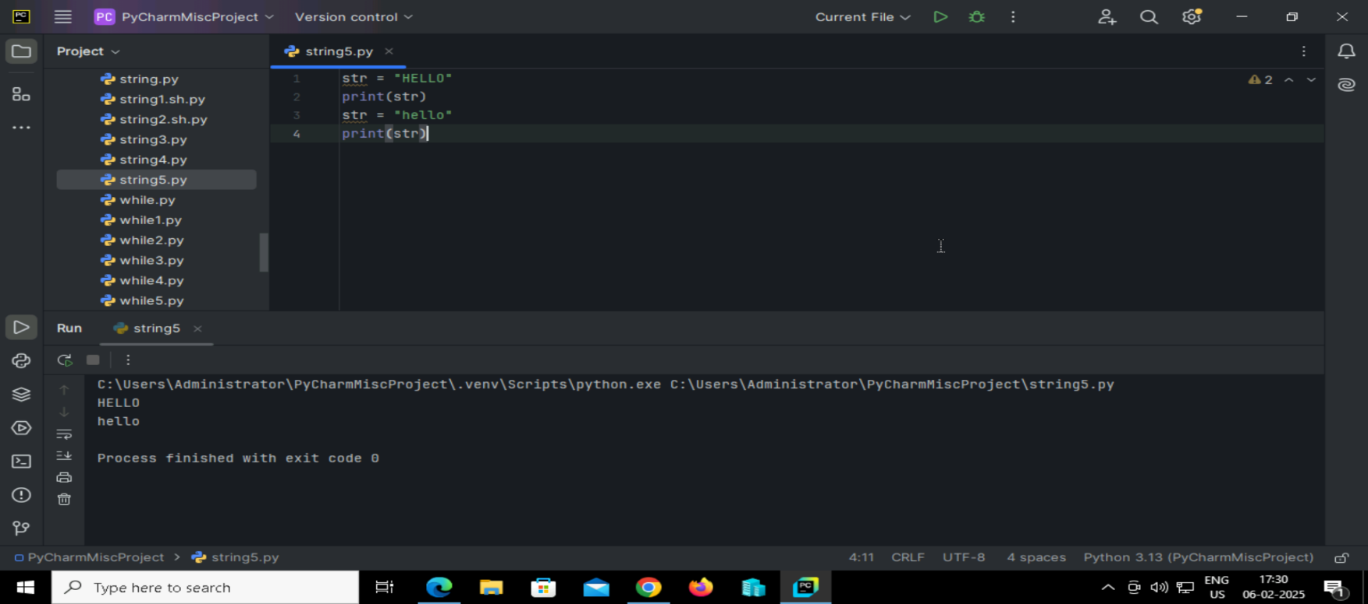

**63. Python program to delete the string.**

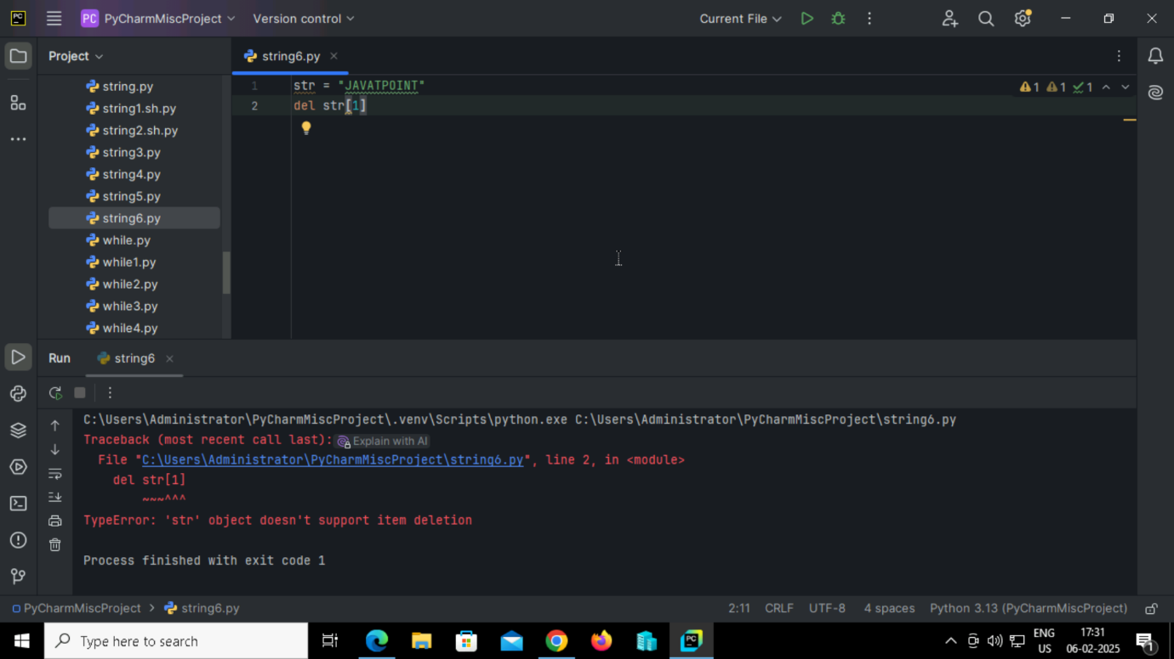

**Output:**

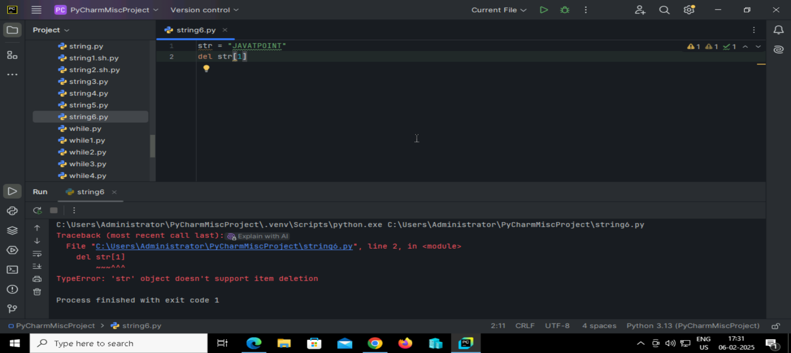

**64. Python program to delete the entire string.**

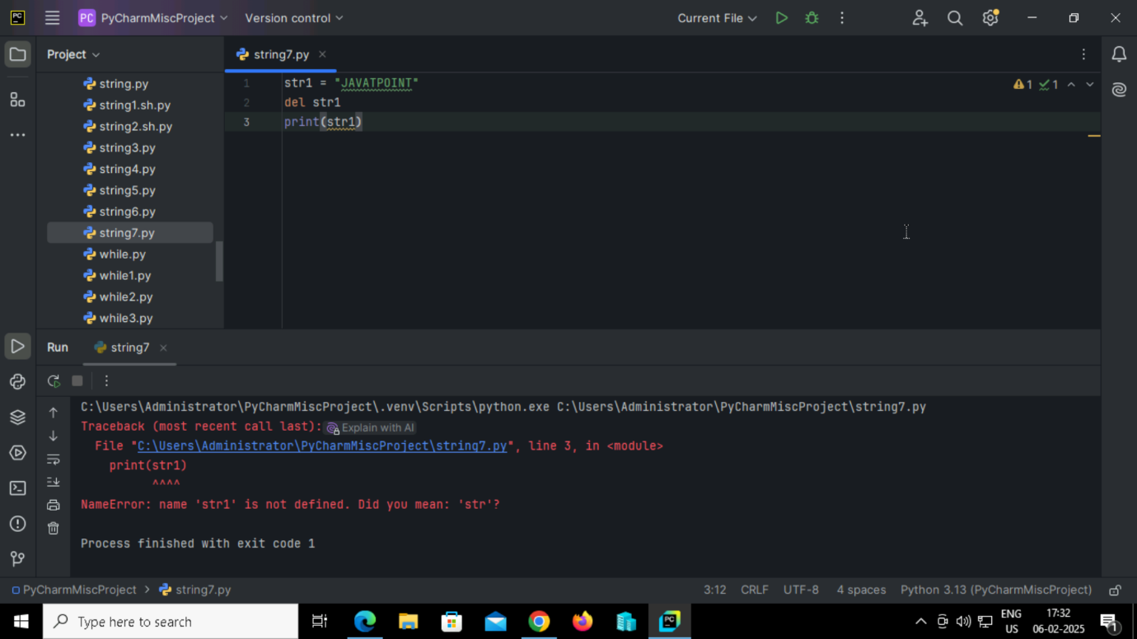

**Output:**

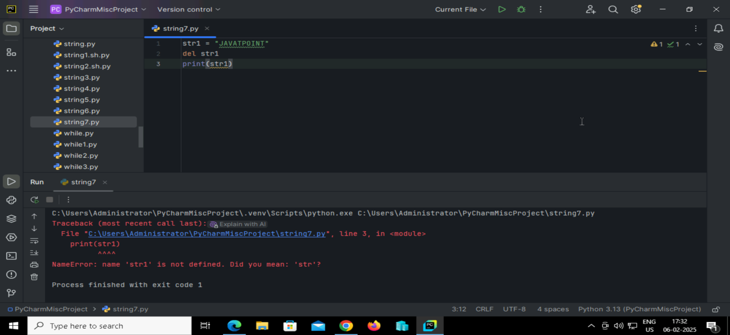**65. Python program to understand the real use of Python operators.**

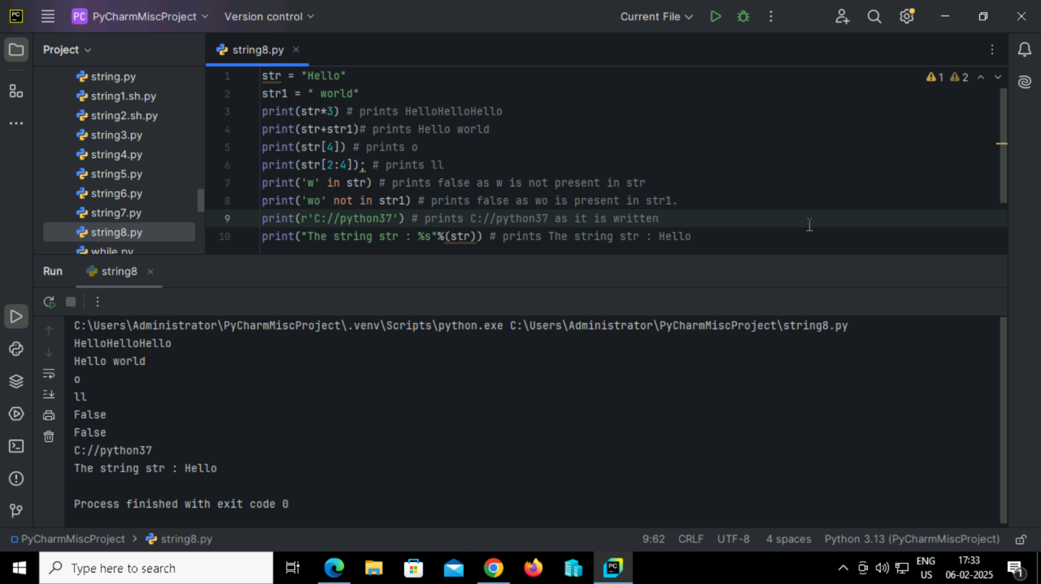

**Output:**

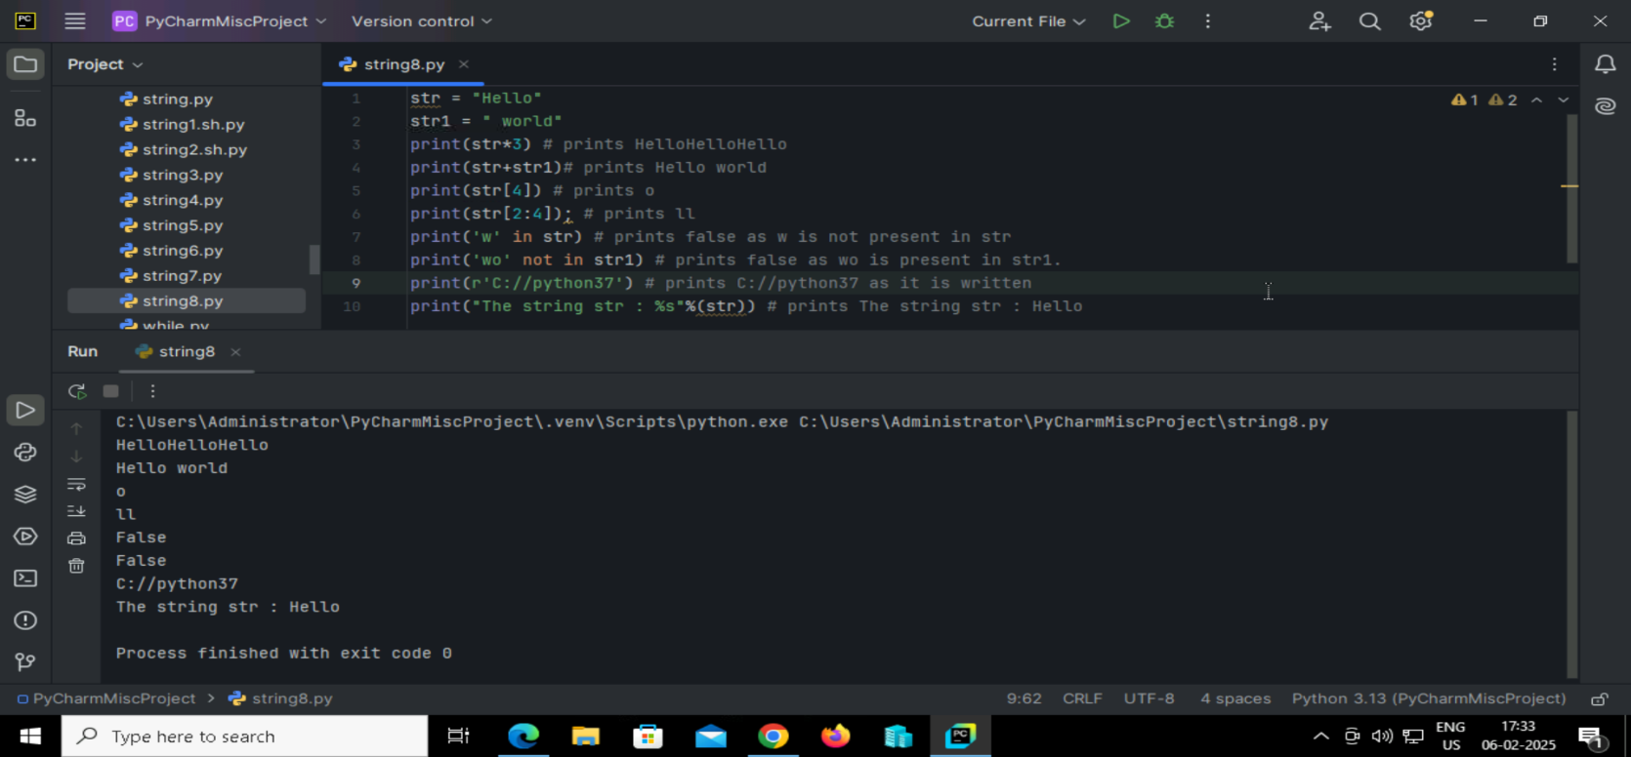

**66. Python program to understand the string formatting.**

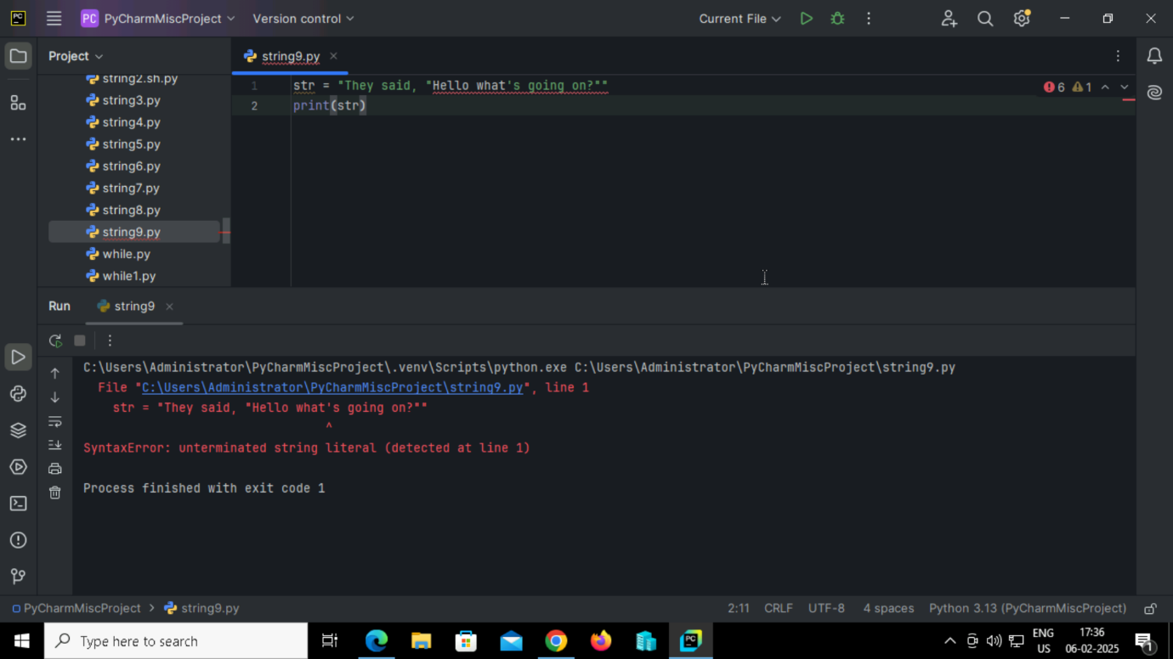

**Output:**

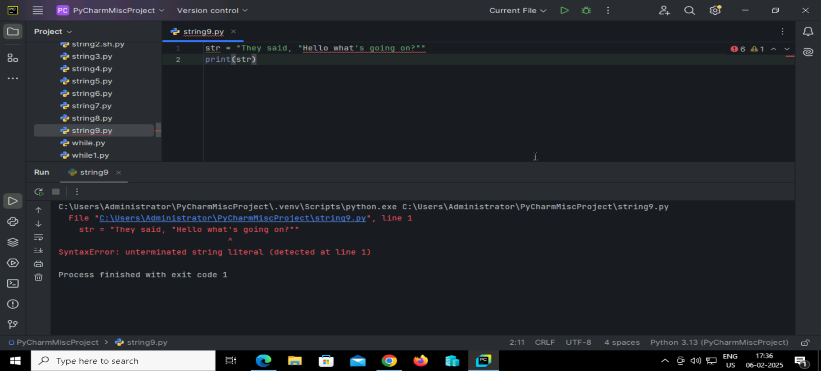

**67. Python code to handle quotes in strings**

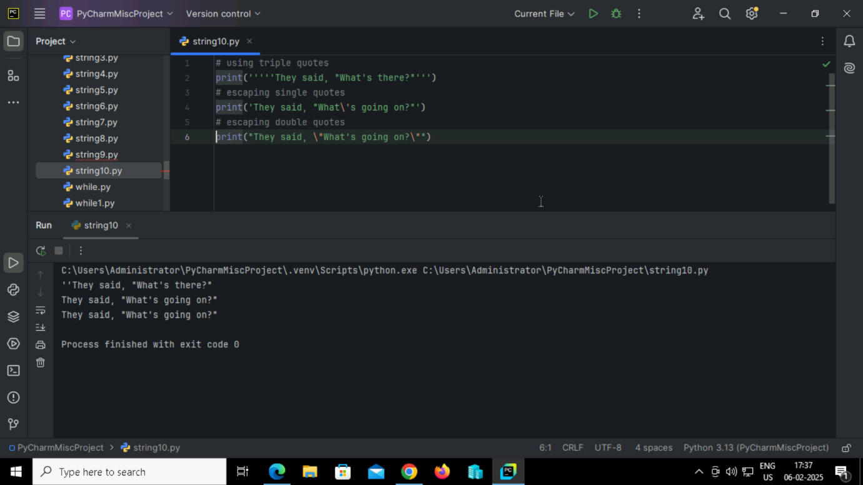

**Output:**

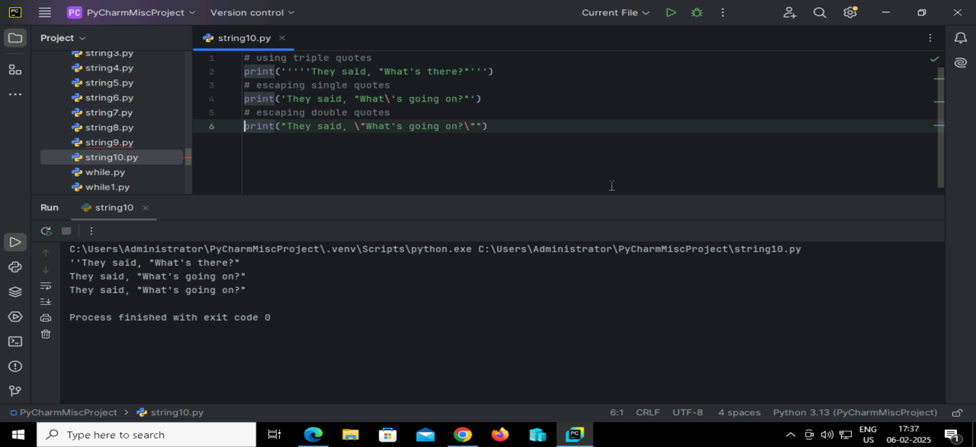

**68. Python program to perform escape sequence in strings**

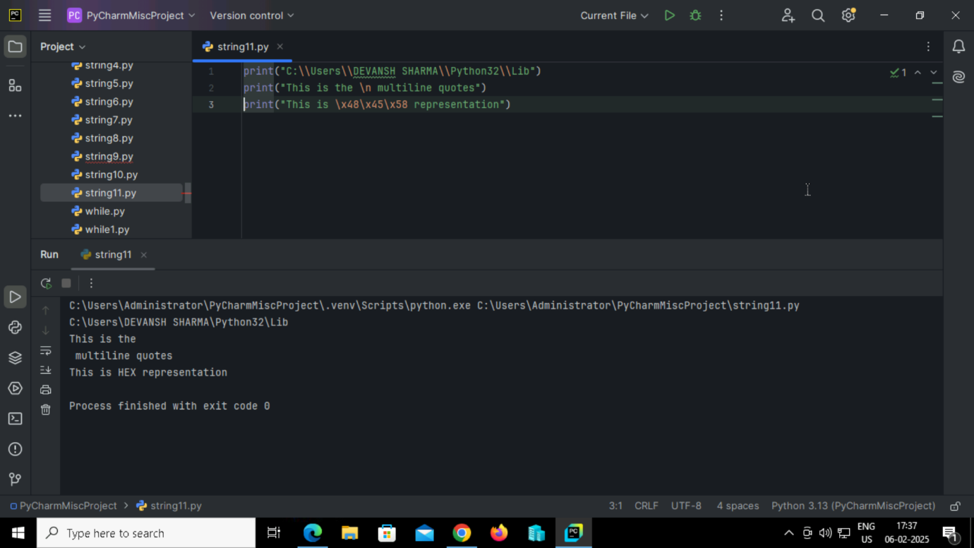

**Output:**

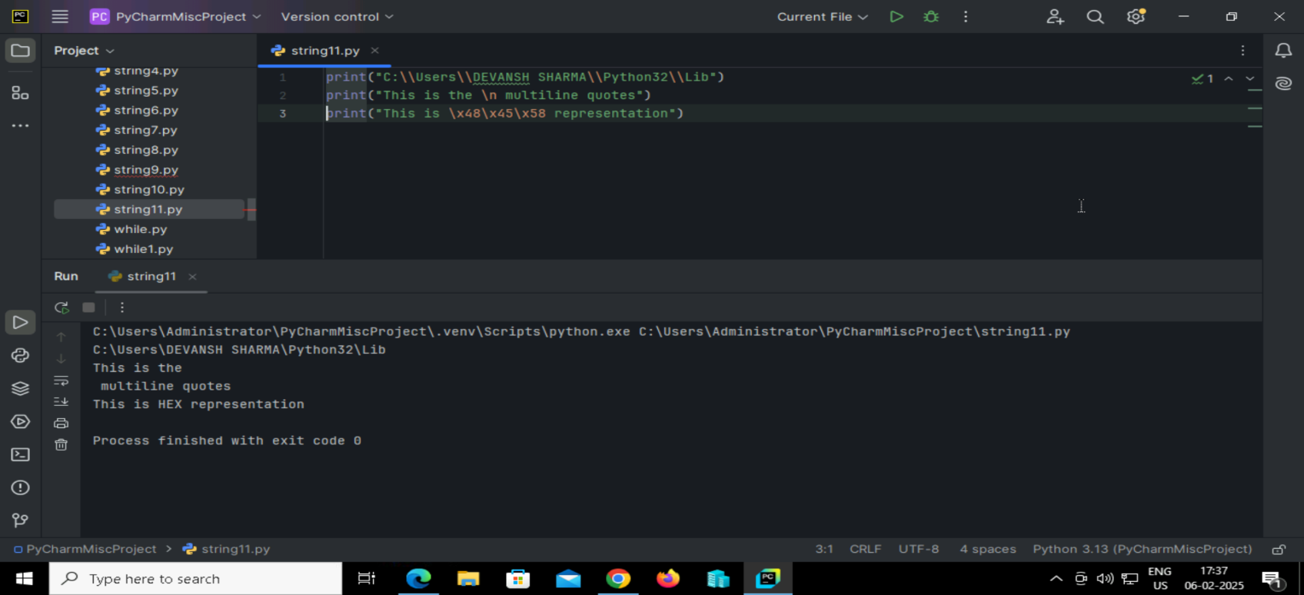

**69. Python code to demonstrate different ways to format strings using curly braces {}.**

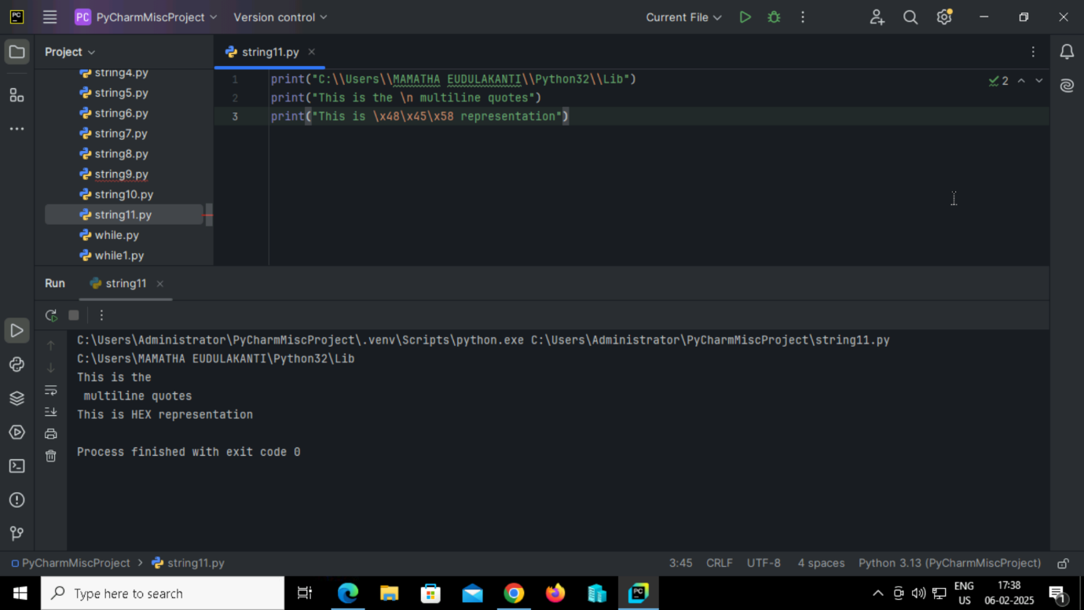

**Output:**

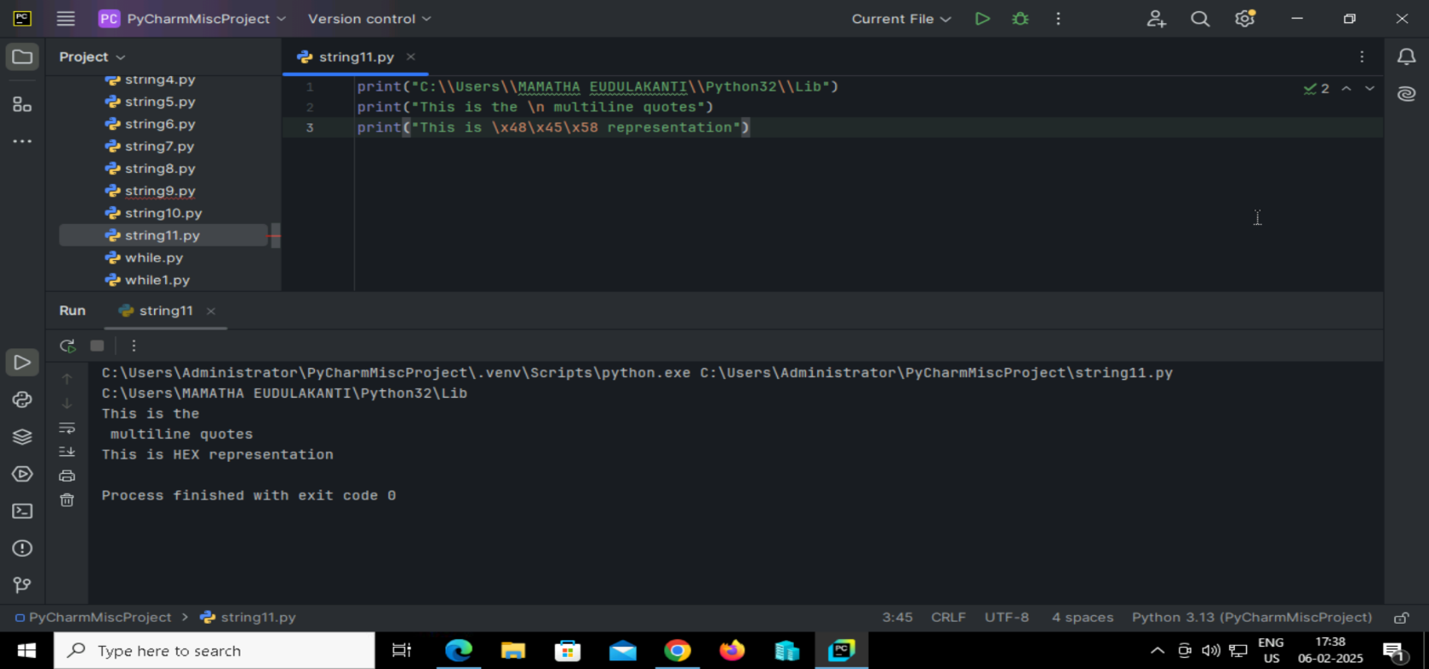

**70. Python code to demonstrate different ways to format strings using curly braces {}.**

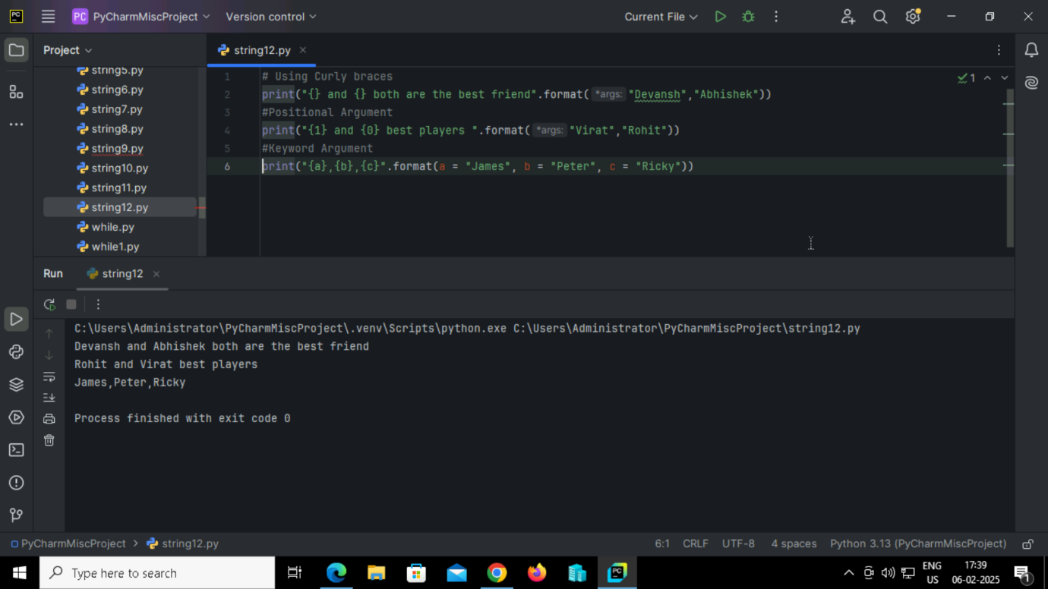

**Output:**

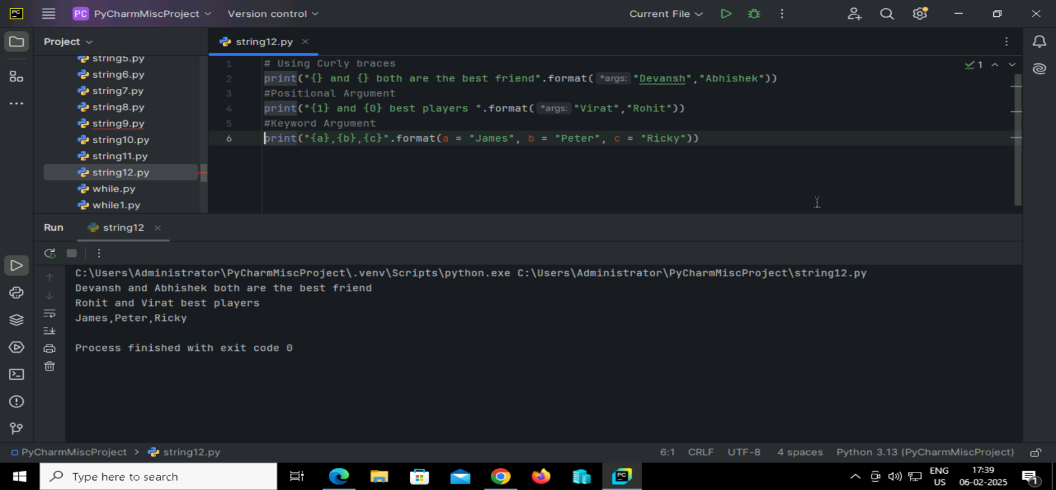

**71. Python String Formatting Using % Operator.**

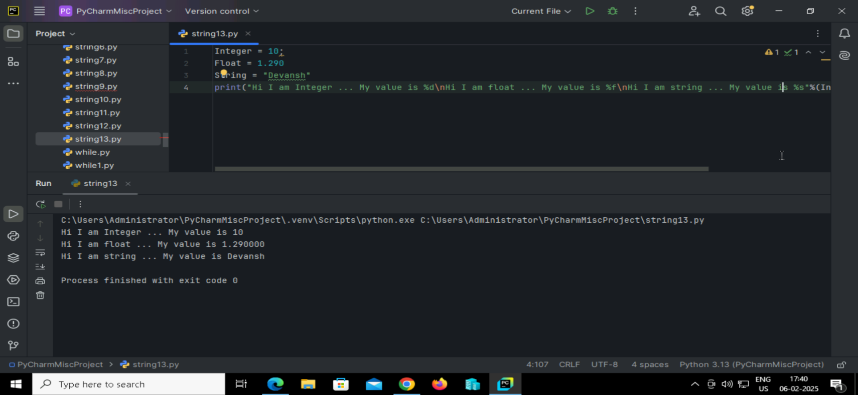**Output:**

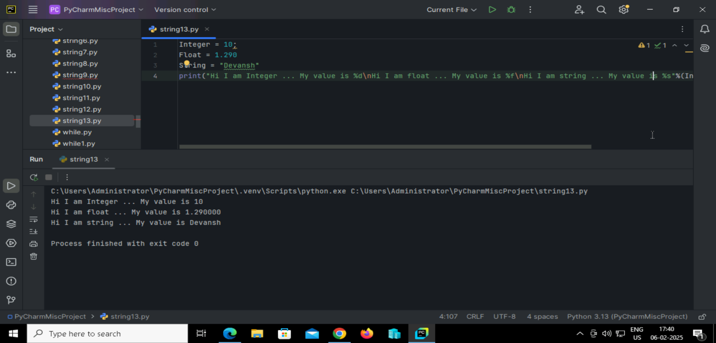

**72.** **Python code to show the difference between creating a list and a tuple**

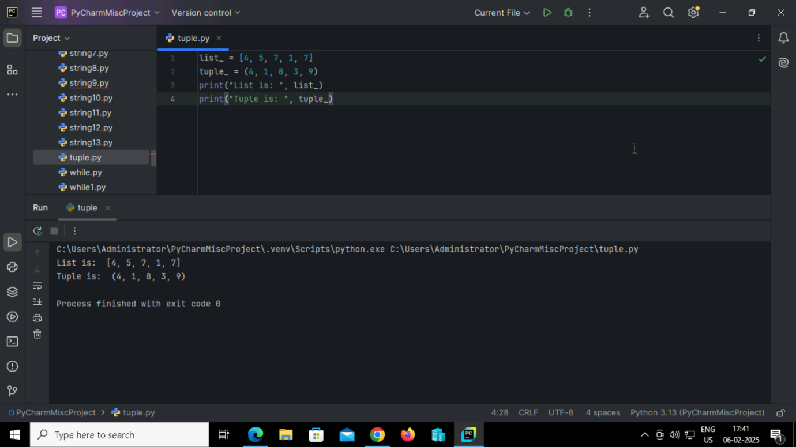

**Output:**

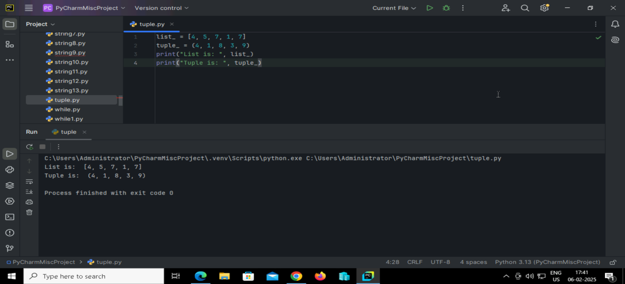**73.Python code to print the data type of the data structure using the type() function**

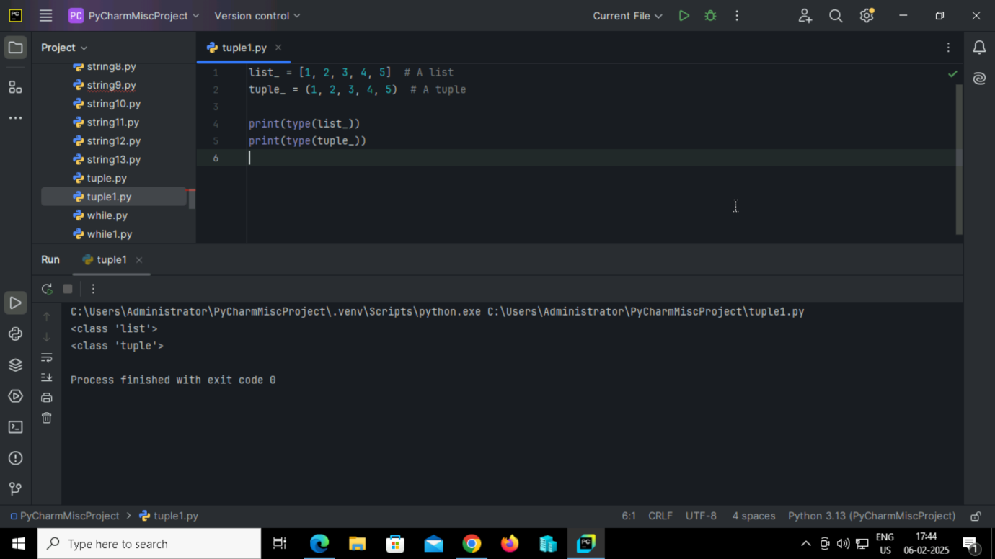

**Output:**

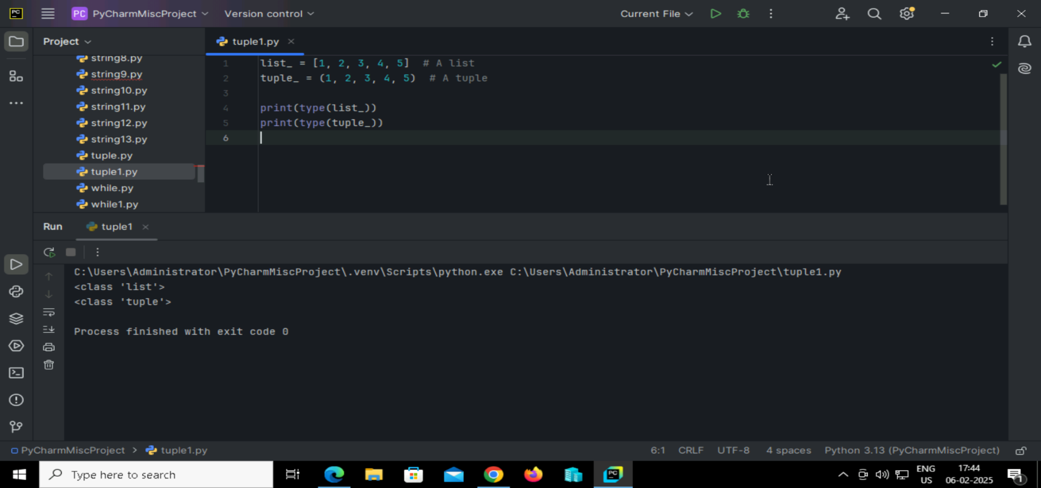

**74.**  **Python code to Update the element of list and tuple at a particular index**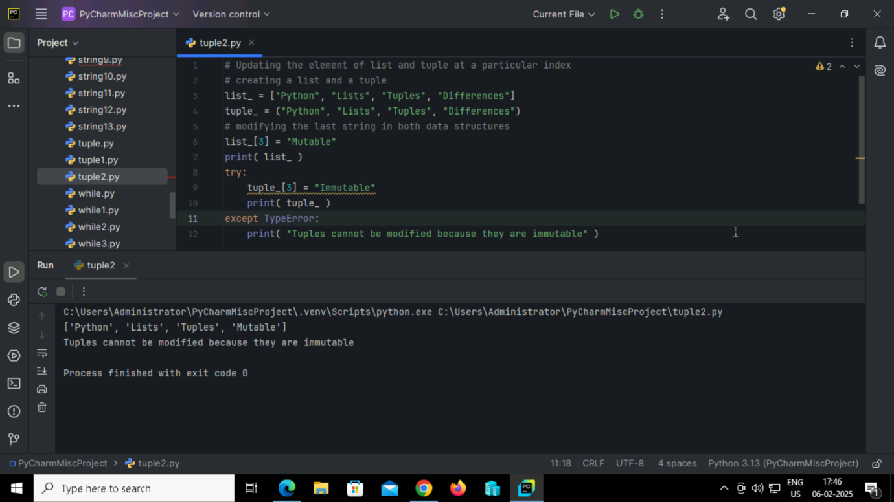

**Output:**

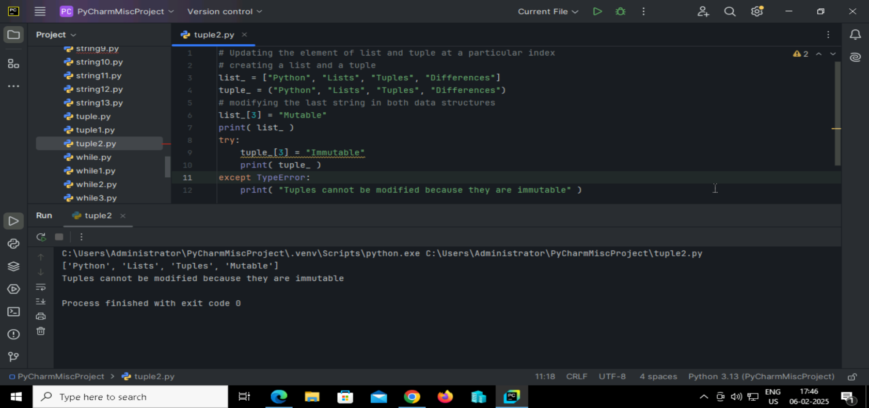

**75. Python Code to show the difference in the size of a list and a tuple**

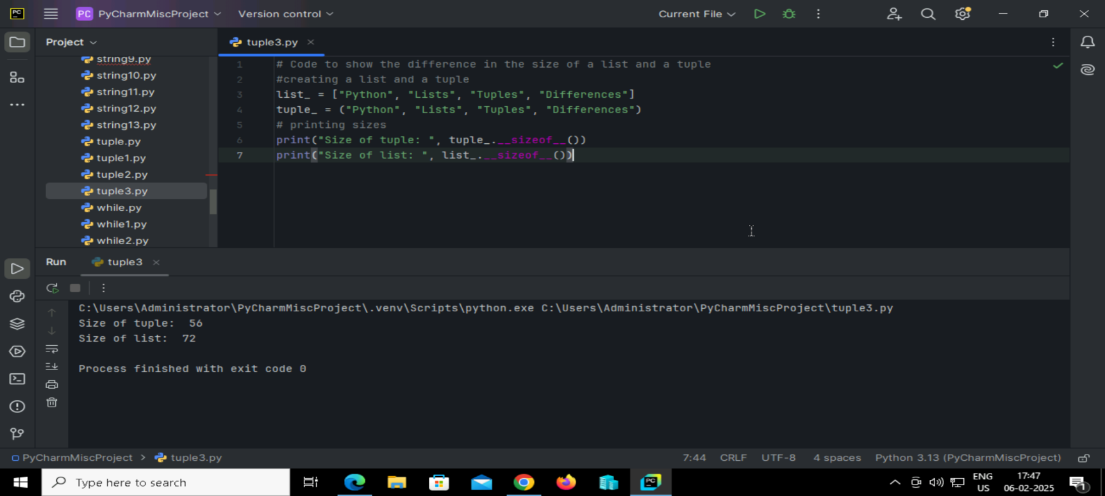

**Output:**

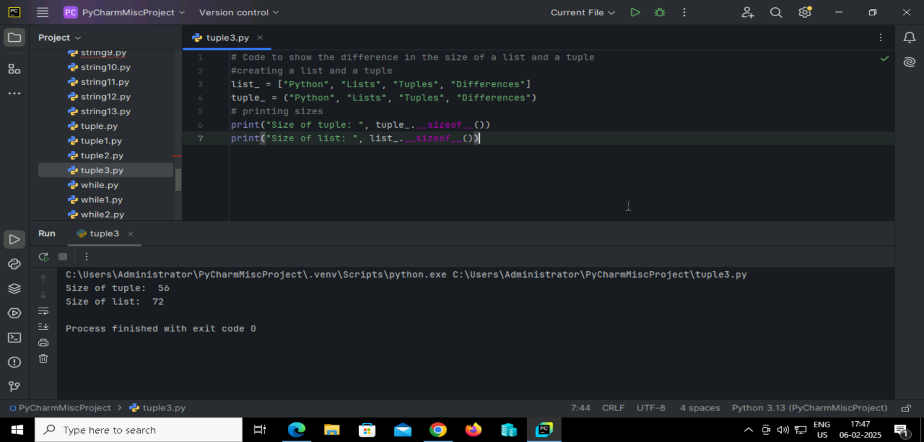

**76. Python code to understand the basic inbuilt functions.**

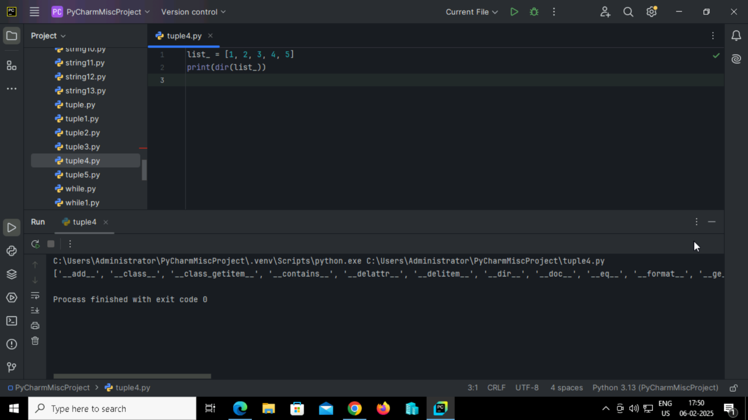

**Output:**

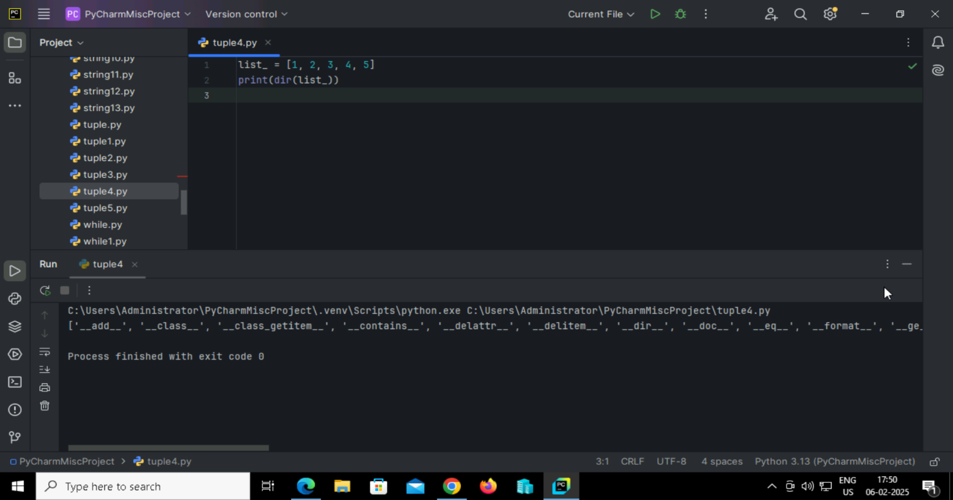

**77. Python program to print the directory of a tuple.**

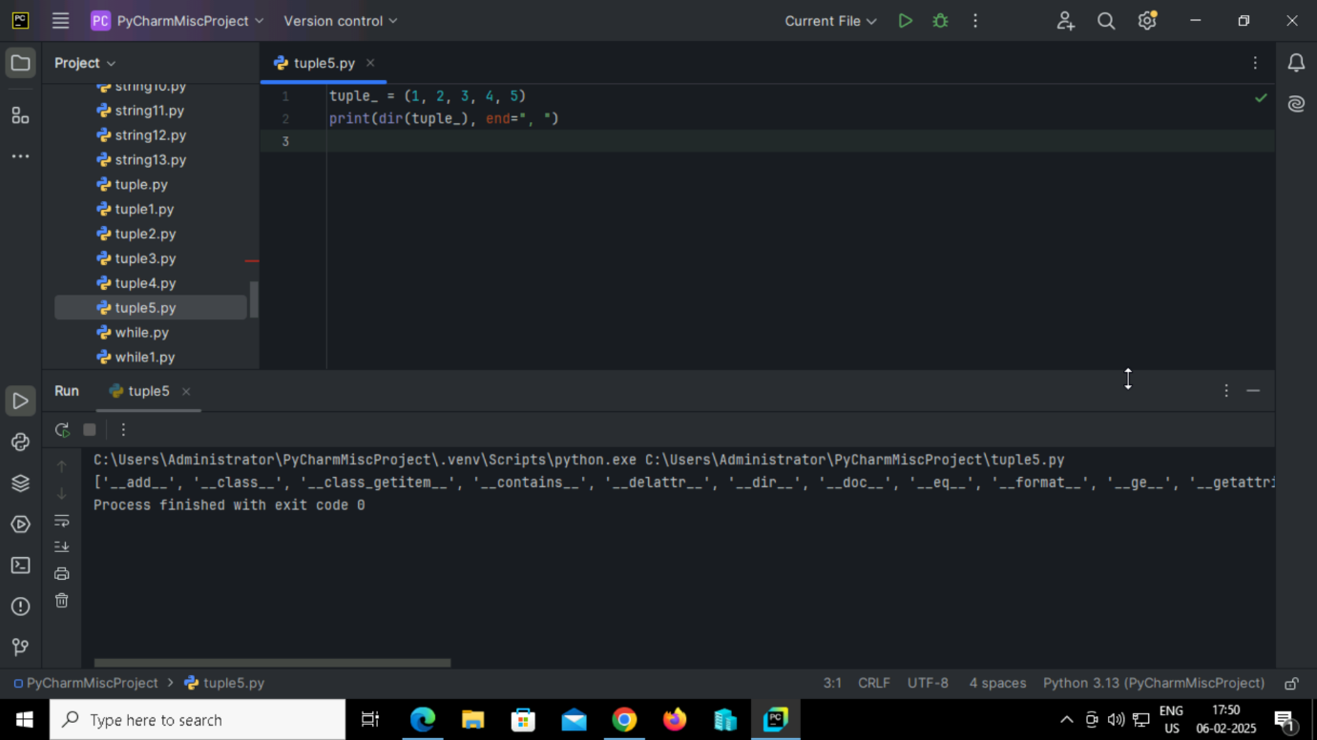

**Output:**

